Lesson 3 Practice Problems
- Select all solutions to $m⋅m⋅m=729$.
  - $\sqrt{729}$
  - $\frac{729}{3}$
  - $\frac{\sqrt{729}}{3}$
  - $\frac{1}{3}\sqrt{729}$
  - ${729}^{\frac{1}{3}}$
  - $\sqrt[3]{729}$
- In a pond, the area that is covered by algae doubles each week. When the algae was first spotted, the area it covered was about 12.5 square meters.
  - Find the area, in square meters, covered by algae 10 days after it was spotted. Show your reasoning.
  - Explain why we can find the area covered by algae 1 day after it was spotted by multiplying 12.5 by $\sqrt[7]{2}$.
- The function $m$, defined by $m\left(h\right)=300⋅{\left(\frac{3}{4}\right)}^{h}$, represents the amount of a medicine, in milligrams, in a patient’s body. $h$ represents the number of hours after the medicine is administered.
  - What does $m\left(0.5\right)$ represent in this situation?
  - This graph represents the function $m$. Use the graph to estimate $m\left(0.5\right)$.
  - 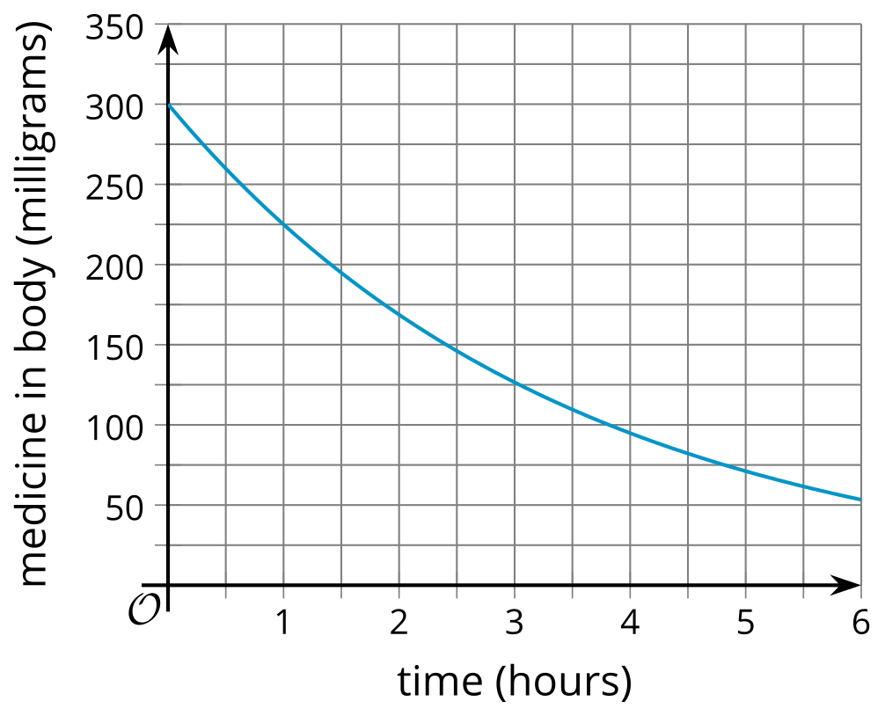
  - Suppose the medicine is administered at noon. Use the graph to estimate the amount of medicine in the body at 4:30 p.m. on the same day.
- The area covered by a lake is 11 square kilometers. It is decreasing exponentially at a rate of 2 percent each year and can be modeled by $A\left(t\right)=11⋅{\left(0.98\right)}^{t}$.
  - By what factor does the area decrease in 10 years?
  - By what factor does the area decrease each month?
- The third and fourth numbers in an exponential sequence are 100 and 500. What are the first and second numbers in this sequence?
- (From Unit 4, Lesson 1.)
- The population of a city in thousands is modeled by the function $f\left(t\right)=250⋅{\left(1.01\right)}^{t}$ where $t$ is the number of years after 1950. Which of the following are predicted by the model? Select all that apply.
  - The population in 1950 was 250.
  - The population in 1950 was 250,000.
  - The population grows by 1 percent each year.
  - The population in 1951 was 275,000.
  - The population grows exponentially.
- (From Unit 4, Lesson 2.)
© CC BY 2019 by Illustrative Mathematics®

