Lesson 12 Practice Problems
- The knitting club sold 40 scarves and hats at a winter festival and made $700 from the sales. They charged $18 for each scarf and $14 for each hat.
- If $s$ represents the number of scarves sold and $h$ represents the number of hats sold, which system of equations represents the constraints in this situation?
  - $\left\{\begin{matrix}40s+h=700 \\ 18s+14h=700\end{matrix}\right.$
  - $\left\{\begin{matrix}18s+14h=40 \\ s+h=700\end{matrix}\right.$
  - $\left\{\begin{matrix}s+h=40 \\ 18s+14h=700\end{matrix}\right.$
  - $\left\{\begin{matrix}40\left(s+h\right)=700 \\ 18s=14h\end{matrix}\right.$
- Here are two equations:
- Equation 1: $6x+4y=34$
Equation 2: $5x−2y=15$
  - Decide whether each $\left(x,y\right)$ pair is a solution to one equation, both equations, or neither of the equations.
    - $\left(3,4\right)$
    - $\left(4,2.5\right)$
    - $\left(5,5\right)$
    - $\left(3,2\right)$
  - Is it possible to have more than one $\left(x,y\right)$ pair that is a solution to both equations? Explain or show your reasoning.
- Explain or show that the point $\left(5,\text{-}4\right)$ is a solution to this system of equations: $\left\{\begin{matrix}3x−2y=23 \\ 2x+y=6\end{matrix}\right.$
- Diego is thinking of two positive numbers. He says, “If we triple the first number and double the second number, the sum is 34.”
  - Write an equation that represents this clue. Then, find two possible pairs of numbers Diego could be thinking of.
  - Diego then says, “If we take half of the first number and double the second, the sum is 14.”
  - Write an equation that could represent this description.
  - What are Diego’s two numbers? Explain or show how you know. A coordinate plane is given here, in case helpful.

  - 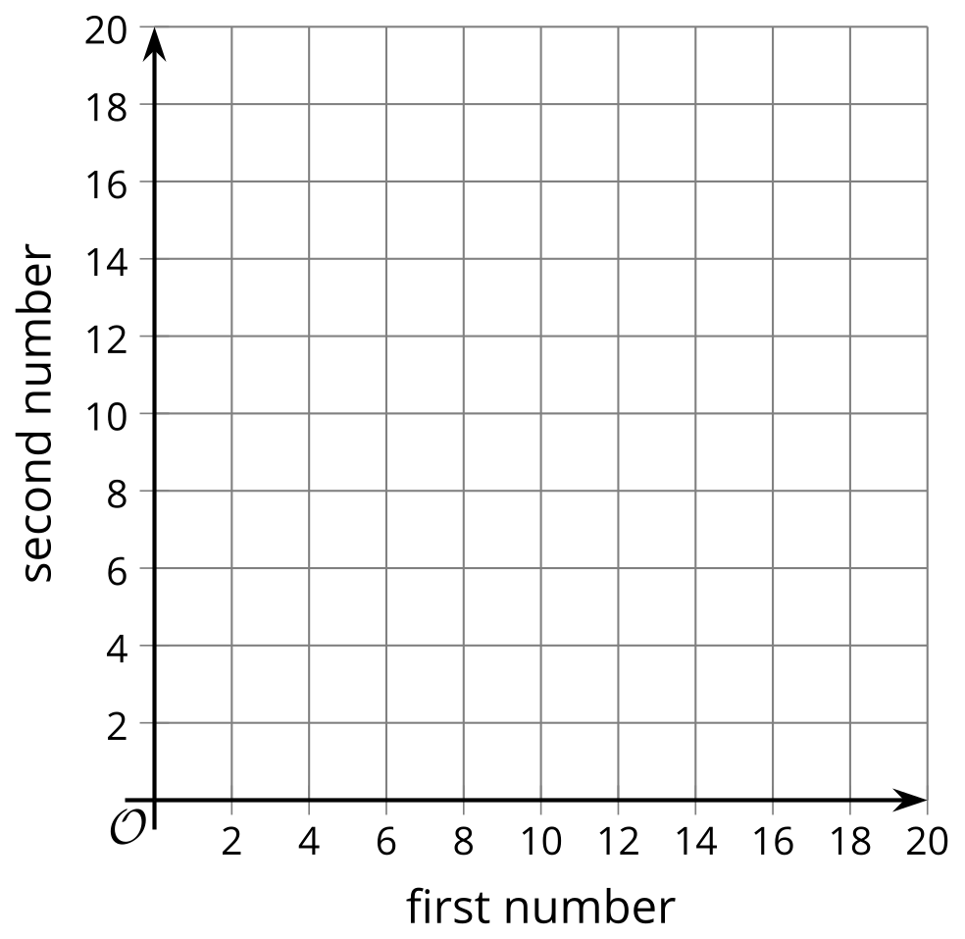
- The table shows the volume of water in a tank after it has been filled to a certain height.
- Which equation could represent the volume of water in cubic inches, $V$, when the height is $h$ inches?
- height of water  (inches) | - volume of water  (cubic inches)
- 0 | - 0
- 1 | - 1.05
- 2 | - 8.40
- 3 | - 28.35
  - $h=V$
  - $h=\frac{V}{4}$
  - $V=h^{2}+0.05$
  - $V=1.05h^{3}$
- (From Unit 2, Lesson 4.)
- Andre does not understand why a solution to the equation $3−x=4$ must also be a solution to the equation $12=9−3x$.
- Write a convincing explanation as to why this is true.
- (From Unit 2, Lesson 7.)
- Volunteer drivers are needed to bring 80 students to the championship baseball game. Drivers either have cars, which can seat 4 students, or vans, which can seat 6 students. The equation $4c+6v=80$ describes the relationship between the number of cars $c$ and number of vans $v$ that can transport exactly 80 students.
- Explain how you know that this graph represents this equation.
- 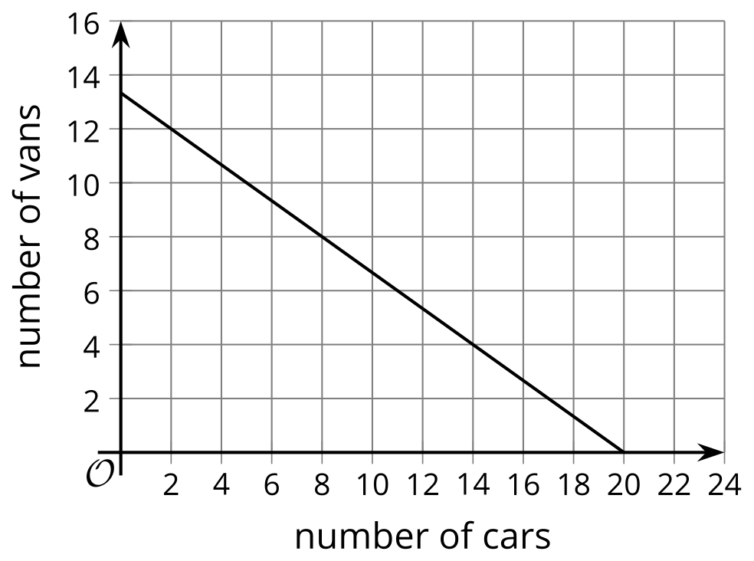
- (From Unit 2, Lesson 10.)
- Three siblings are participating in a family-friendly running event.
  - The oldest sibling begins at the start line of the race and runs 7 miles per hour the entire time.
  - The middle sibling begins at the start line and walks at 3.5 miles per hour throughout the race.
  - The youngest sibling joins the race 4 miles from the start line and runs 5 miles per hour the rest of the way.
- 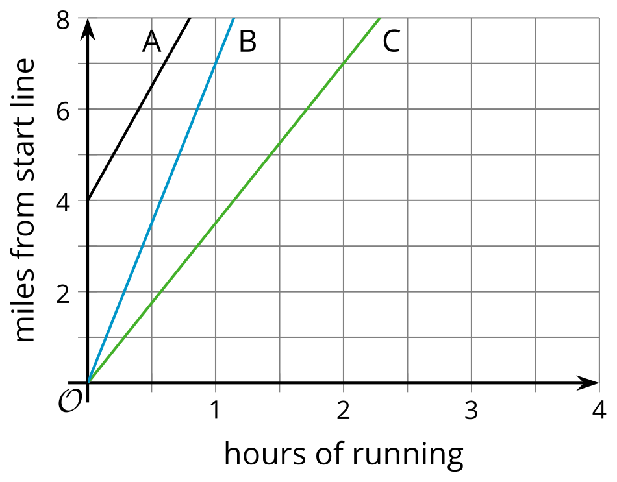
- Match each graph to the sibling whose running is represented by the graph.
  - Oldest Sibling
  - Middle Sibling
  - Youngest Sibling
  - Graph A
  - Graph B
  - Graph C
- (From Unit 2, Lesson 11.)
- What is the $x$-intercept of the graph of $y=3−5x$?
  - $\left(\frac{3}{5},0\right)$
  - $\left(\text{-}5,0\right)$
  - $\left(0,3\right)$
  - $\left(0,\frac{5}{3}\right)$
- (From Unit 2, Lesson 11.)
© CC BY 2019 by Illustrative Mathematics®

