Unit 2 Lesson 11: Side-Side-Angle (Sometimes) Congruence

1 Notice and Wonder: Congruence Fail (Warm up)

Images for Launch
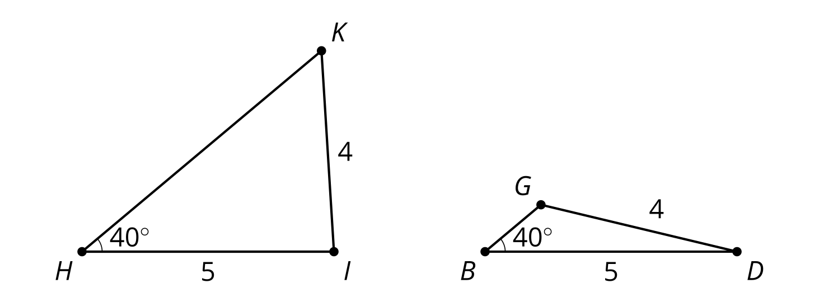

Student Task Statement
What do you notice? What do you wonder?
In triangles $GBD$ and $KHI$:
- Angle $GBD$ is congruent to angle $KHI$.
- Segment $BD$ is congruent to segment $HI$.
- Segment $DG$ is congruent to segment $IK$.

2 Dare to Be (Even More) Different (Optional)

Student Task Statement
Copy these segments and use them to make a triangle using the given angle so that the given angle is not between the 2 given sides. Draw your triangle on tracing paper. Try to make your triangle different from the triangles drawn by the other people in your group.

3 Ambiguously Ambiguous? (Optional)

Student Task Statement
Your teacher will give you some sets of information.
- For each set of information, make a triangle using that information.
- If you think you can make more than one triangle, make more than one triangle.
- If you think you can’t make any triangle, note that.
When you are confident they are accurate, create a visual display.

Images for Activity Synthesis

Unique!
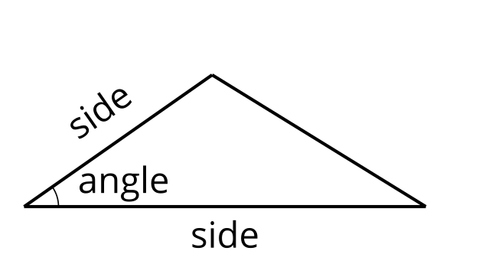

Unique!
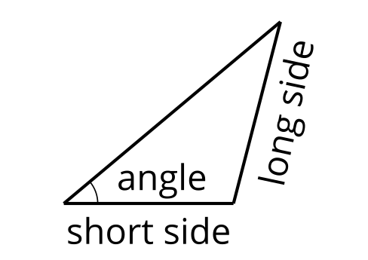

Unique!
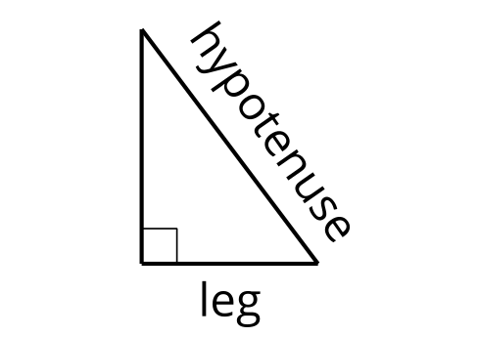

Not unique!
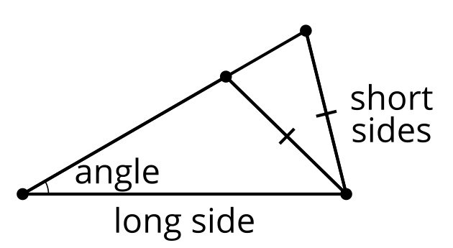
© CC BY 2019 by Illustrative Mathematics®

