Unit 6 Lesson 4 Cumulative Practice Problems
- Draw a square with side length 7 cm.
  - Predict the perimeter and the length of the diagonal of the square.
  - Measure the perimeter and the length of the diagonal of the square.
  - Describe how close the predictions and measurements are.
- (From Unit 3, Lesson 1.)
- Find the products.
  - $(100)⋅(\text{-}0.09)$
  - $(\text{-}7)⋅(\text{-}1.1)$
  - $(\text{-}7.3)⋅(5)$
  - $(\text{-}0.2)⋅(\text{-}0.3)$
- (From Unit 5, Lesson 9.)
- Here are three stories:
  - A family buys 6 tickets to a show. They also pay a $3 parking fee. They spend $27 to see the show.
  - Diego has 27 ounces of juice. He pours equal amounts for each of his 3 friends and has 6 ounces left for himself.
  - Jada works for 6 hours preparing for the art fair. She spends 3 hours on a sculpture and then paints 27 picture frames.
- Here are three equations:
  - $3x+6=27$
  - $6x+3=27$
  - $27x+3=6$
  - Decide which equation represents each story. What does $x$ represent in each equation?
  - Find the solution to each equation. Explain or show your reasoning.
  - What does each solution tell you about its situation?
- Here is a diagram and its corresponding equation. Find the solution to the equation and explain your reasoning.
- 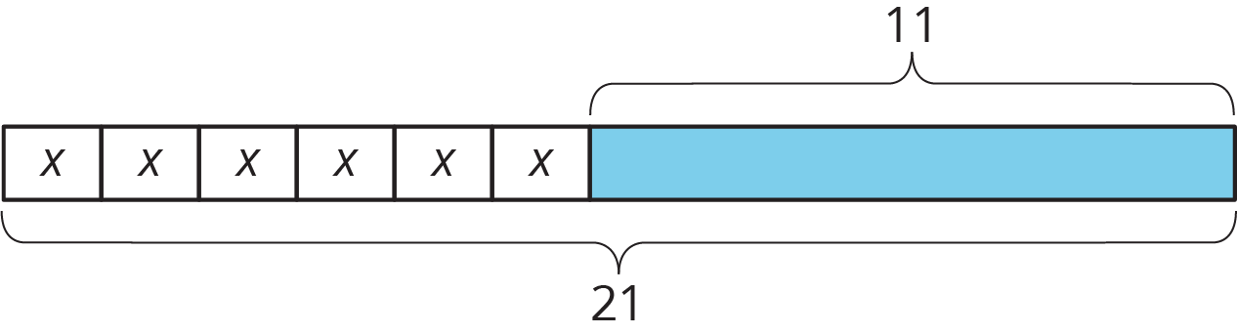
- $6x+11=21$
  - Plot these points on the coordinate plane:
  - $A=(3,2),B=(7.5,2),C=(7.5,\text{-}2.5),D=(3,\text{-}2)$
  - 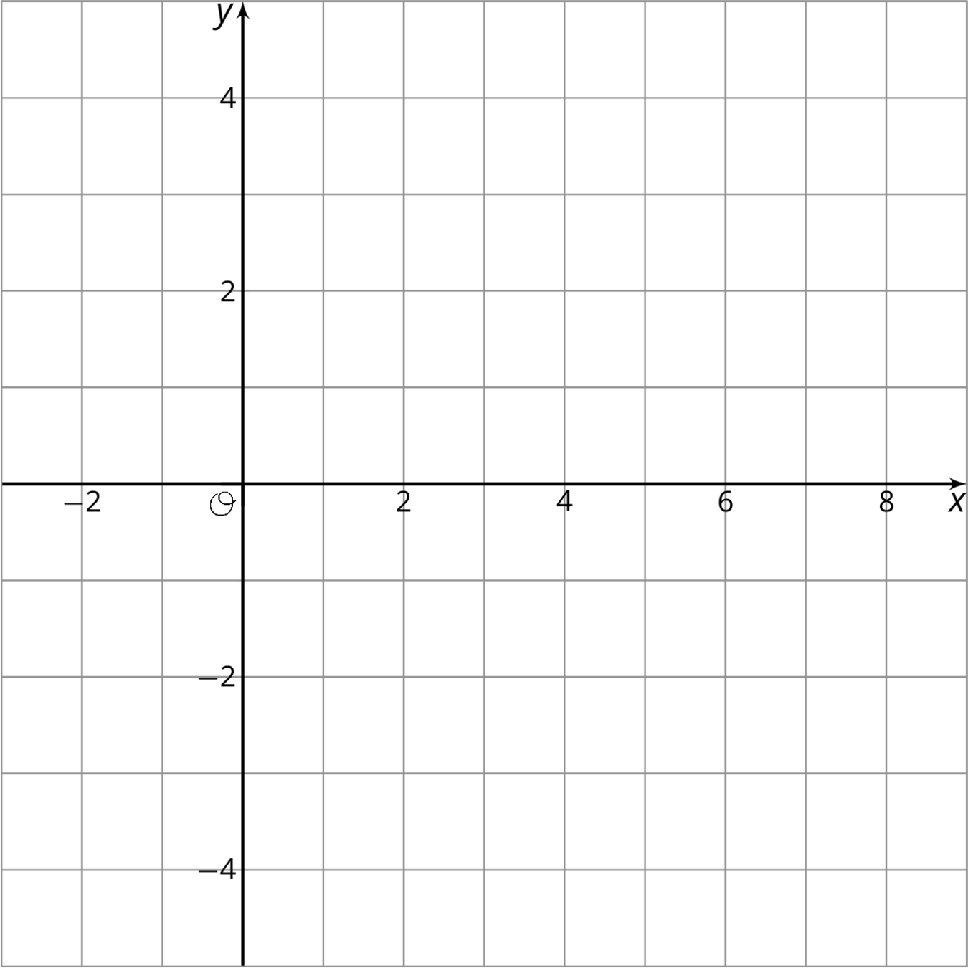
  - What is the vertical difference between $D$ and $A$?
  - Write an expression that represents the vertical distance between $B$ and $C$.
- (From Unit 5, Lesson 7.)
© CC BY Open Up Resources. Adaptations CC BY IM.

