## Unit 4 Lesson 9: When Are They the Same?

### 1 Which Would You Choose? (Warm up)

#### Student Task Statement

If you were babysitting, would you rather

* Charge $5 for the first hour and $8 for each additional hour?

Or

* Charge $15 for the first hour and $6 for each additional hour?

Explain your reasoning.

### 2 Water Tanks

#### Student Task Statement

The amount of water in two tanks every 5 minutes is shown in the table.

|  |  |  |
| --- | --- | --- |
| time (minutes) | tank 1 (liters) | tank 2 (liters) |
| 0 | 25 | 1000 |
| 5 | 175 | 900 |
| 10 | 325 | 800 |
| 15 | 475 | 700 |
| 20 | 625 | 600 |
| 25 | 775 | 500 |
| 30 | 925 | 400 |
| 35 | 1075 | 300 |
| 40 | 1225 | 200 |
| 45 | 1375 | 100 |
| 50 | 1525 | 0 |

1. Describe what is happening in each tank. Either draw a picture, say it verbally, or write a few sentences.
2. Use the table to estimate when the tanks will have the same amount of water.
3. The amount of water (in liters) in tank 1 after minutes is . The amount of water (in liters) in tank 2 after minutes is . Find the time when the amount of water will be equal.

### 3 Elevators

#### Student Task Statement

A building has two elevators that both go above and below ground.

At a certain time of day, the travel time it takes elevator A to reach height in meters is seconds.

The travel time it takes elevator B to reach height in meters is seconds.

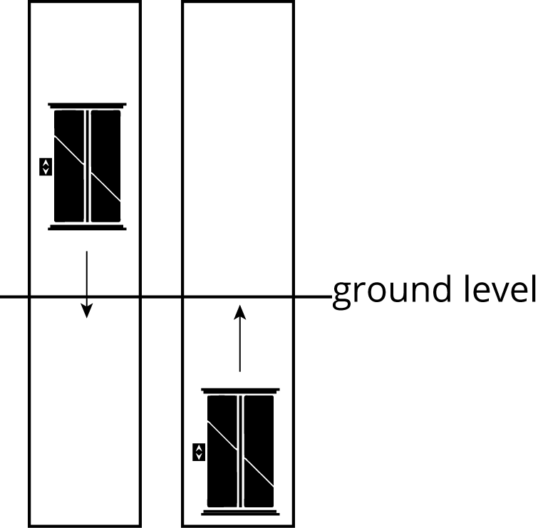

1. What is the height of each elevator at this time?
2. How long would it take each elevator to reach ground level at this time?
3. If the two elevators travel toward one another, at what height do they pass each other? How long would it take?
4. If you are on an underground parking level 14 meters below ground, which elevator would reach you first?



© CC BY Open Up Resources. Adaptations CC BY IM.