Unit 1 Lesson 10: Bases and Heights of Triangles

1 An Area of 12 (Warm up)

Student Task Statement
On the grid, draw a triangle with an area of 12 square units. Try to draw a non-right triangle. Be prepared to explain how you know the area of your triangle is 12 square units.

2 Hunting for Heights

Images for Launch
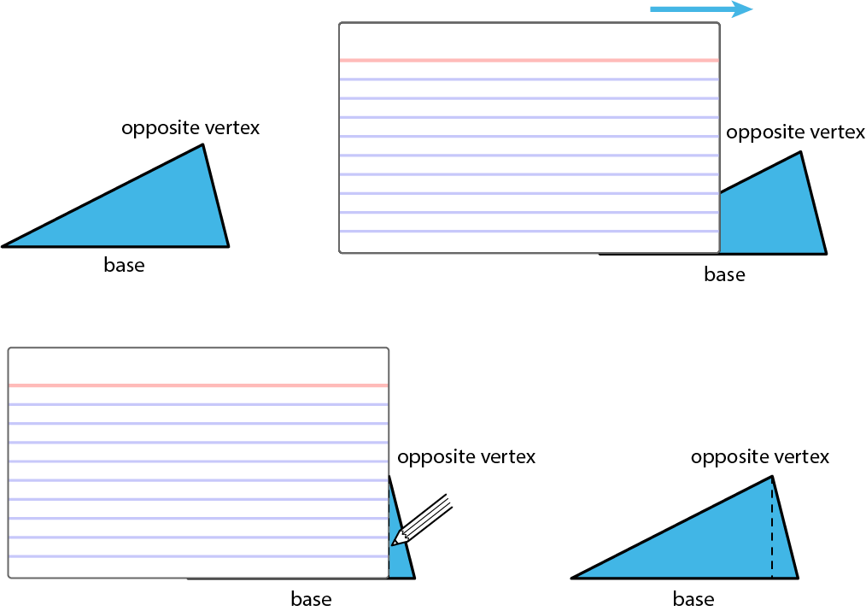
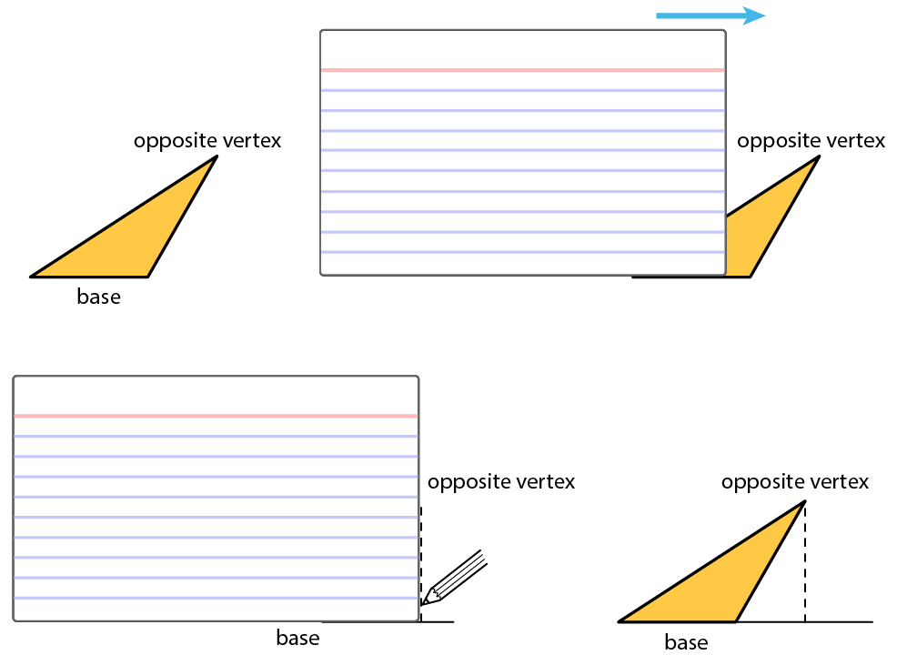

Student Task Statement
- Here are three copies of the same triangle. The triangle is rotated so that the side chosen as the base is at the bottom and is horizontal. Draw a height that corresponds to each base. Use an index card to help you.
- Side $a$ as the base:
- 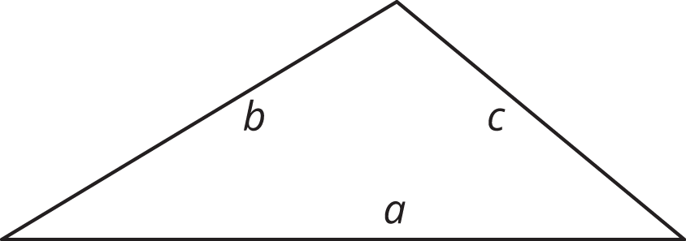
- Side $b$ as the base:
- 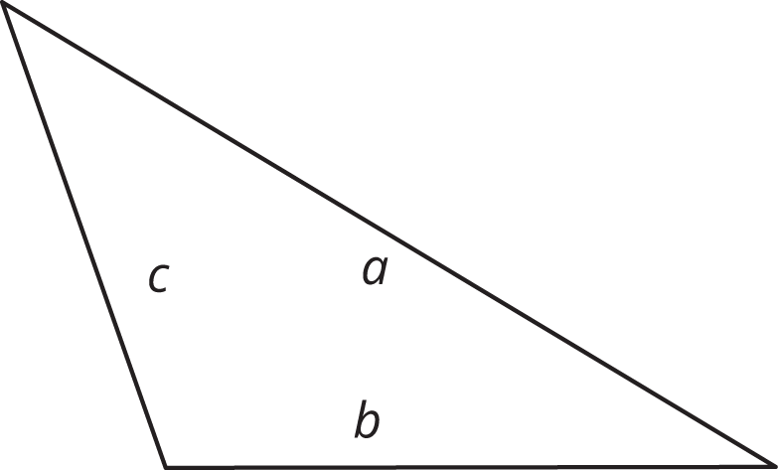
- Side $c$ as the base:
- 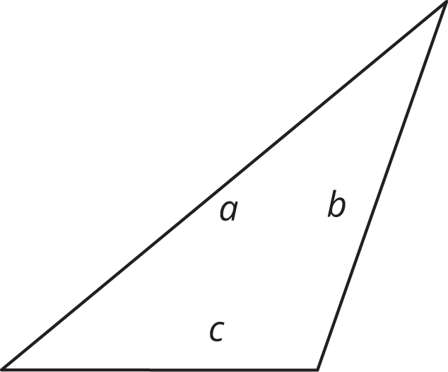

- Pause for your teacher’s instructions before moving to the next question.
- Draw a line segment to show the height for the chosen base in each triangle.
- 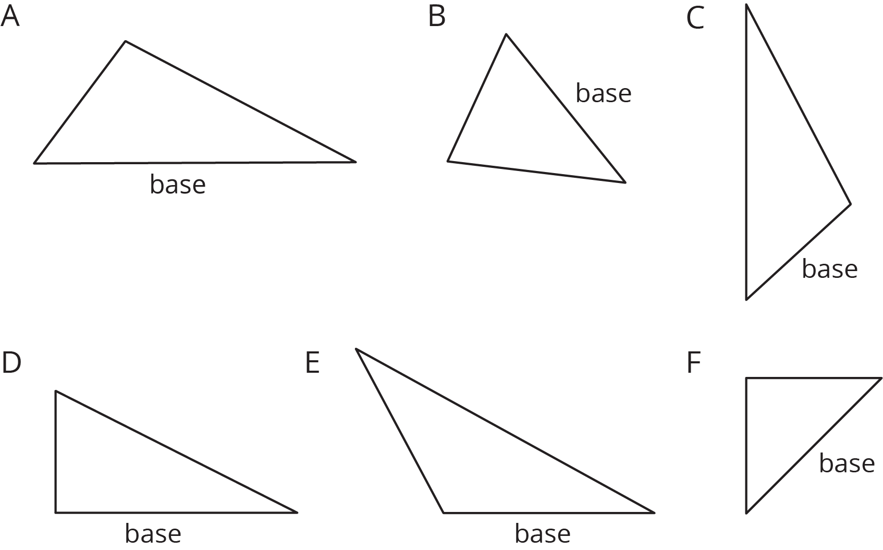

3 Some Bases Are Better Than Others (Optional)

Student Task Statement
For each triangle, identify and label a base and height. If needed, draw a line segment to show the height.
Then, find the area of the triangle. Show your reasoning. (The side length of each square on the grid is 1 unit.)
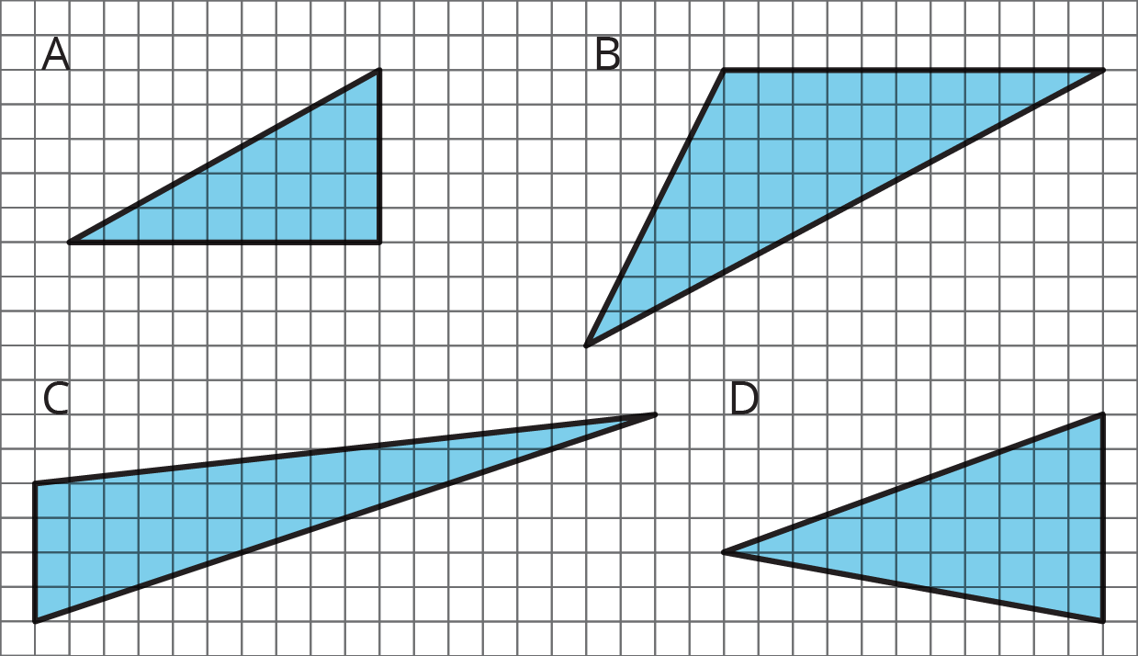
© CC BY Open Up Resources. Adaptations CC BY IM.

