Unit 2 Lesson 7: Using Factors and Zeros

1 More Than Factors (Warm up)

Student Task Statement
$M$ and $K$ are both polynomial functions of $x$ where $M(x)=(x+3)(2x−5)$ and $K(x)=3(x+3)(2x−5)$.
- How are the two functions alike? How are they different?
- If a graphing window of $\text{-}5≤x≤5$ and $\text{-}20≤y≤20$ shows all intercepts of a graph of $y=M(x)$, what graphing window would show all intercepts of $y=K(x)$?

2 Choosing Windows

Student Task Statement
Mai graphs the function $p$ given by $p(x)=(x+1)(x−2)(x+15)$ and sees this graph.
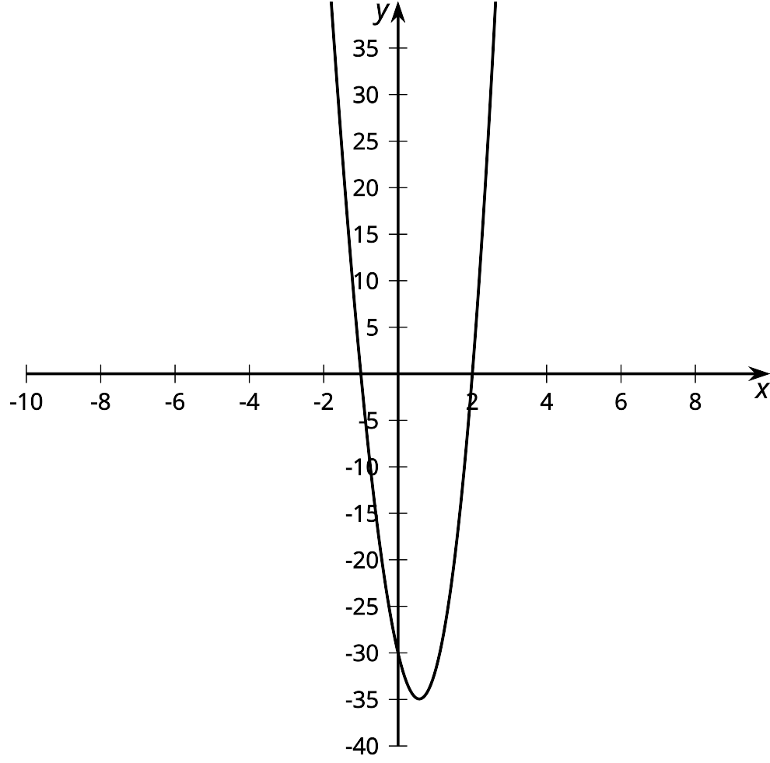
She says, “This graph looks like a parabola, so it must be a quadratic.”
- Is Mai correct? Use graphing technology to check.
- Explain how you could select a viewing window before graphing an expression like $p(x)$ that would show the main features of a graph.
- Using your explanation, what viewing window would you choose for graphing $f(x)=(x+1)(x−1)(x−2)(x−28)$?

3 What’s the Equation?

Student Task Statement
Write a possible equation for a polynomial whose graph has the following horizontal intercepts. Check your equation using graphing technology.
- $(4,0)$
- $(0,0)$ and $(4,0)$
- $(\text{-}2,0)$, $(0,0)$ and $(4,0)$
- $(\text{-}4,0),(0,0)$, and $(2,0)$
- $(\text{-}5,0)$, $\left(\frac{1}{2},0\right)$, and $(3,0)$
© CC BY 2019 by Illustrative Mathematics

