Lesson 5: Multiply a Unit Fraction by a Non-unit Fraction
- Let’s multiply a unit fraction and a non-unit fraction.

Warm-up: Estimation Exploration: Shaded Rectangle
What is the area of the shaded region?
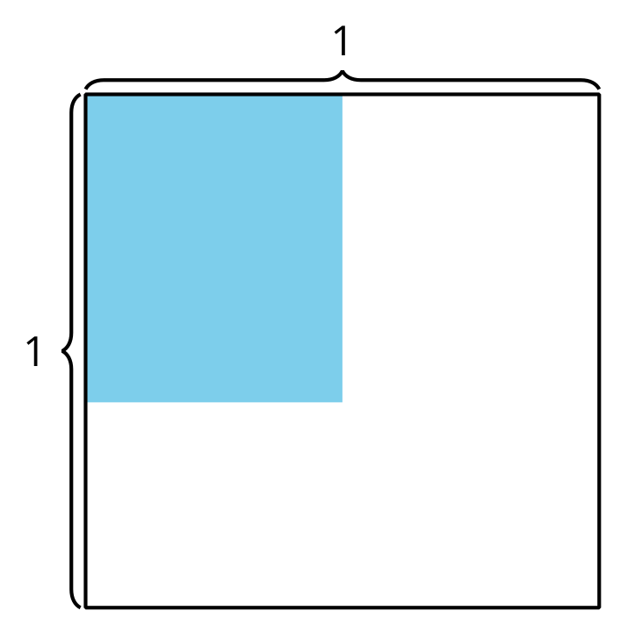
Record an estimate that is:
too low | about right | too high

5.1: Write Equations
- Write a multiplication expression that represents the shaded region in each diagram.
- A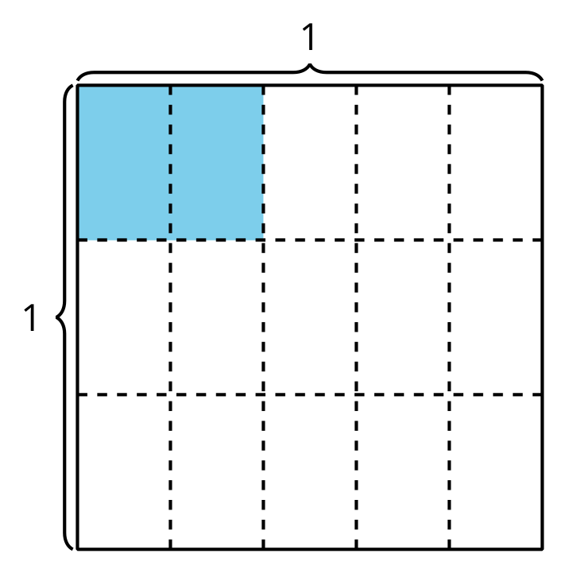
- B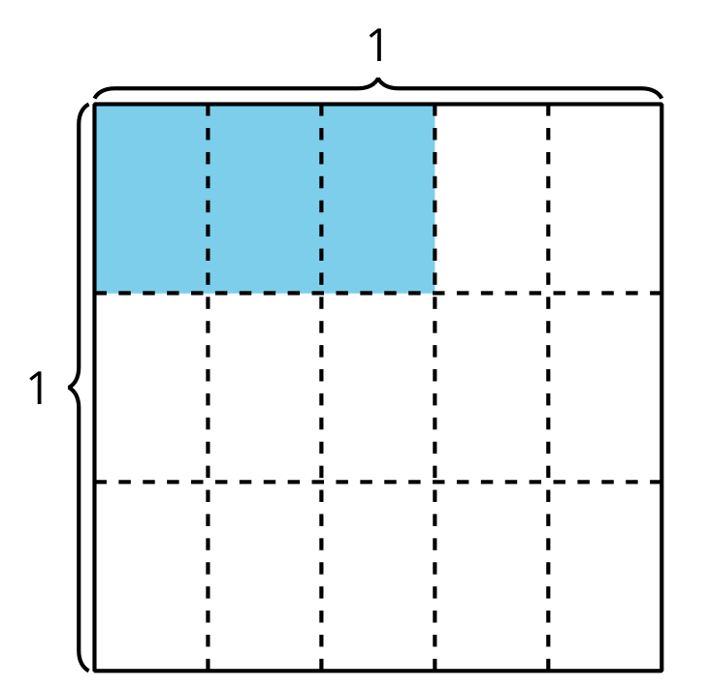
- C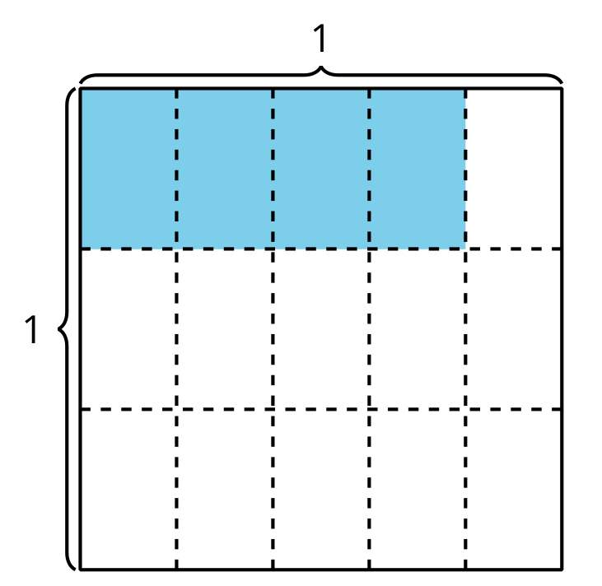
- What patterns do you notice in the multiplication expressions?
- Han wrote this equation to represent the area of the shaded region. Explain how the diagram represents the equation.
- 2.5cm65×13=615
- 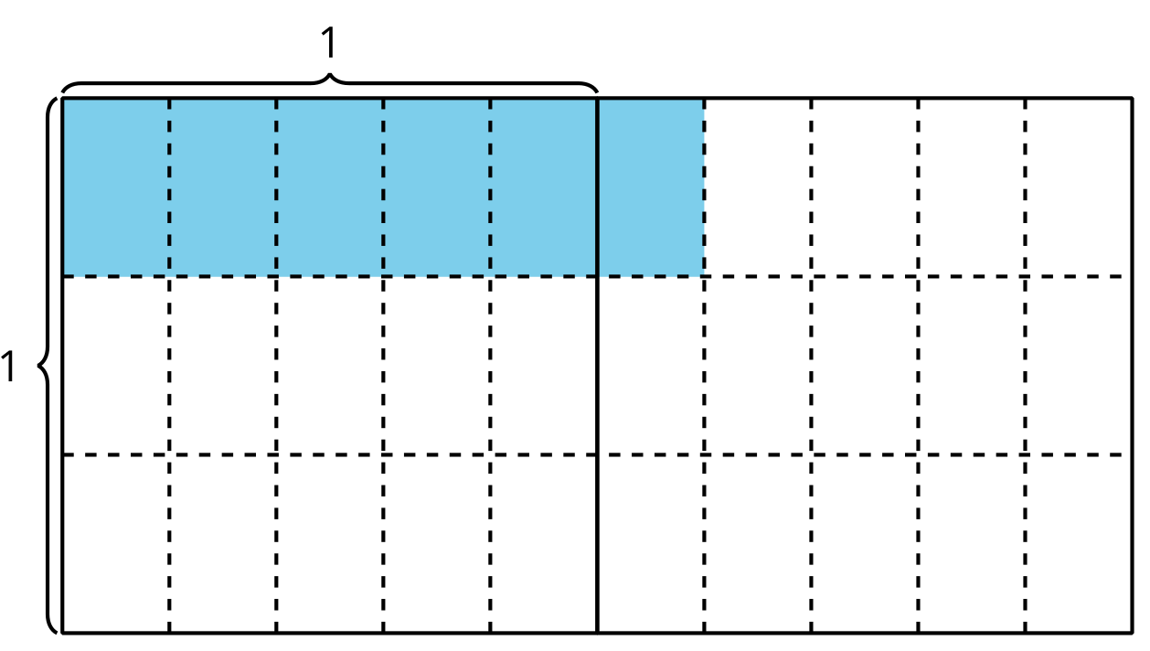

5.2: Estimate With Expressions
Write a multiplication expression that might represent the area of the shaded region. Be prepared to explain your reasoning.

- 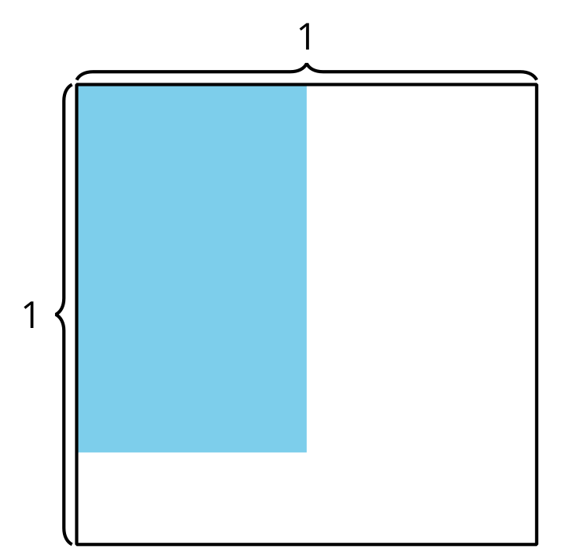

- 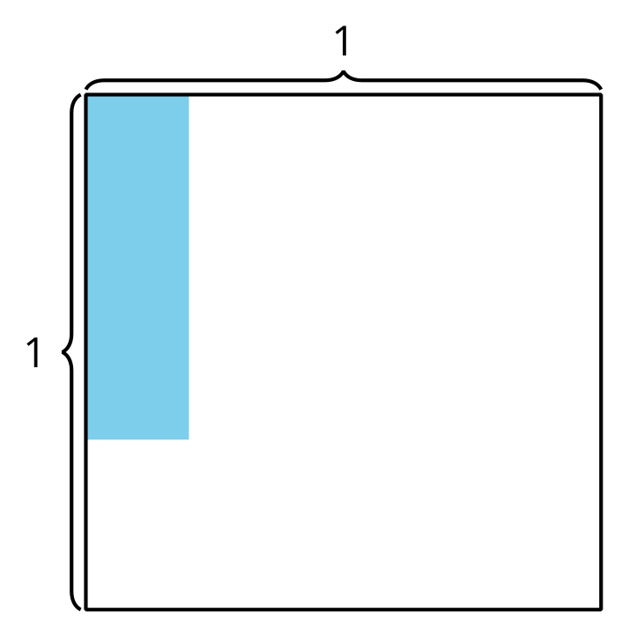

- 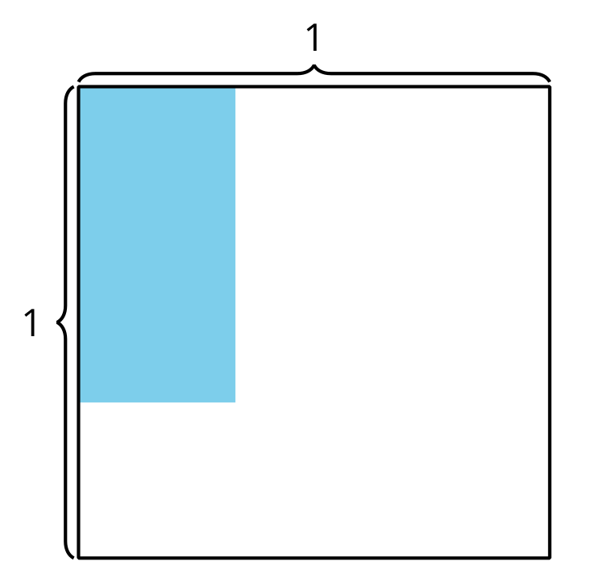

- 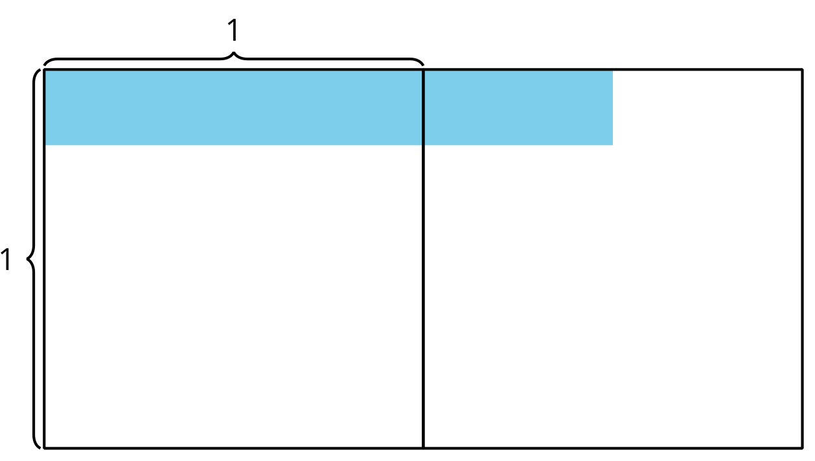
© CC BY 2021 Illustrative Mathematics®

