Unit 4 Lesson 17: Add 0 and 1

WU Notice and Wonder: Add 1 More (Warm up)

Student Task Statement
What do you notice?
What do you wonder?
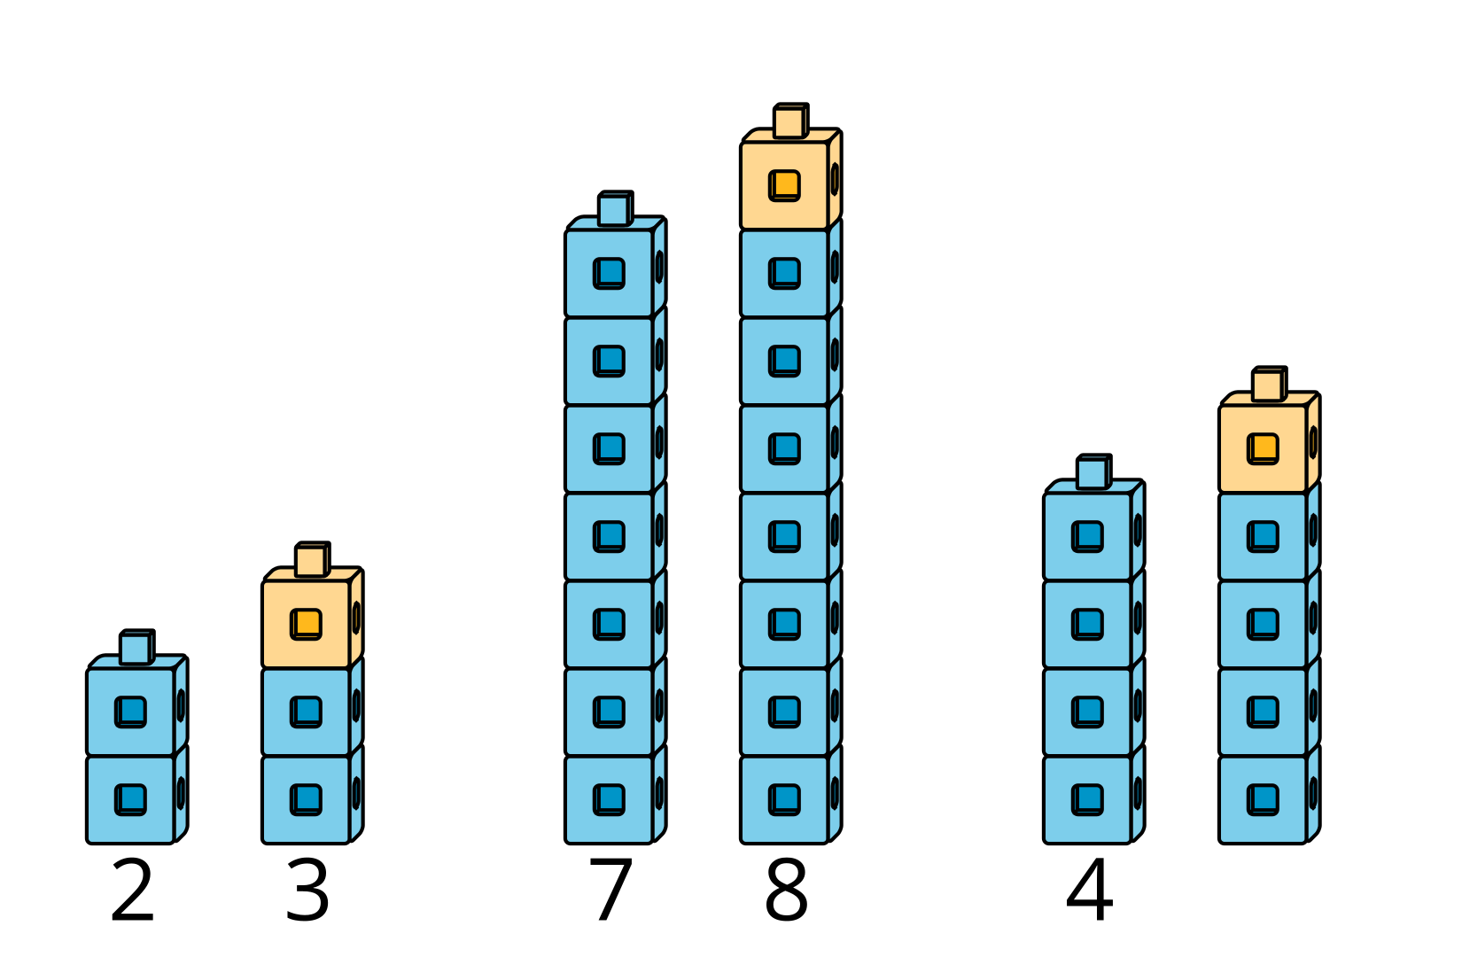

1 Add 0 and 1

Images for Launch
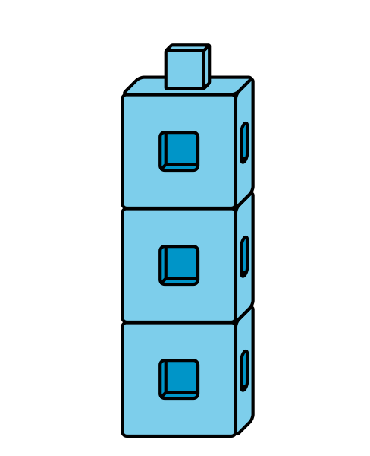

Student Task Statement
$4+\underset{_}{}$
$2+\underset{_}{}$
$8+\underset{_}{}$
$3+\underset{_}{}$
$9+\underset{_}{}$
$1+\underset{_}{}$

2 Notice $+0$ and $+1$ Patterns

Student Task Statement
$4+0$
4
$2+0$
2
$8+0$
8
$3+1$
4
$9+1$
10
$1+1$
2

3 Introduce Find the Value of Expressions, Color the Total or Difference

Student Task Statement
Choose a center.
Find the Value of
Expressions
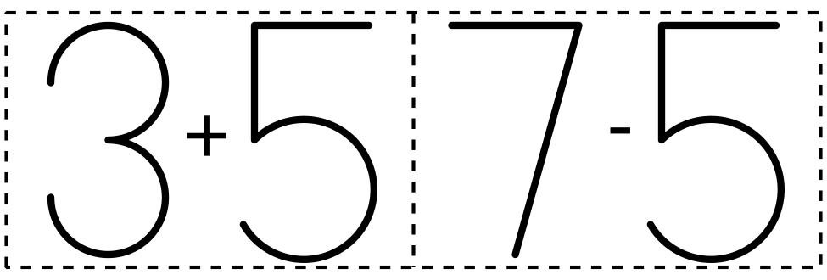
​​​​​​
Roll and Add
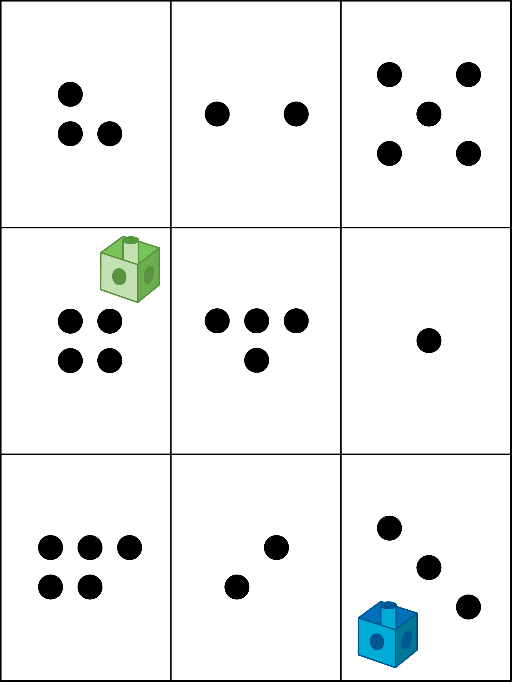
Shake and Spill
Math Stories
Number Race
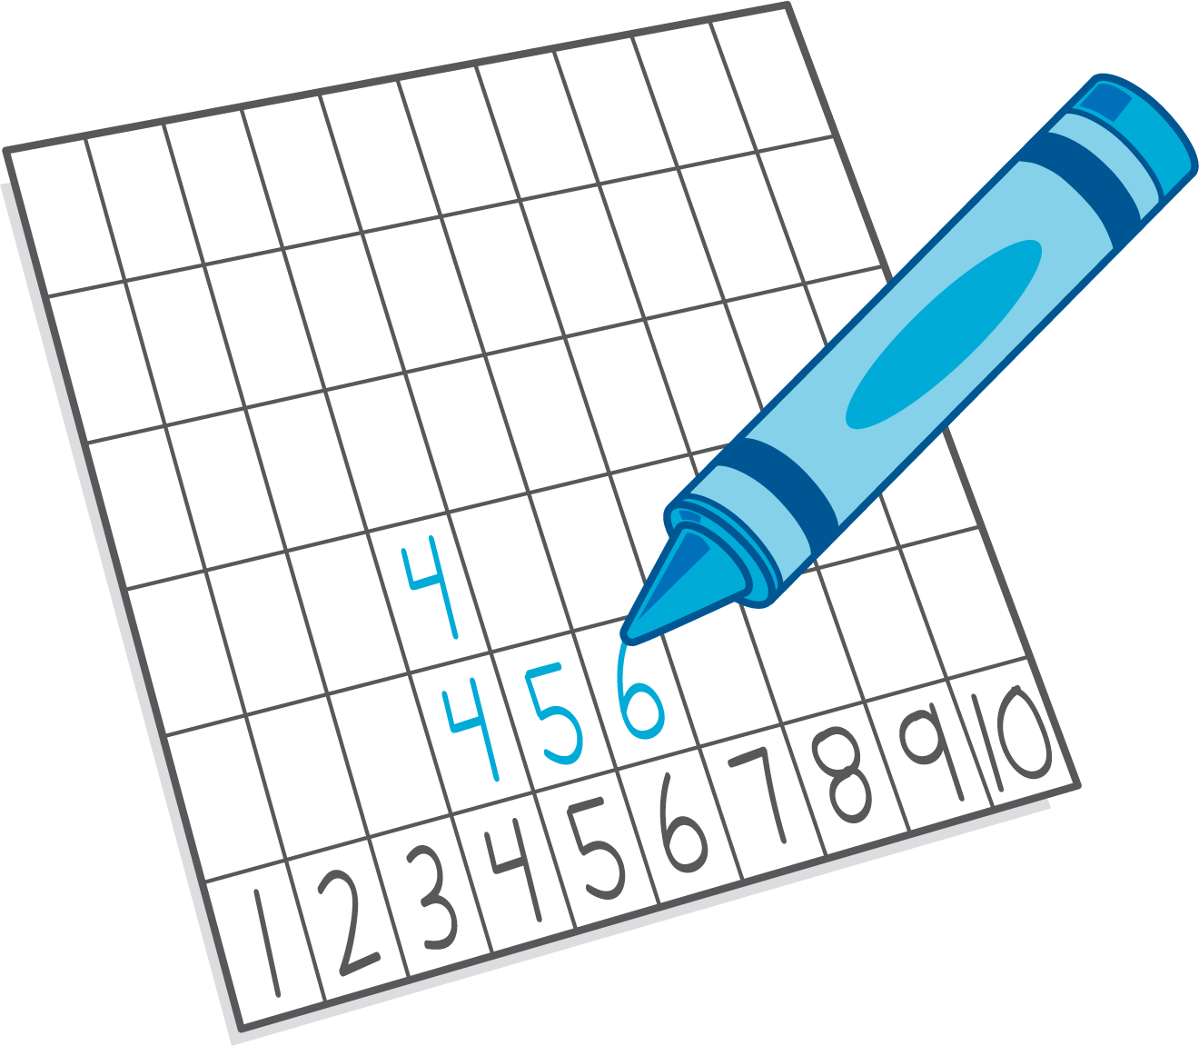

Images for Activity Synthesis
© CC BY 2021 Illustrative Mathematics®

