Lesson 1: Addition Fluency Within 10
- Let’s add within 10.

Warm-up: How Many Do You See: Within 10
How many do you see?
How do you see them?
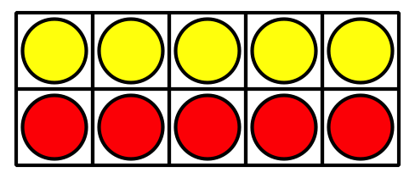
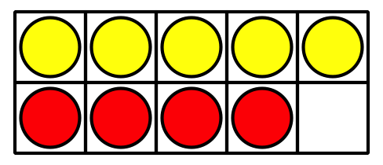
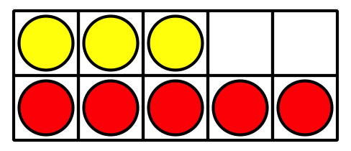

1.1: Sums I've Got
Color the sums you know the value of from memory.
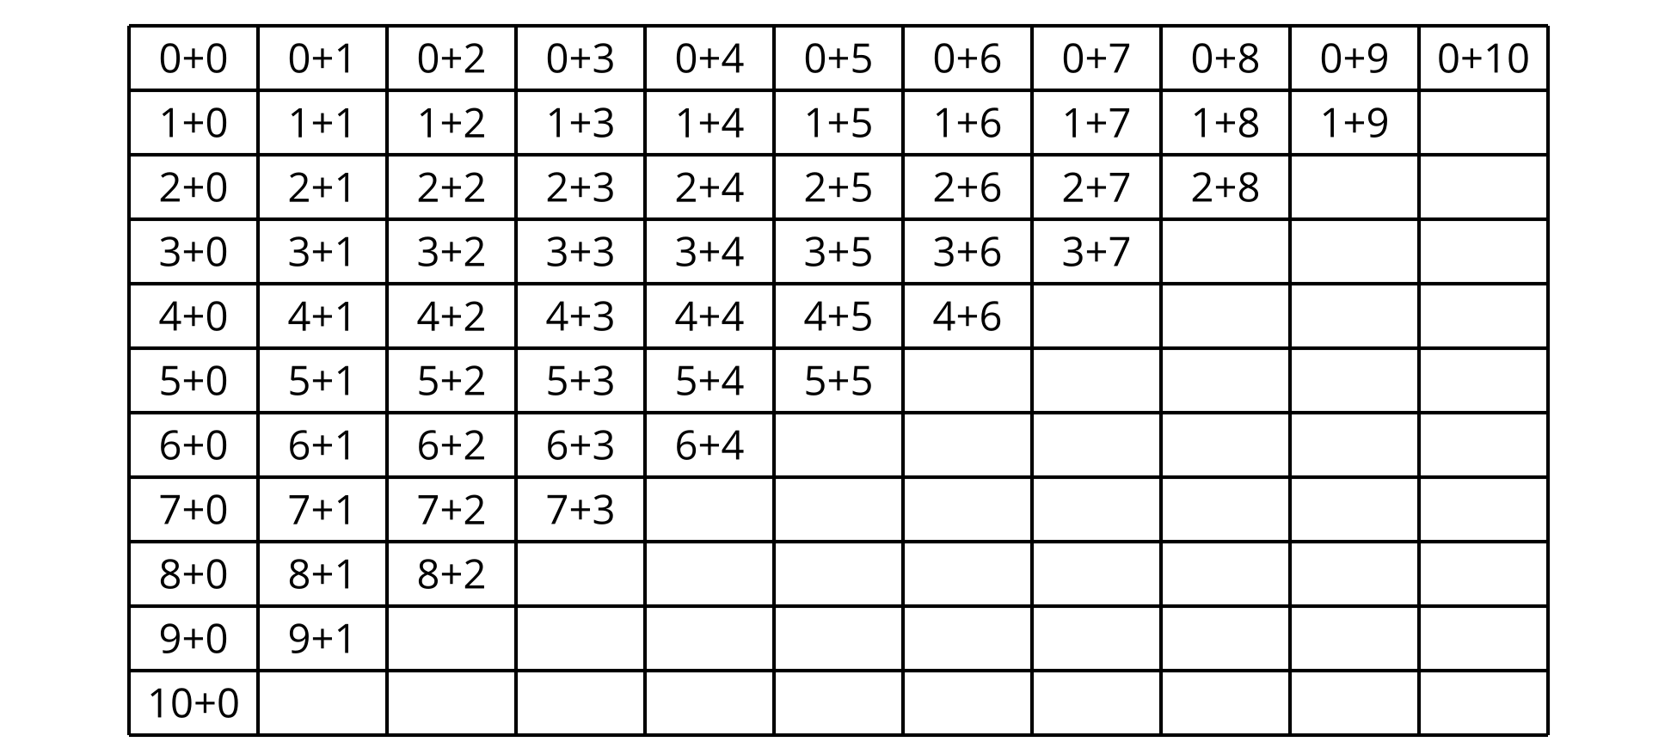
Write each sum that is not colored, on an index card.
Use the cards to practice these sums.

1.2: Centers: Choice Time
Choose a center.
Check it Off
Number Puzzles
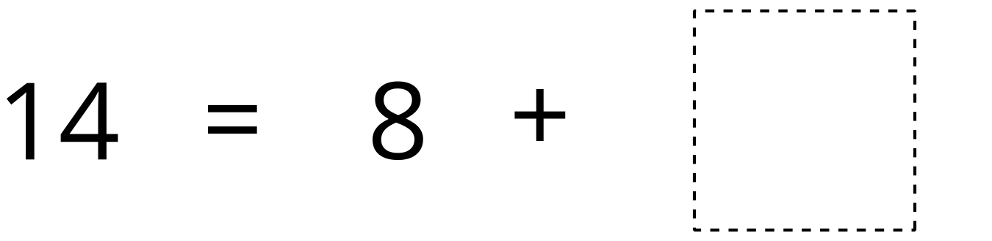
Capture Squares
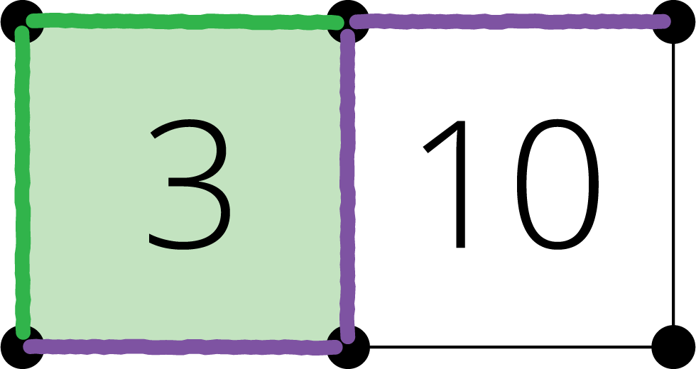
© CC BY 2021 Illustrative Mathematics®

