Lesson 11: Center Day 2
- Let’s add numbers within 1,000.

Warm-up: Number Talk: Make 100
Find the value of each expression mentally.
- $80¢+20¢+37¢$
- $80¢+20¢+37¢+42¢$
- $75¢+37¢+25¢$
- $75¢+80¢+25¢+20¢$

11.2: Introduce Five in a Row, Add Within 1,000 with Composing
Choose a center.
Five a Row: Addition and Subtraction
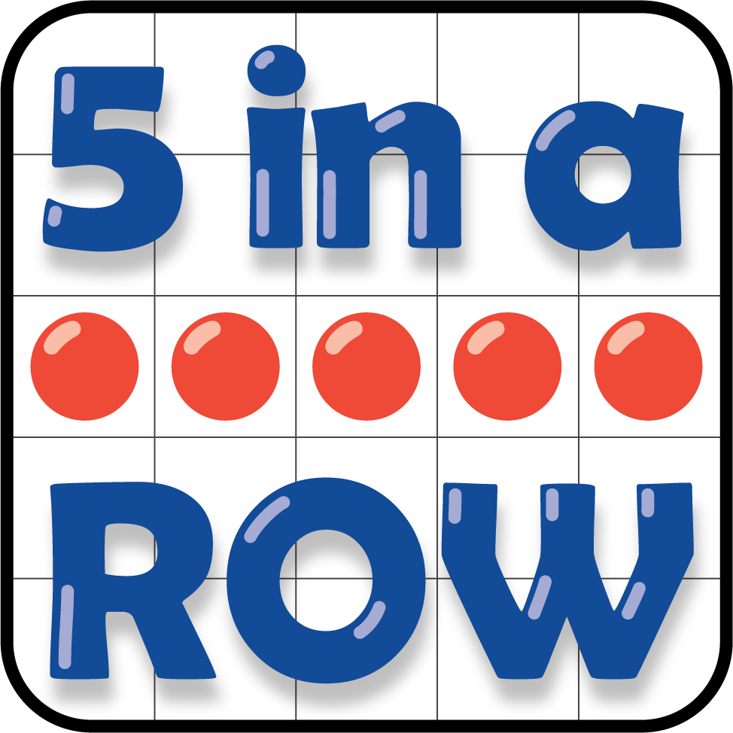
How Close?
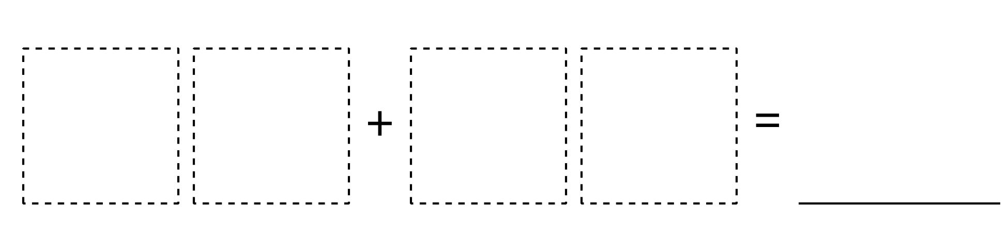
© CC BY 2021 Illustrative Mathematics®

