Unit 7 Lesson 12 Cumulative Practice Problems
- Which is larger: the number of meters across the Milky Way, or the number of cells in all humans? Explain or show your reasoning.
- Some useful information:
  - The Milky Way is about 100,000 light years across.
  - There are about 37 trillion cells in a human body.
  - One light year is about ${10}^{16}$ meters.
  - The world population is about 7 billion.

- Write each number in scientific notation.
  - 14,700
  - 0.00083
  - 760,000,000
  - 0.038
  - 0.38
  - 3.8
  - 3,800,000,000,000
  - 0.0000000009
- Perform the following calculations. Express your answers in scientific notation.
  - $(2×{10}^{5})+(6×{10}^{5})$
  - $(4.1×{10}^{7})⋅2$
  - $(1.5×{10}^{11})⋅3$
  - $(3×{10}^{3})^{2}$
  - $(9×{10}^{6})⋅(3×{10}^{6})$
- Jada is making a scale model of the solar system. The distance from Earth to the Moon is about $2.389×{10}^{5}$ miles. The distance from Earth to the Sun is about $9.296×{10}^{7}$ miles. She decides to put Earth on one corner of her dresser and the Moon on another corner, about a foot away. Where should she put the sun?
  - On a windowsill in the same room?
  - In her kitchen, which is down the hallway?
  - A city block away?
- Explain your reasoning.
- Diego was solving an equation, but when he checked his answer, he saw his solution was incorrect. He knows he made a mistake, but he can’t find it. Where is Diego’s mistake and what is the solution to the equation?
- $\begin{matrix}\text{-}4(7−2x)=3(x+4) \\ \text{-}28−8x=3x+12 \\ \text{-}28=11x+12 \\ \text{-}40=11x \\ \text{-}\frac{40}{11}=x \end{matrix}$
- (From Unit 4, Lesson 13.)
- Here is the graph for one equation in a system of equations.
- 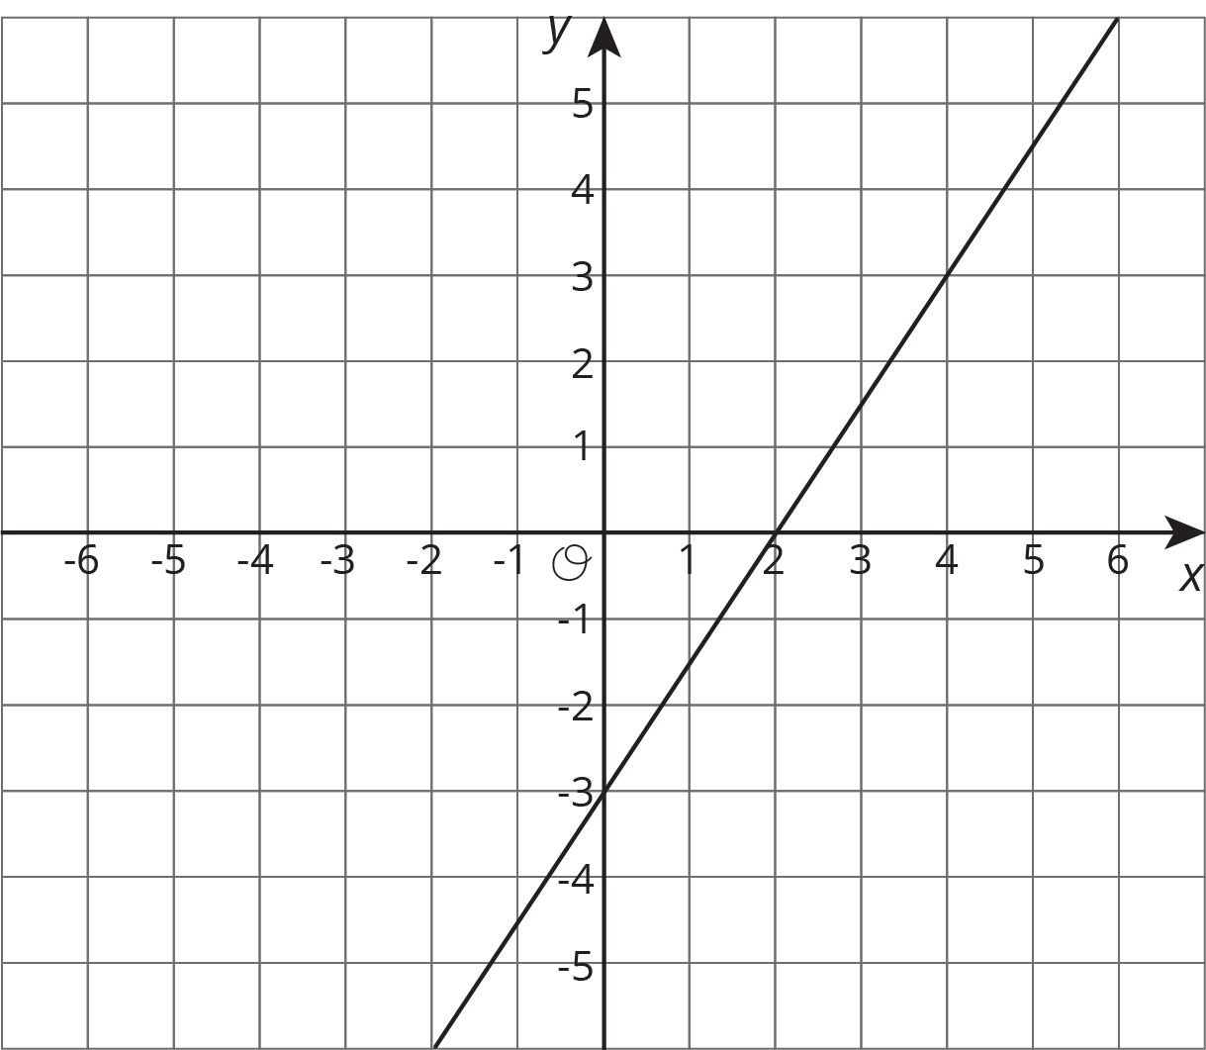
  - Write a second equation for the system so it has infinitely many solutions.
  - Write a second equation whose graph goes through $(0,2)$ so that the system has no solutions.
  - Write a second equation whose graph goes through $(2,2)$ so that the system has one solution at $(4,3)$.
- (From Unit 5, Lesson 13.)
© CC BY Open Up Resources. Adaptations CC BY IM.

