Lesson 16: Triangles with 3 Common Measures

16.1: 3 Sides; 3 Angles
Examine each set of triangles. What do you notice? What is the same about the triangles in the set? What is different?
Set 1:
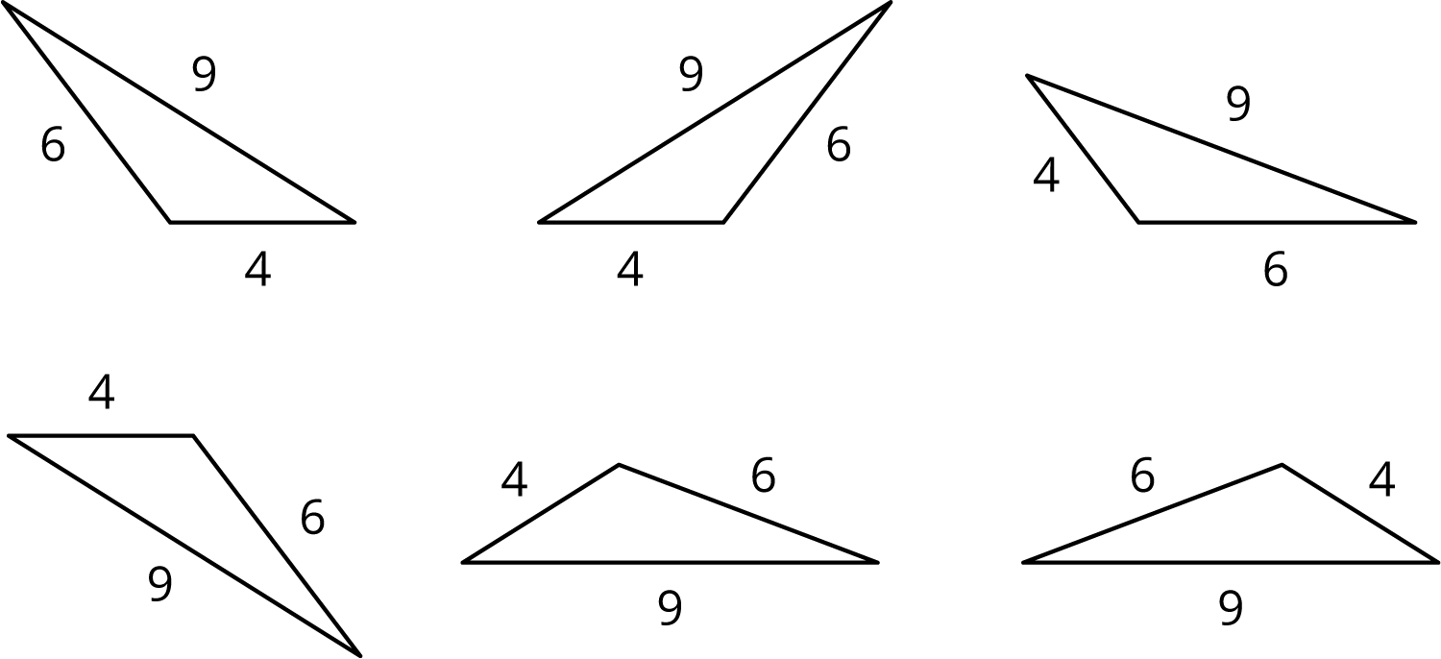
Set 2:
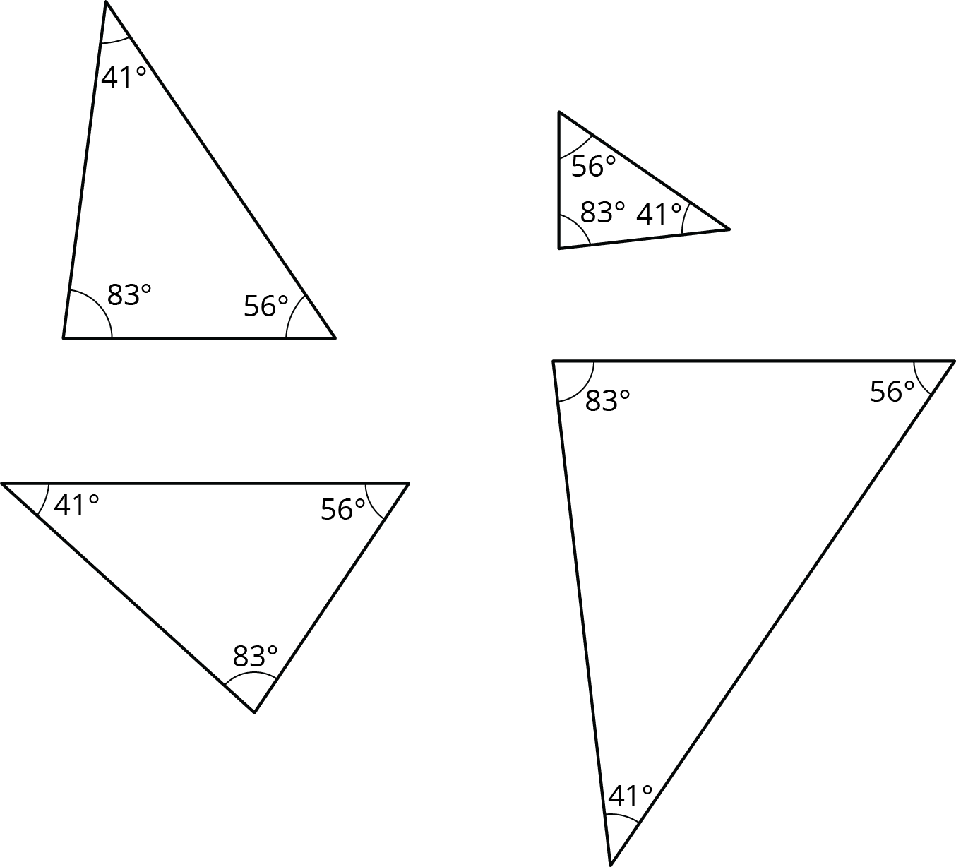

16.2: 2 Sides and 1 Angle
Examine this set of triangles.
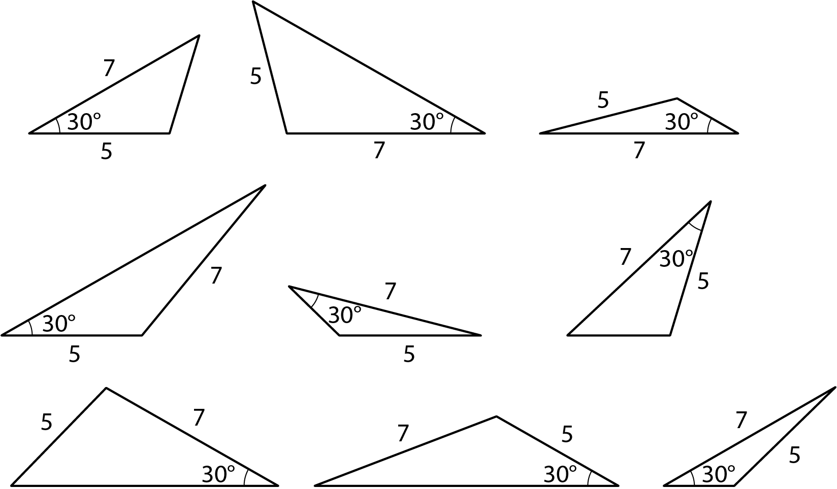
- What is the same about the triangles in the set? What is different?
- How many different triangles are there? Explain or show your reasoning.

16.3: 2 Angles and 1 Side
Examine this set of triangles.
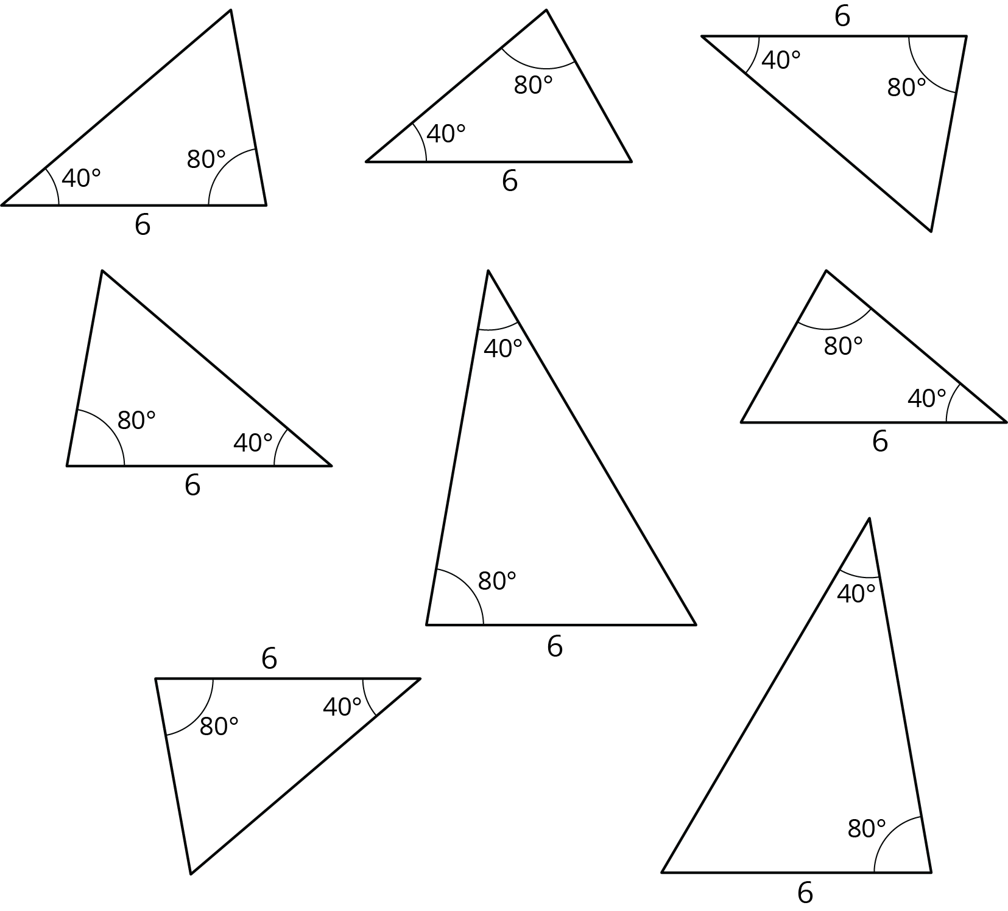
- What is the same about the triangles in the set? What is different?
- How many different triangles are there? Explain or show your reasoning.

Lesson 16 Summary
Both of these quadrilaterals have a right angle and side lengths 4 and 5:
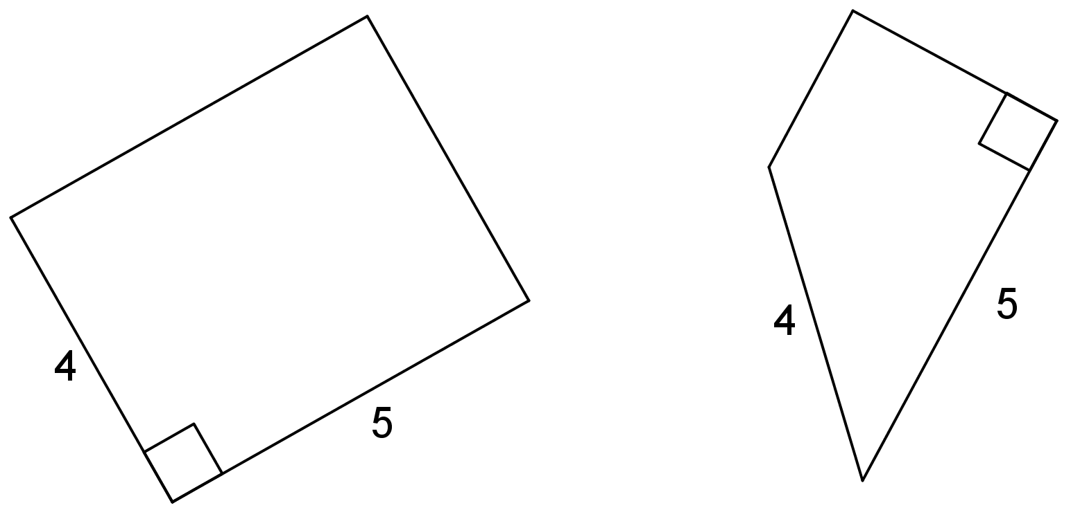
However, in one case, the right angle is between the two given side lengths; in the other, it is not.
If we create two triangles with three equal measures, but these measures are not next to each other in the same order, that usually means the triangles are different. Here is an example:
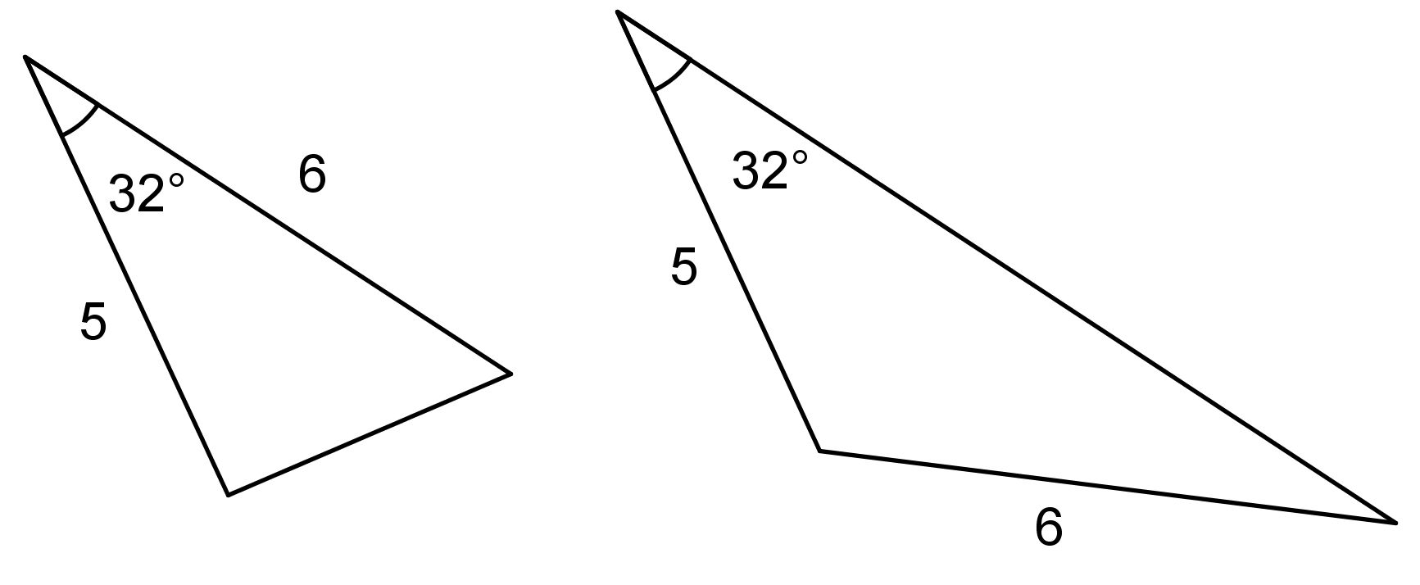
© CC BY Open Up Resources. Adaptations CC BY IM.

