Lesson 12 Practice Problems
- The Empire State Building in New York City is about 1,450 feet high (including the antenna at the top) and 400 feet wide. Andre wants to make a scale drawing of the front view of the Empire State Building on an $8\frac{1}{2}$-inch-by-$11$-inch piece of paper. Select a scale that you think is the most appropriate for the scale drawing. Explain your reasoning.
  - 1 inch to 1 foot
  - 1 inch to 100 feet
  - 1 inch to 1 mile
  - 1 centimeter to 1 meter
  - 1 centimeter to 50 meters
  - 1 centimeter to 1 kilometer
- Elena finds that the area of a house on a scale drawing is 25 square inches. The actual area of the house is 2,025 square feet. What is the scale of the drawing?
- Which of these scales are equivalent to 3 cm to 4 km? Select all that apply. Recall that 1 inch is 2.54 centimeters.
  - 0.75 cm to 1 km
  - 1 cm to 12 km
  - 6 mm to 2 km
  - 0.3 mm to 40 m
  - 1 inch to 7.62 km
- These two triangles are scaled copies of one another. The area of the smaller triangle is 9 square units. What is the area of the larger triangle? Explain or show how you know.
- 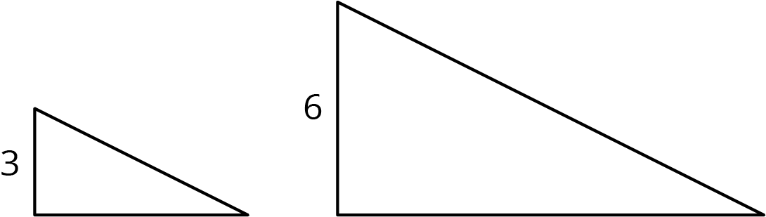

- Water costs $1.25 per bottle. At this rate, what is the cost of:
  - 10 bottles?
  - 20 bottles?
  - 50 bottles?
- The first row of the table shows the amount of dish detergent and water needed to make a soap solution.
  - Complete the table for 2, 3, and 4 batches.
  - How much water and detergent is needed for 8 batches? Explain your reasoning.
- number of batches | - cups of water | - cups of detergent
- 1 | - 6 | - 1
- 2
- 3
- 4
© CC BY Open Up Resources. Adaptations CC BY IM.

