Unit 8 Lesson 3 Cumulative Practice Problems
- List the sample space for each chance experiment.
  - Flipping a coin
  - Selecting a random season of the year
  - Selecting a random day of the week
- A computer randomly selects a letter from the alphabet.
  - How many different outcomes are in the sample space?
  - What is the probability the computer produces the first letter of your first name?
- What is the probability of selecting a random month of the year and getting a month that starts with the letter “J?” If you get stuck, consider listing the sample space.
- $E$ represents an object’s weight on Earth and $M$ represents that same object’s weight on the Moon. The equation $M=\frac{1}{6}E$ represents the relationship between these quantities.
  - What does the $\frac{1}{6}$ represent in this situation?
  - Give an example of what a person might weigh on Earth and on the Moon.
- (From Unit 2, Lesson 4.)
- Here is a diagram of the base of a bird feeder which is in the shape of a pentagonal prism. Each small square on the grid is 1 square inch.
- The distance between the two bases is 8 inches. What will be the volume of the completed bird feeder?
- 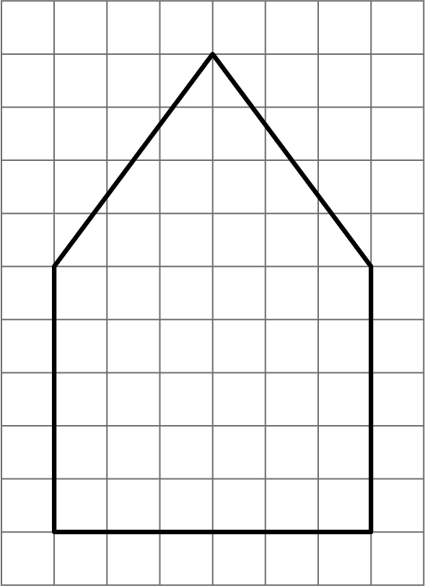

- (From Unit 7, Lesson 13.)
- Find the surface area of the triangular prism.
- 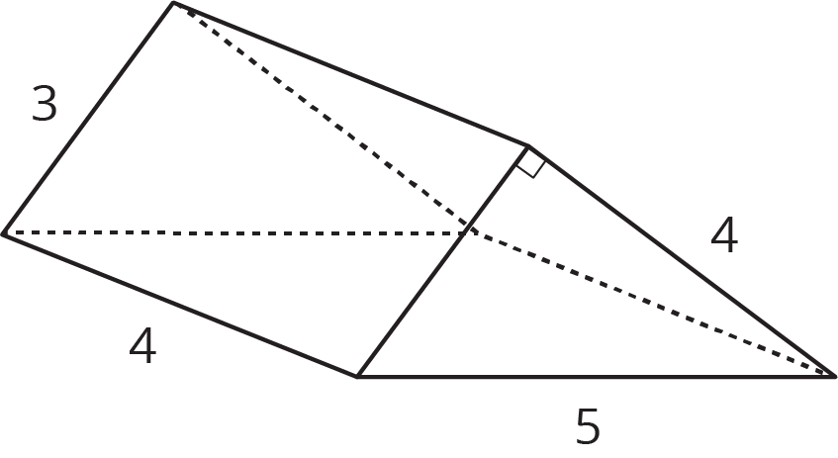
- (From Unit 7, Lesson 14.)
© CC BY Open Up Resources. Adaptations CC BY IM.

