Lesson 9: Representing Subtraction
Let's subtract signed numbers.

9.1: Equivalent Equations
Consider the equation $2+3=5$. Here are some more equations, using the same numbers, that express the same relationship in a different way:
$3+2=5$
$5−3=2$
$5−2=3$
For each equation, write two more equations, using the same numbers, that express the same relationship in a different way.
- $9+\left(\text{-}1\right)=8$
- $\text{-}11+x=7$

9.2: Subtraction with Number Lines
- Here is an unfinished number line diagram that represents a sum of 8.
- 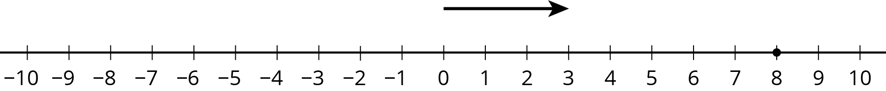
  - How long should the other arrow be?
  - For an equation that goes with this diagram, Mai writes $3+?=8$.
Tyler writes $8−3=?$. Do you agree with either of them?
  - What is the unknown number? How do you know?
- Here are two more unfinished diagrams that represent sums.
- 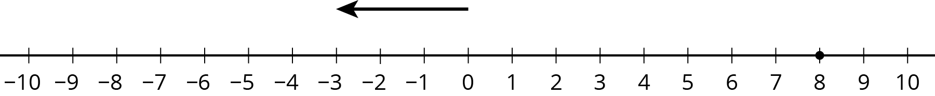

- 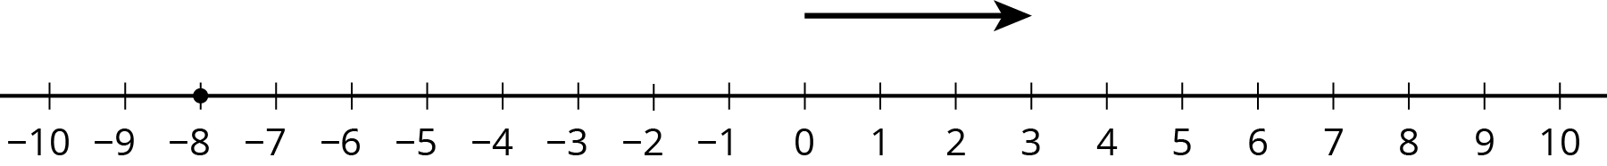

- For each diagram:
  - What equation would Mai write if she used the same reasoning as before?
  - What equation would Tyler write if he used the same reasoning as before?
  - How long should the other arrow be?
  - What number would complete each equation? Be prepared to explain your reasoning.
- Draw a number line diagram for $\left(\text{-}8\right)−\left(\text{-}3\right)=?$ What is the unknown number? How do you know?

9.3: We Can Add Instead
- Match each diagram to one of these expressions:
- $3+7$
- $3−7$
- $3+\left(\text{-}7\right)$
- $3−\left(\text{-}7\right)$

  - 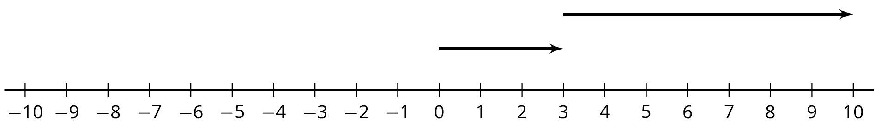
  - 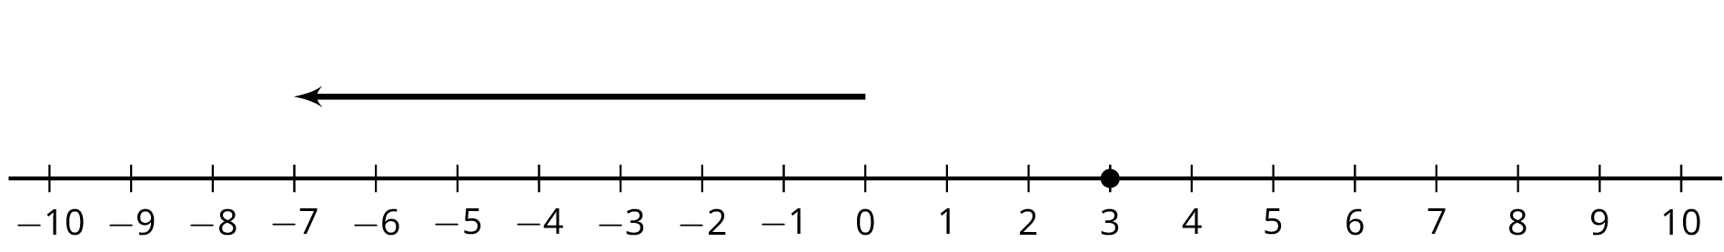
  - 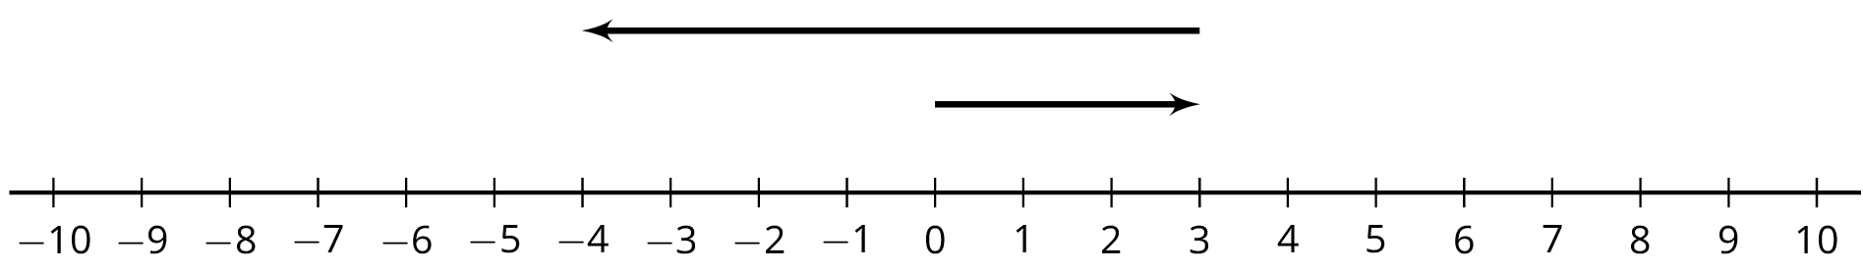
  - 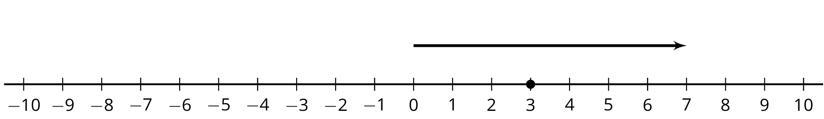
- Which expressions in the first question have the same value? What do you notice?
- Complete each of these tables. What do you notice?
- expression | - value
- $8+\left(\text{-}8\right)$
- $8−8$
- $8+\left(\text{-}5\right)$
- $8−5$
- $8+\left(\text{-}12\right)$
- $8−12$

- expression | - value
- $\text{-}5+5$
- $\text{-}5−\left(\text{-}5\right)$
- $\text{-}5+9$
- $\text{-}5−\left(\text{-}9\right)$
- $\text{-}5+2$
- $\text{-}5−\left(\text{-}2\right)$

Are you ready for more?
It is possible to make a new number system using only the numbers 0, 1, 2, and 3. We will write the symbols for adding and subtracting in this system like this: $2⊕1=3$ and $2⊖1=1$. The table shows some of the sums.
$⊕$ | 0 | 1 | 2 | 3
0 | 0 | 1 | 2 | 3
1 | 1 | 2 | 3 | 0
2 | 2 | 3 | 0 | 1
3
- In this system, $1⊕2=3$ and $2⊕3=1$. How can you see that in the table?
- What do you think $3⊕1$ should be?
- What about $3⊕3$?
- What do you think $3⊖1$ should be?
- What about $2⊖3$?
- Can you think of any uses for this number system?

Lesson 9 Summary
The equation $7−5=?$ is equivalent to $?+5=7$. The diagram illustrates the second equation.
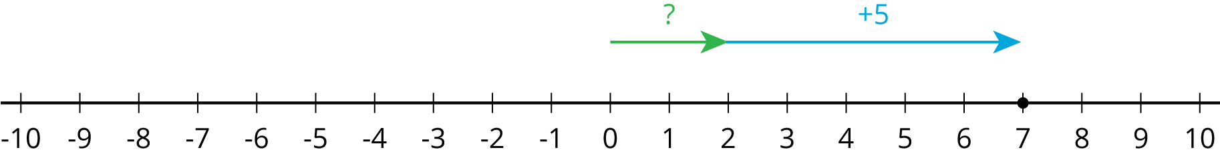
Notice that the value of $7+\left(\text{-}5\right)$ is 2.
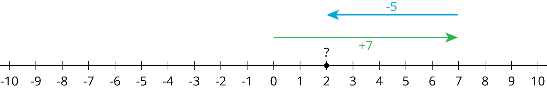
We can solve the equation $?+5=7$ by adding -5 to both sides. This shows that $7−5=7+\left(\text{-}5\right)$
Likewise, $3−5=?$ is equivalent to $?+5=3$.
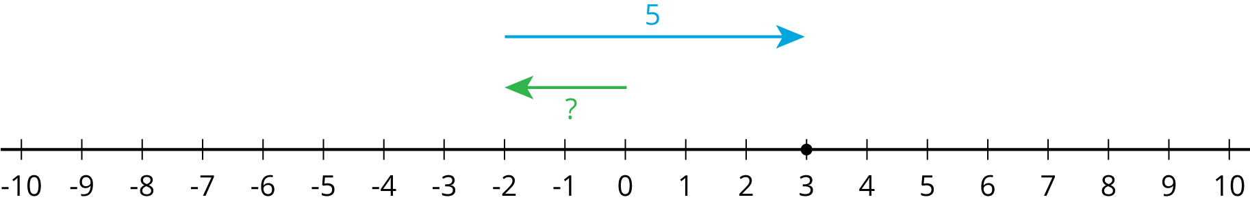
Notice that the value of $3+\left(\text{-}5\right)$ is -2.
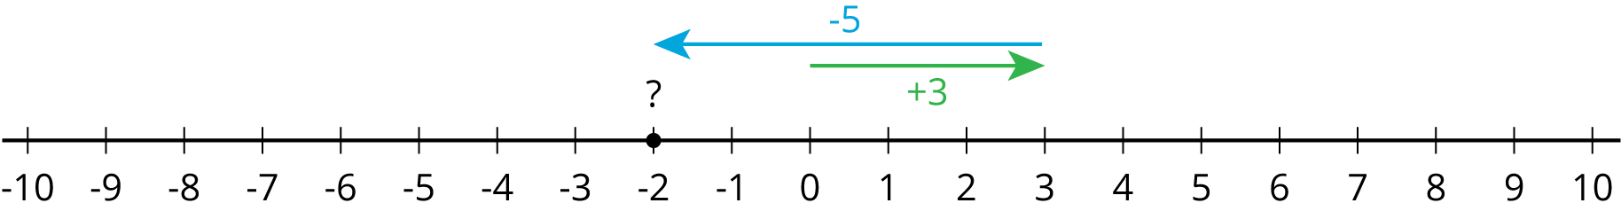
We can solve the equation $?+5=3$ by adding -5 to both sides. This shows that $3−5=3+\left(\text{-}5\right)$
In general:
$a−b=a+\left(\text{-}b\right)$
If $a−b=x$, then $x+b=a$. We can add $\text{-}b$ to both sides of this second equation to get that $x=a+\left(\text{-}b\right)$
© CC BY Open Up Resources. Adaptations CC BY IM.

