Lesson 16 Practice Problems
- Edge lengths are given in units. Find the surface area of each prism in square units.
- 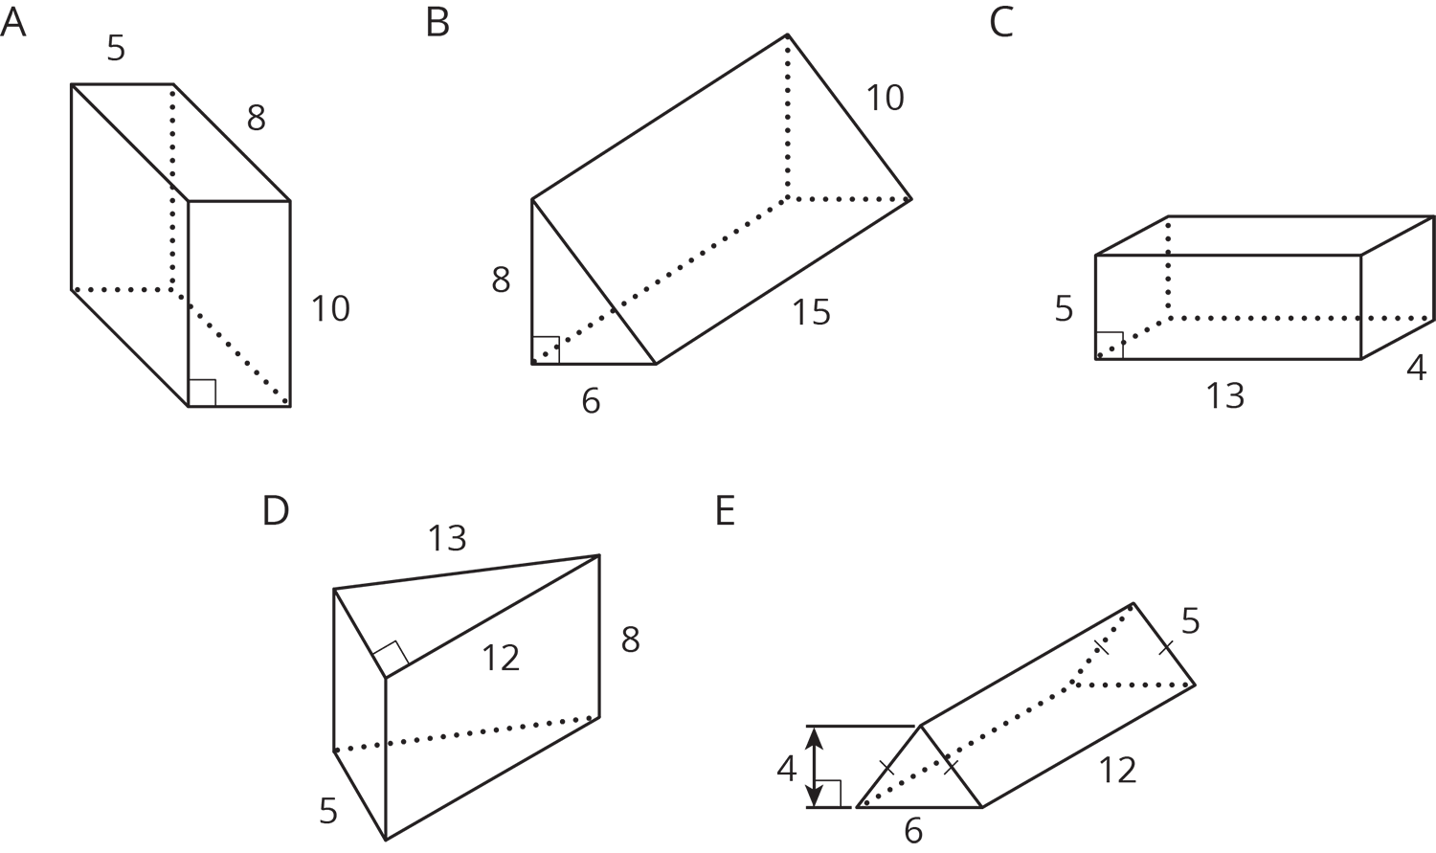

- Here is the base of a prism.
- 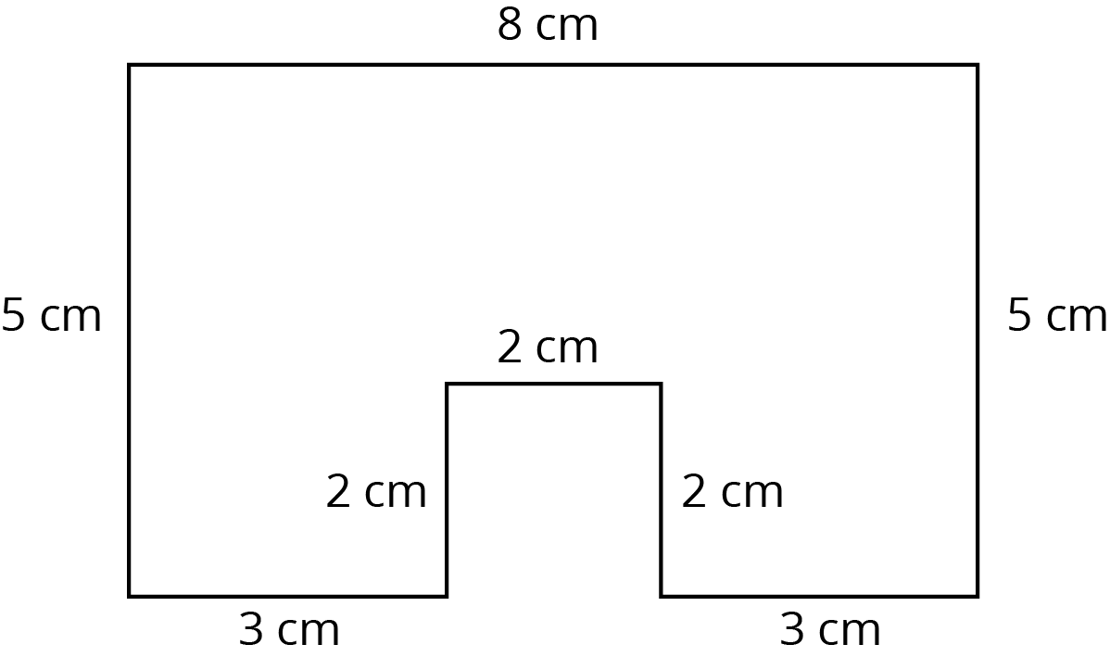
  - If the height of the prism is 5 cm, what is its surface area? What is its volume?
  - If the height of the prism is 10 cm, what is its surface area? What is its volume?
  - When the height doubled, what was the percent increase for the surface area? For the volume?
- Select all the situations where knowing the volume of an object would be more useful than knowing its surface area.
  - Determining the amount of paint needed to paint a barn.
  - Determining the monetary value of a piece of gold jewelry.
  - Filling an aquarium with buckets of water.
  - Deciding how much wrapping paper a gift will need.
  - Packing a box with watermelons for shipping.
  - Charging a company for ad space on your race car.
  - Measuring the amount of gasoline left in the tank of a tractor.
- Priya says, “No matter which way you slice this rectangular prism, the cross section will be a rectangle.” Mai says, “I’m not so sure.” Describe a slice that Mai might be thinking of.
- 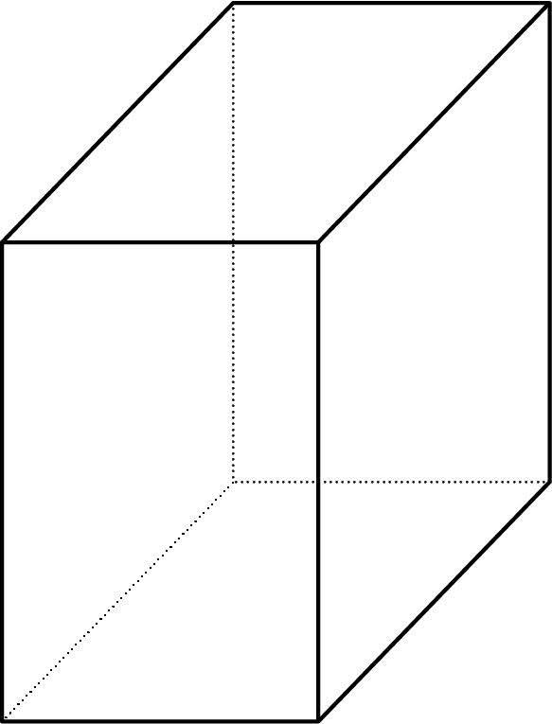
- (From Unit 6, Lesson 11.)
- $B$ is the intersection of line $AC$ and line $ED$. Find the measure of each of the angles.
  - Angle $ABF$
  - Angle $ABD$
  - Angle $EBC$
  - Angle $FBC$
  - Angle $DBG$
- 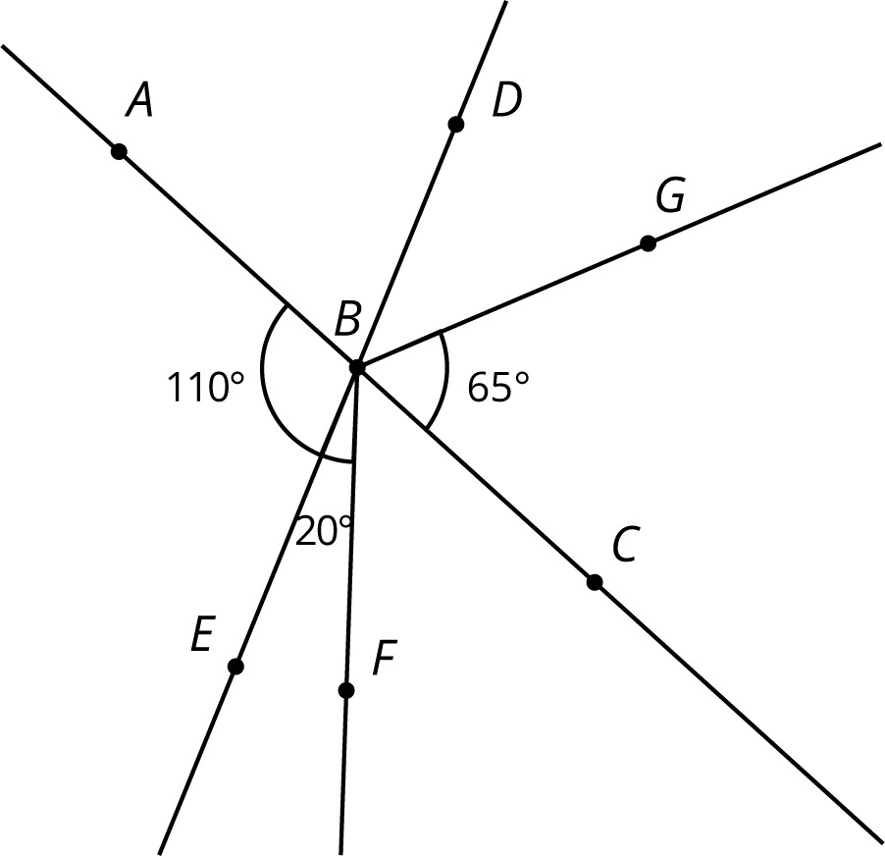
- (From Unit 3, Lesson 13.)
- Write each expression with fewer terms.
  - $12m−4m$
  - $12m−5k+m$
  - $9m+k−\left(3m−2k\right)$
- (From Unit 4, Lesson 9.)
© CC BY Open Up Resources. Adaptations CC BY IM.

