Unit 1 Lesson 12: How Many Are There? (Part 1)

WU Questions About Us: How Many of Us Are Here Today? (Warm up)

Student Task Statement

1 Counting Collections

Student Task Statement

2 Count to 10 (Optional)

Student Task Statement

3 Introduce Pattern Blocks, Get and Build

Student Task Statement
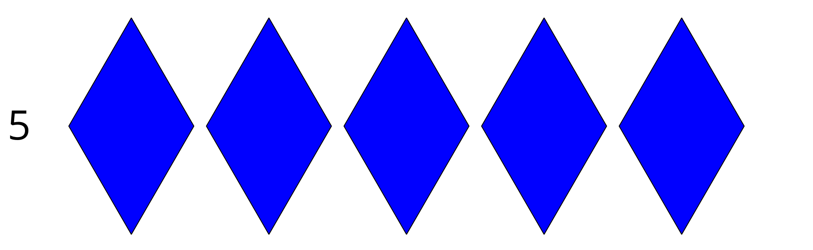
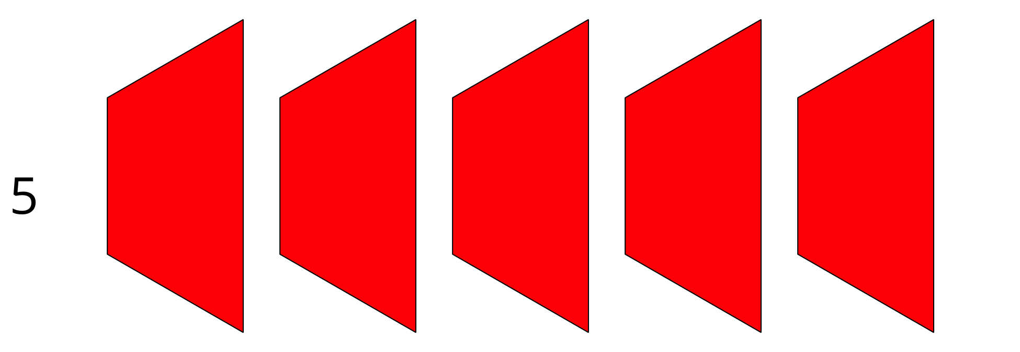
Choose a center.
Geoblocks
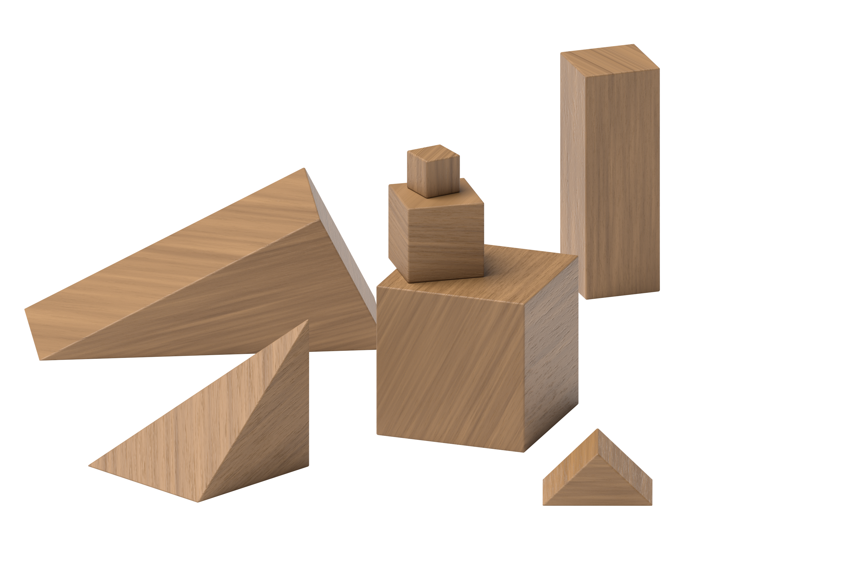
Connecting Cubes
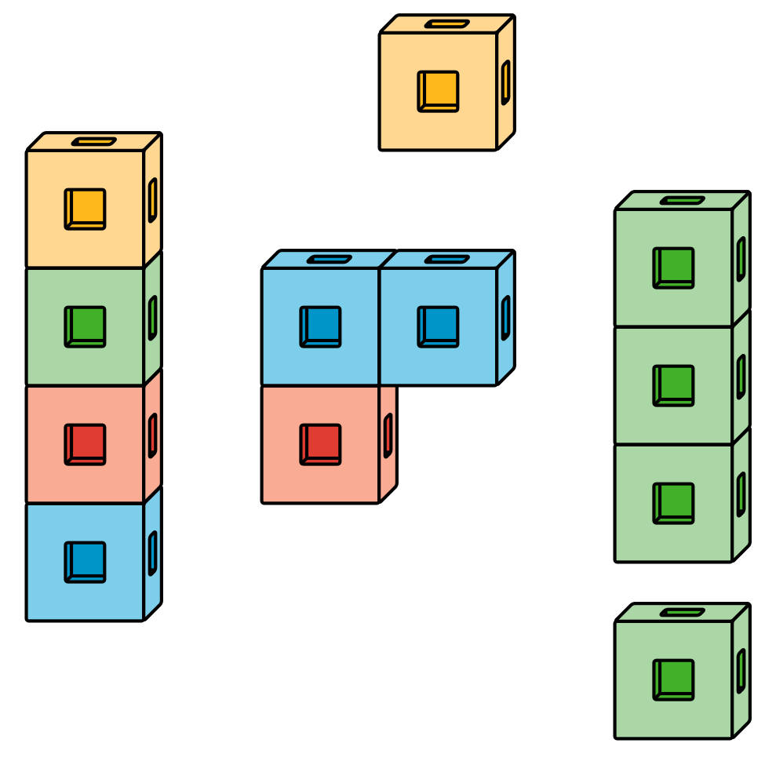
Pattern Blocks
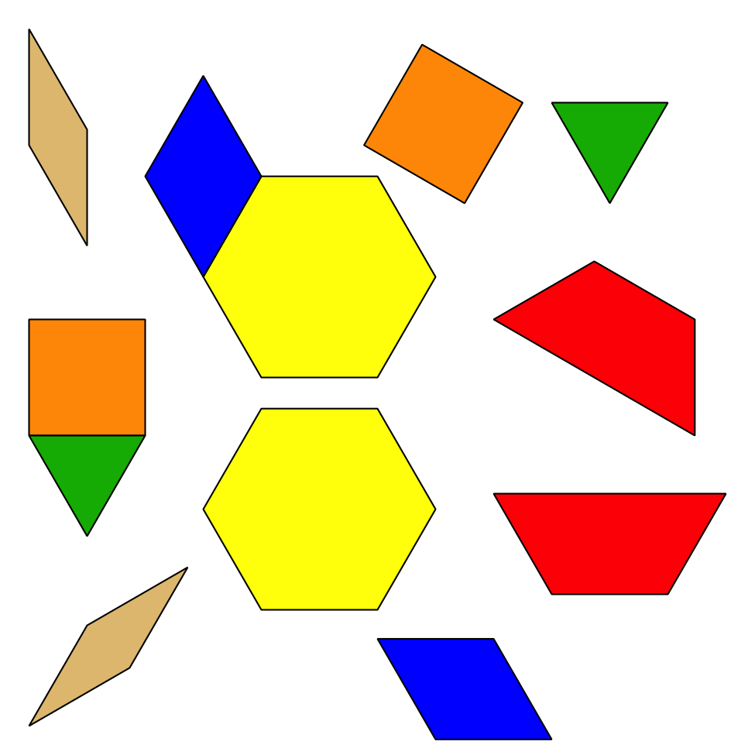
Picture Books
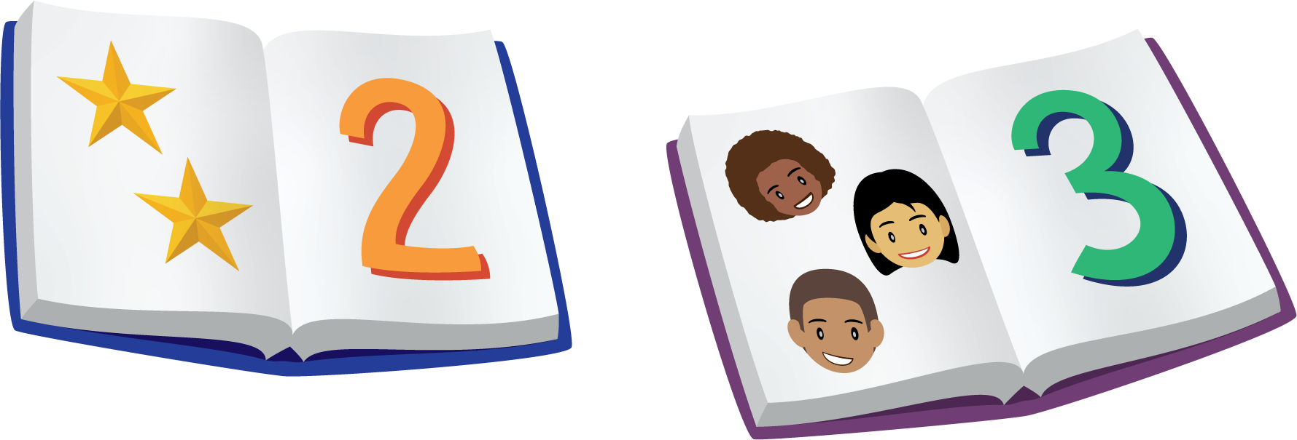
© CC BY 2021 Illustrative Mathematics®

