Lesson 10: Complete Equations
- Let’s write equations to show numbers 11–19.

Warm-up: What do you know about 15?
What do you know about 15?

10.1: What Is Missing?
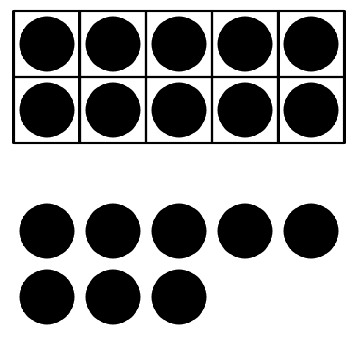
$10+8=\underset{_}{}$
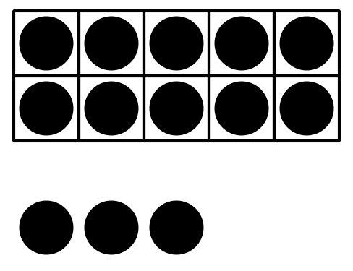
$10+3=\underset{_}{}$
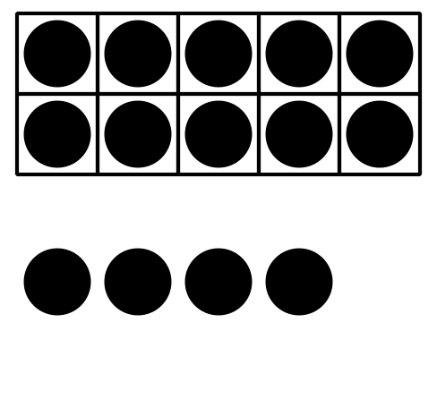
$10+4=\underset{_}{}$
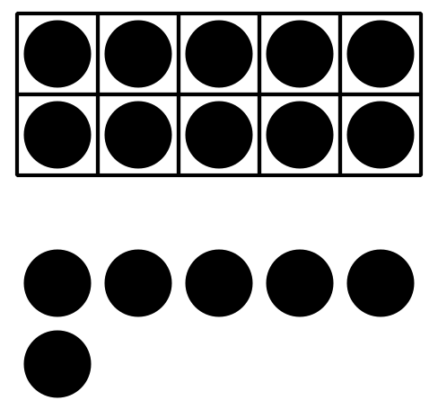
$\underset{_}{}+\underset{_}{}=16$
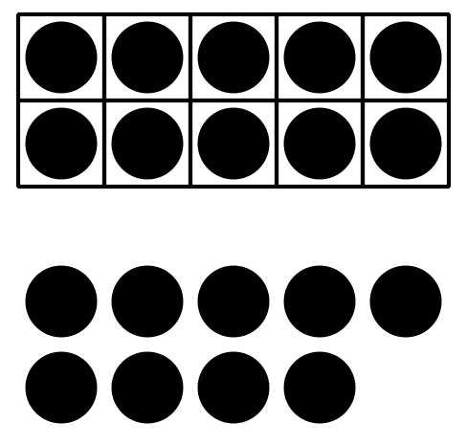
$\underset{_}{}+\underset{_}{}=19$
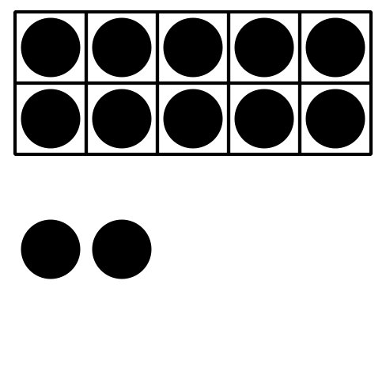
$\underset{_}{}+\underset{_}{}=12$

10.2: Make the Equations True
- $10+5=\underset{_}{}$
- $\underset{_}{}+\underset{_}{}=16$
- $\underset{_}{}+\underset{_}{}=19$
- $\underset{_}{}+\underset{_}{}=13$
- $\underset{_}{}+\underset{_}{}=17$
- $10+1=\underset{_}{}$

10.3: Centers: Choice Time
Choose a center.
Bingo
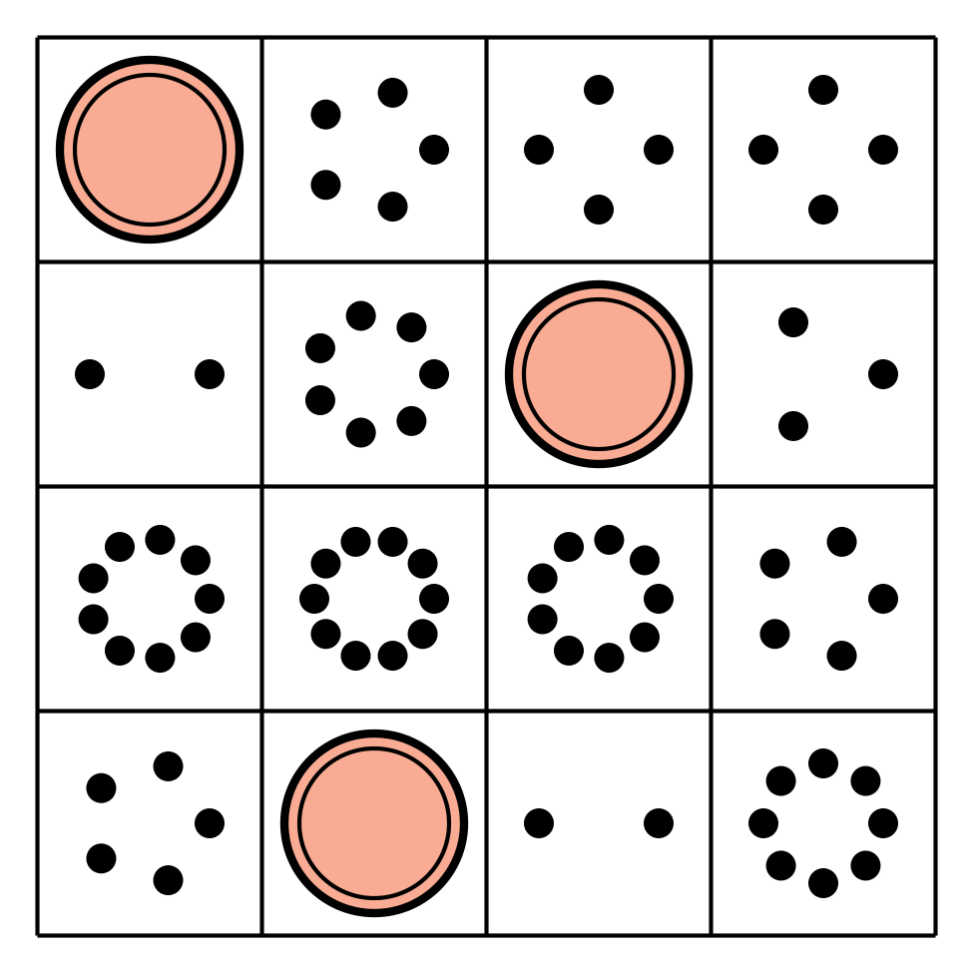
Number Race
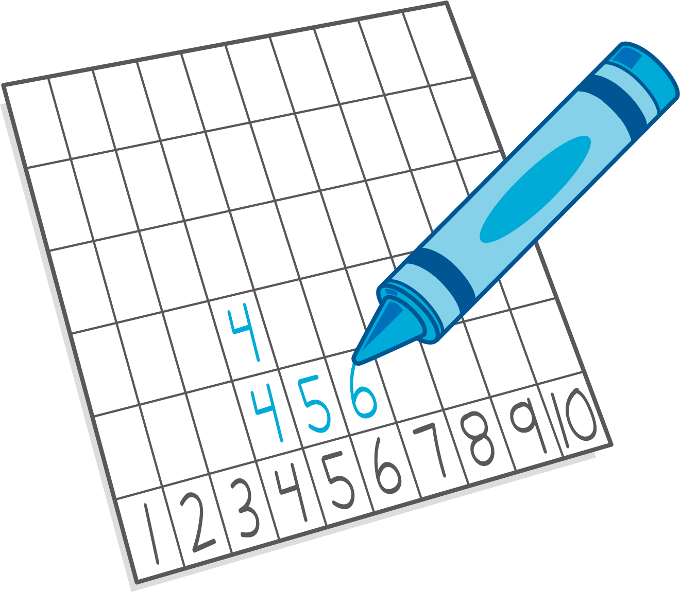
Grab and Count
Make or Break Apart Numbers
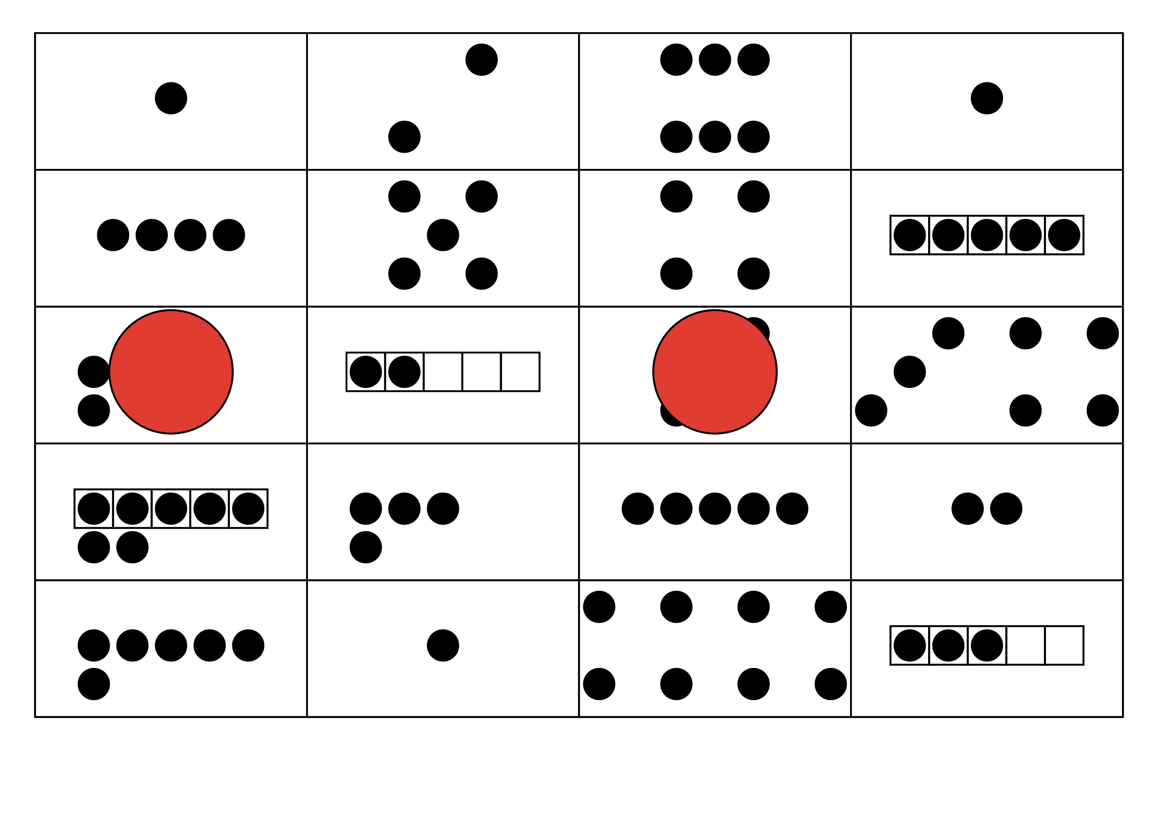
Tower Build
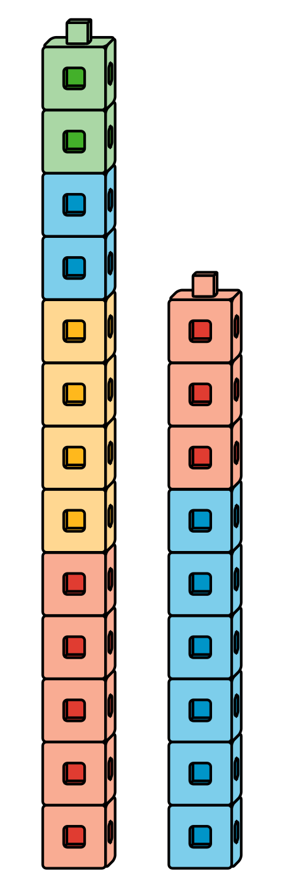

Section Summary
Section Summary
We saw and made numbers 11–19 with fingers and 10-frames.
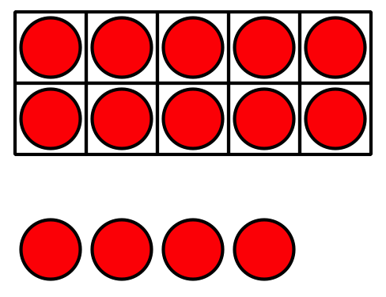
We saw these numbers written as 10 and some more in different ways.
10 and 4 is 14.
$10+4$ is 14.
$10+4=14$
© CC BY 2021 Illustrative Mathematics®

