Lesson 15: Addition and Subtraction Expressions within 5
- Let’s add and subtract within 5.

Warm-up: Which One Doesn’t Belong: Expressions and Equations
Which one doesn’t belong?
A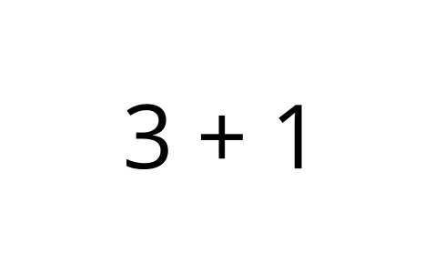
B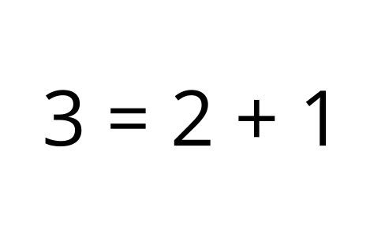
C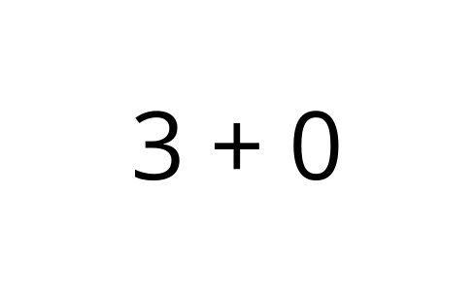
D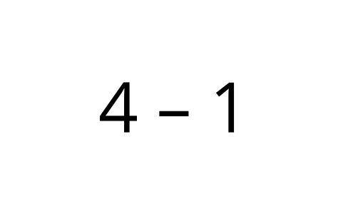

15.3: Centers: Choice Time
Choose a center.
5-frames
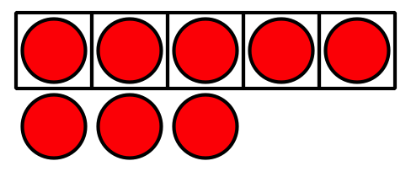
Roll and Add
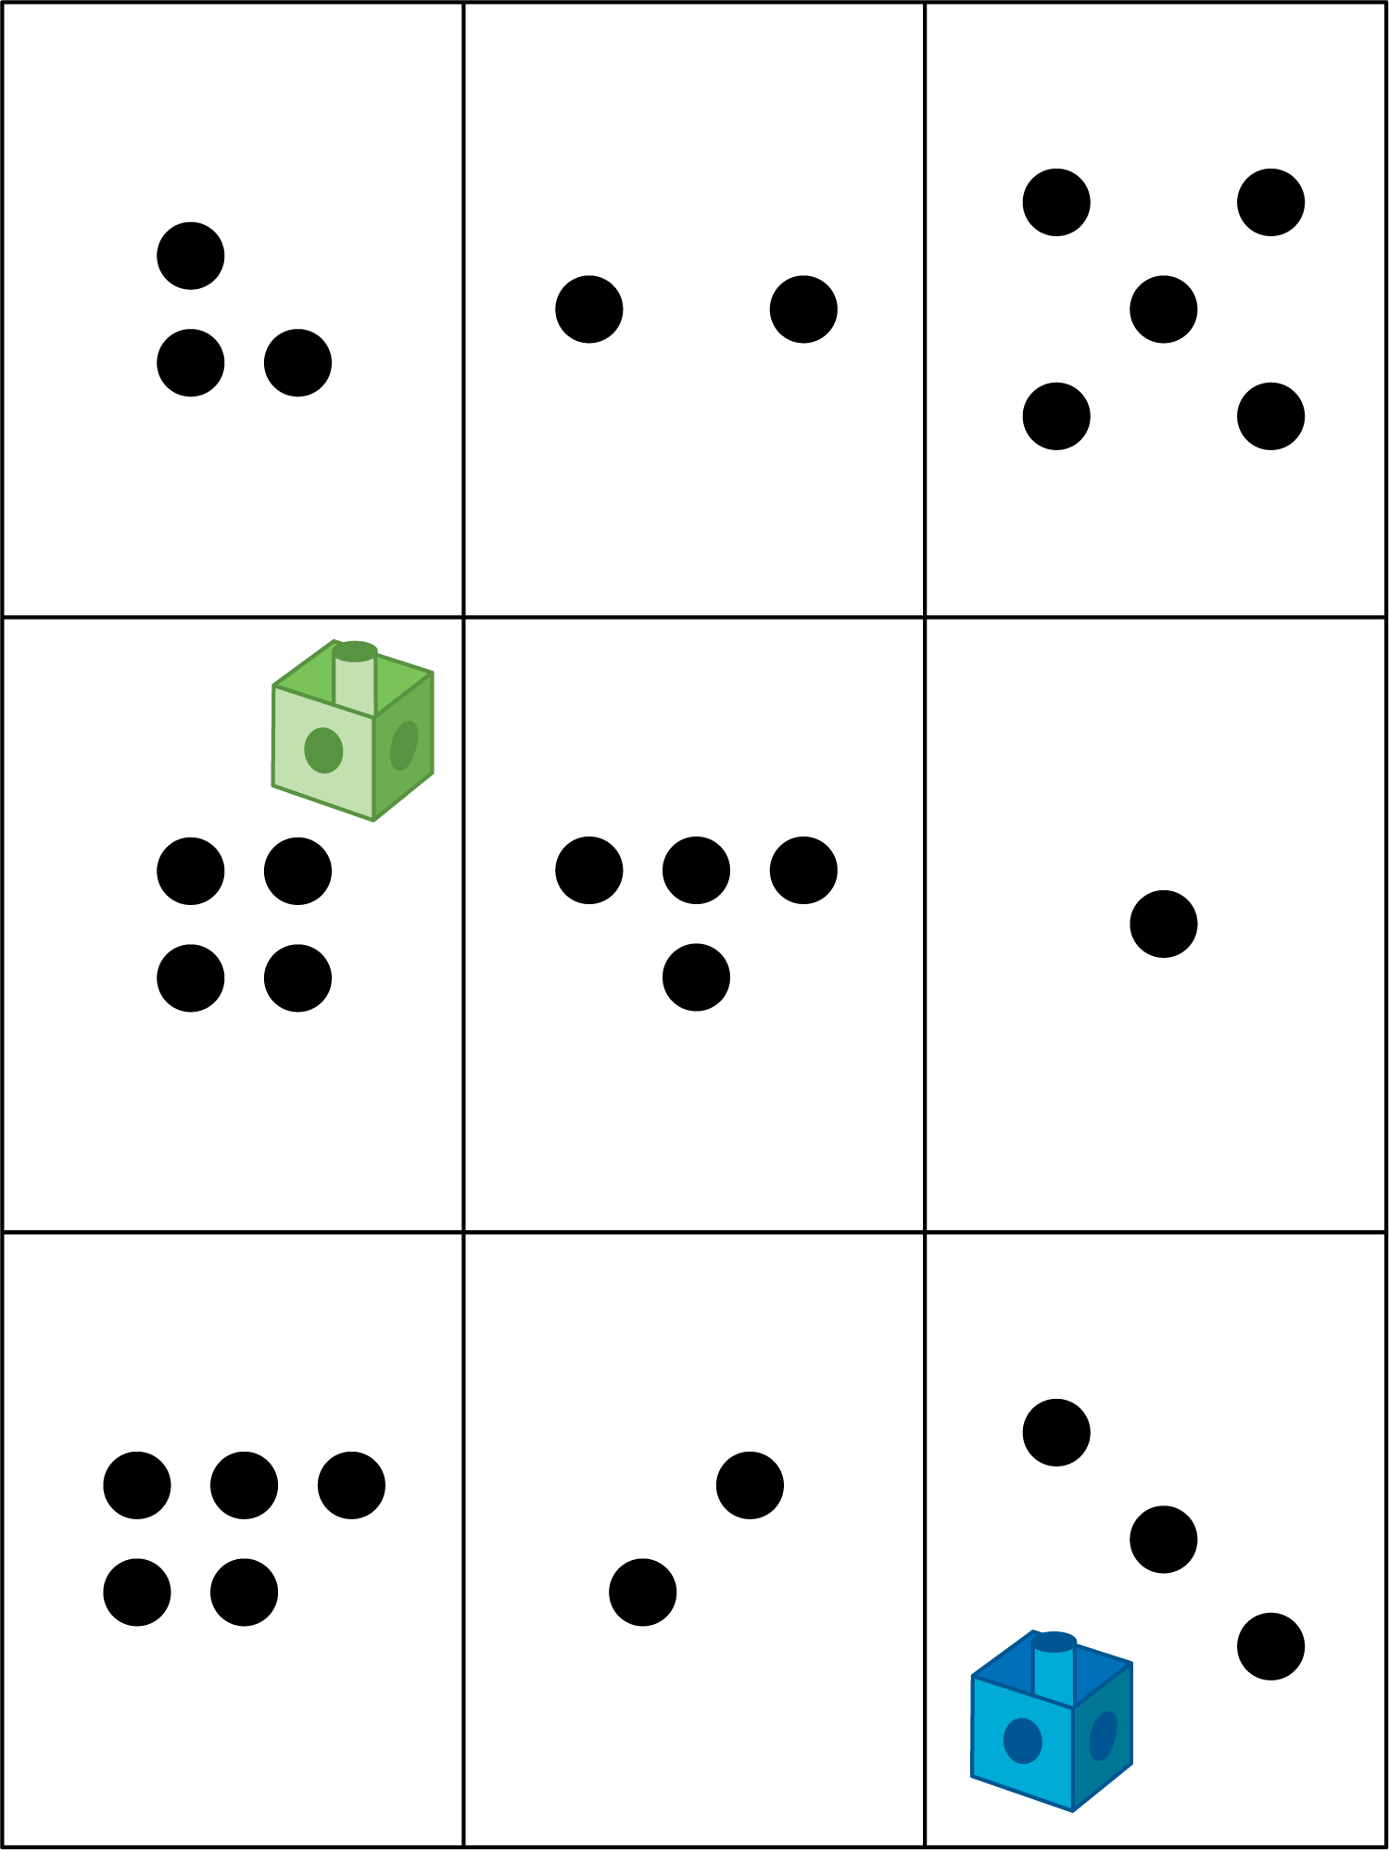
Bingo
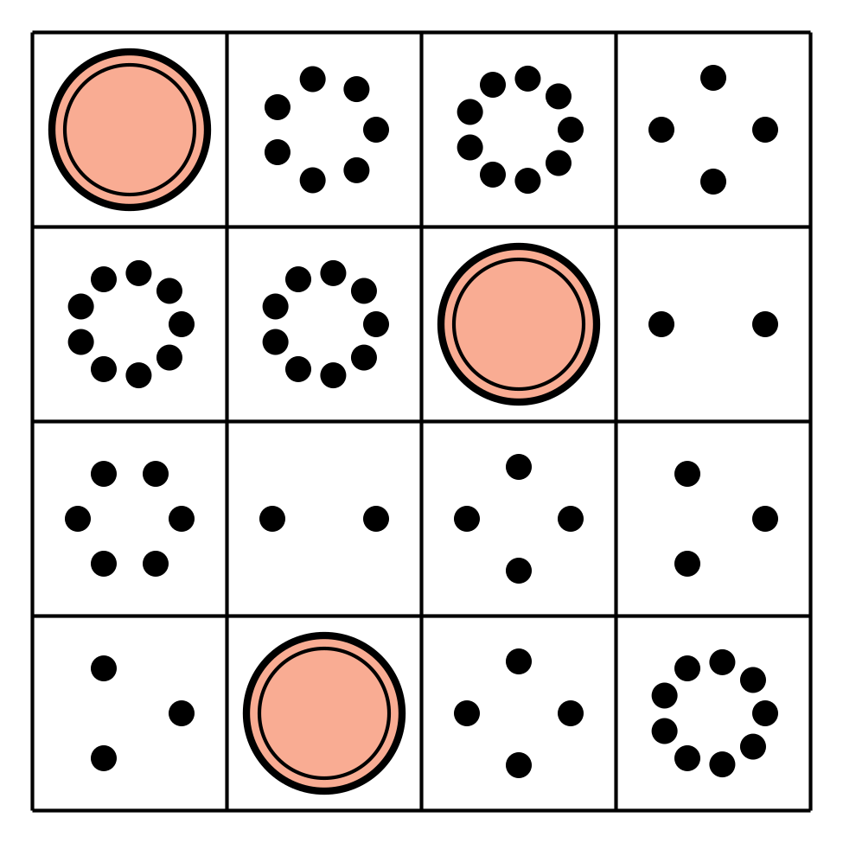
Geoblocks
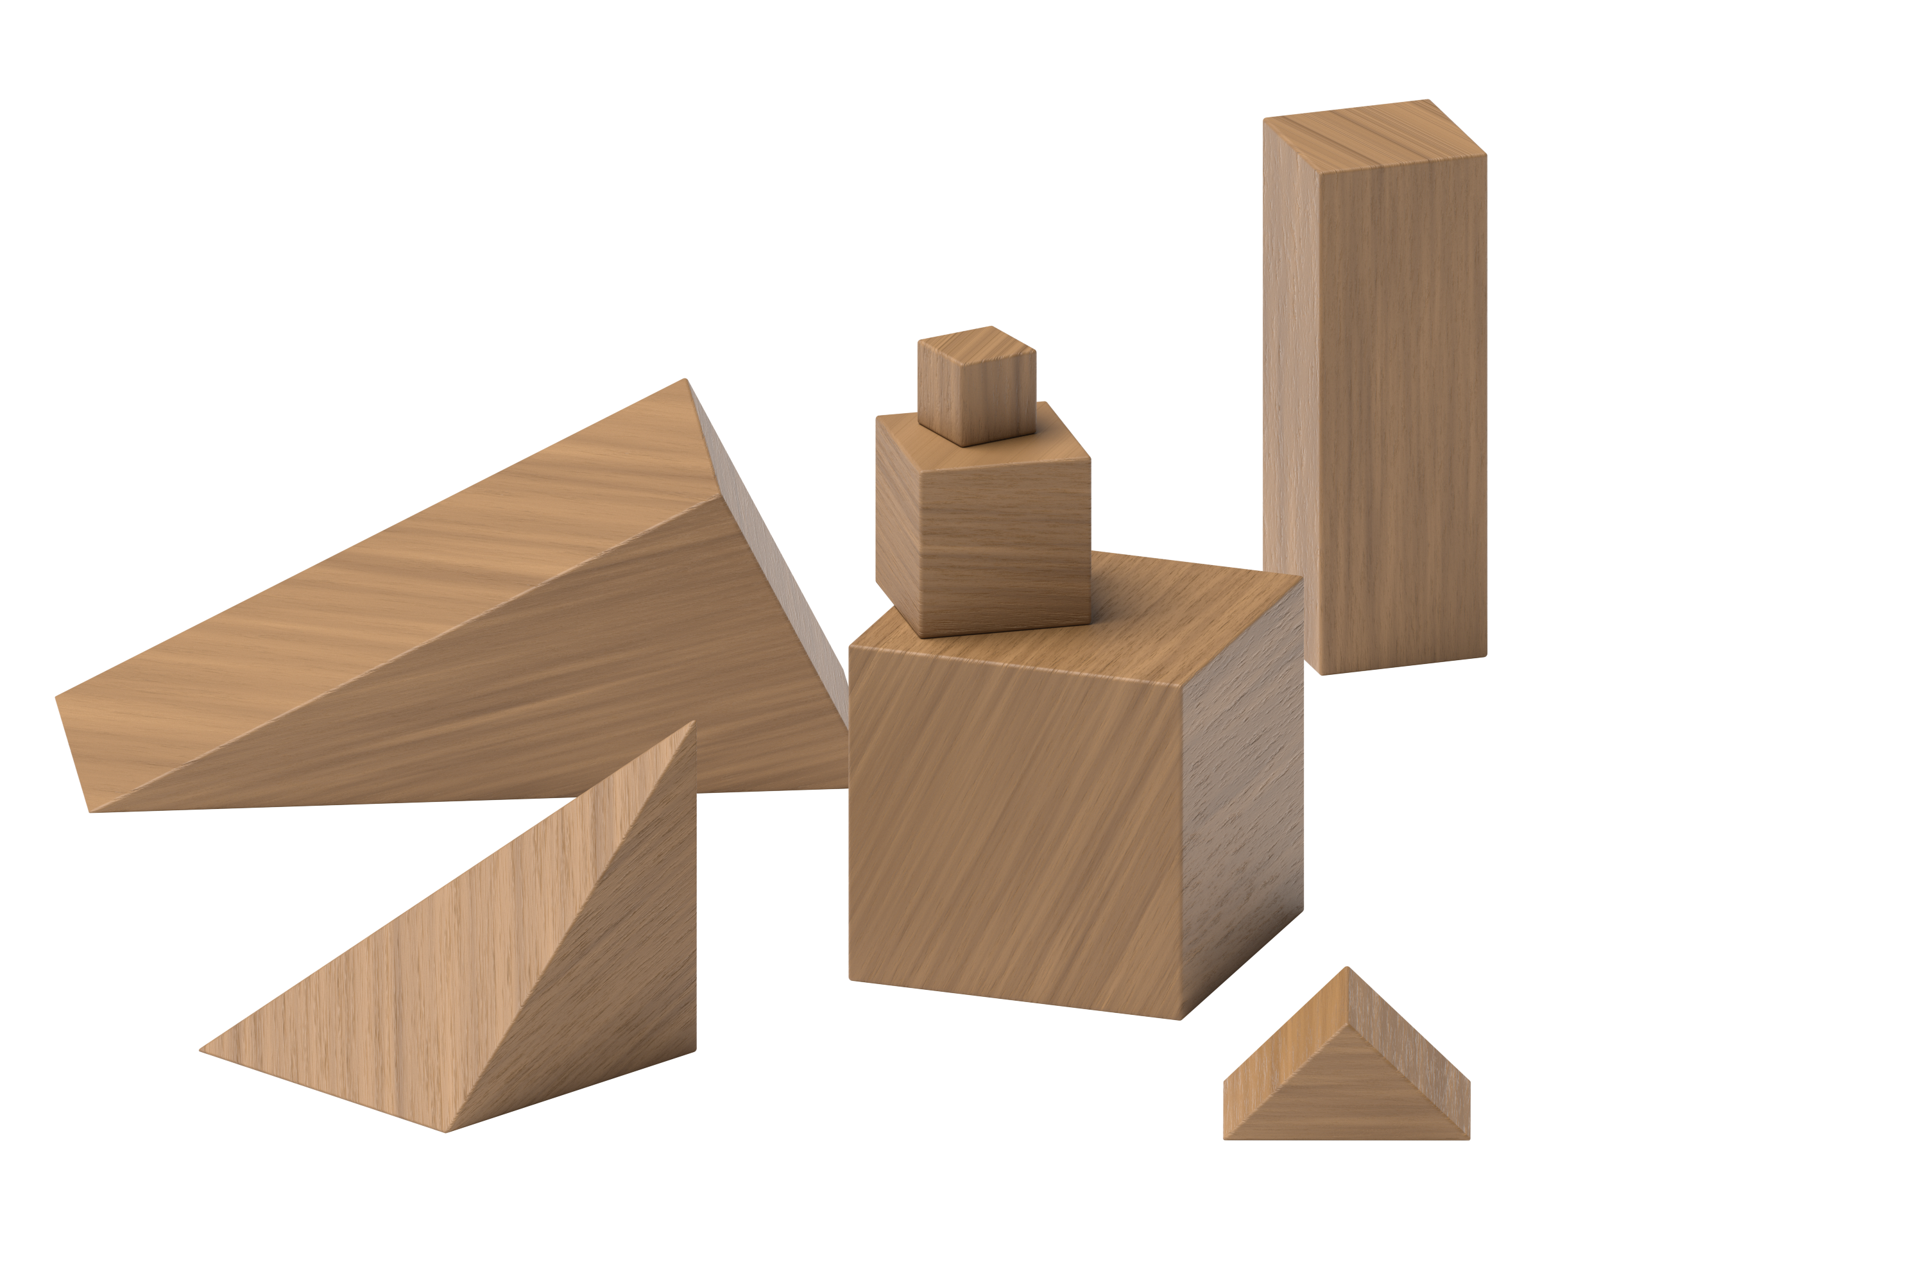
Find the Value of Expressions
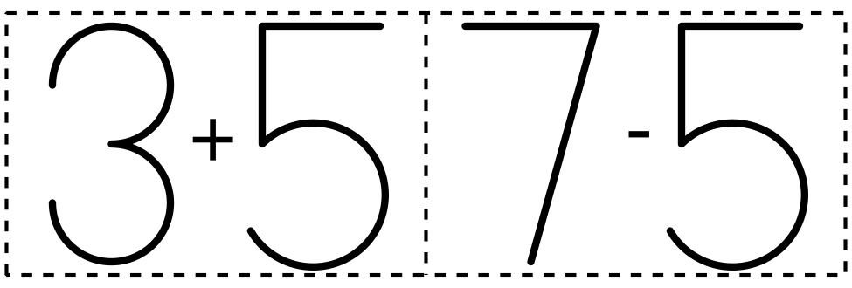
© CC BY 2021 Illustrative Mathematics®

