Unit 2 Lesson 5: Equations and Their Graphs

1 Which One Doesn't Belong: Hours and Dollars (Warm up)

Student Task Statement
Which one doesn’t belong?

A
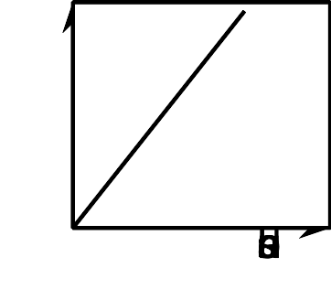

B
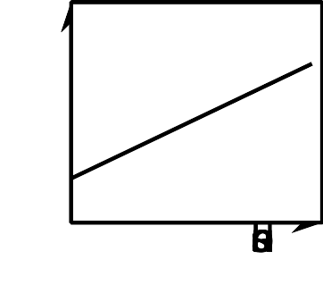

C
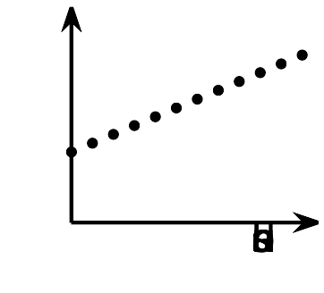

D
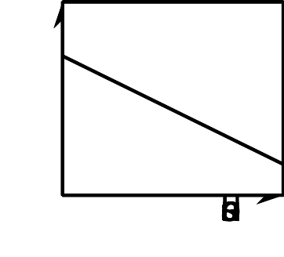

2 Snacks in Bulk

Student Task Statement
To get snacks for a class trip, Clare went to the “bulk” section of the grocery store, where she could buy any quantity of a product and the prices are usually good.
Clare purchased some salted almonds at $6 a pound and some dried figs at $9 per pound. She spent $75 before tax.
- If she bought 2 pounds of almonds, how many pounds of figs did she buy?
- If she bought 1 pound of figs, how many pounds of almonds did she buy?
- Write an equation that describes the relationship between pounds of figs and pounds of almonds that Clare bought, and the dollar amount that she paid. Be sure to specify what the variables represent.
- Here is a graph that represents the quantities in this situation.
  - Choose any point on the line, state its coordinates, and explain what it tells us.
  - Choose any point that is not on the line, state its coordinates, and explain what it tells us.

3 Graph It!

Student Task Statement
- A student has a savings account with $475 in it. She deposits $125 of her paycheck into the account every week. Her goal is to save $7,000 for college.
  - How much will be in the account after 3 weeks?
  - How long will it take before she has $1,350?
  - Write an equation that represents the relationship between the dollar amount in her account and the number of weeks of saving.
  - Graph your equation using graphing technology. Mark the points on the graph that represent the amount after 3 weeks and the week she has $1,350. Write down the coordinates.
  - How long will it take her to reach her goal?
- A 450-gallon tank full of water is draining at a rate of 20 gallons per minute.
  - How many gallons will be in the tank after 7 minutes?
  - How long will it take for the tank to have 200 gallons?
  - Write an equation that represents the relationship between the gallons of water in the tank and minutes the tank has been draining.
  - Graph your equation using graphing technology. Mark the points on the graph that represent the gallons after 7 minutes and the time when the tank has 200 gallons. Write down the coordinates.
  - How long will it take until the tank is empty?
© CC BY 2019 by Illustrative Mathematics®

