Lesson 13 Practice Problems
- Identify a solution to this system of equations: $\left\{\begin{matrix}\text{-}4x+3y=23 \\ x−y=\text{-}7\end{matrix}\right.$
  - $\left(\text{-}5,2\right)$
  - $\left(\text{-}2,5\right)$
  - $\left(\text{-}3,4\right)$
  - $\left(4,\text{-}3\right)$
- Lin is solving this system of equations: $\left\{\begin{matrix}6x−5y=34 \\ 3x+2y=8\end{matrix}\right.$
- She starts by rearranging the second equation to isolate the $y$ variable: $y=4−1.5x$. She then substituted the expression $4−1.5x$ for $y$ in the first equation, as shown:
- $\begin{matrix}6x−5\left(4−1.5x\right) & =34 \\ 6x−20−7.5x & =34 \\ \text{-}1.5x & =54 \\ x & =\text{-}36\end{matrix}$
- $\begin{matrix}y & =4−1.5x \\ y & =4−1.5⋅\left(\text{-}36\right) \\ y & =58\end{matrix}$
  - Check to see if Lin's solution of $\left(\text{-}36,58\right)$ makes both equations in the system true.
  - If your answer to the previous question is "no," find and explain her mistake. If your answer is "yes," graph the equations to verify the solution of the system.
- Solve each system of equations.
  - $\left\{\begin{matrix}2x−4y=20 \\ x=4\end{matrix}\right.$
  - $\left\{\begin{matrix}y=6x+11 \\ 2x−3y=7\end{matrix}\right.$
- Tyler and Han are trying to solve this system by substitution: $\left\{\begin{matrix}x+3y=\text{-}5 \\ 9x+3y=3\end{matrix}\right.$
- Tyler's first step is to isolate $x$ in the first equation to get $x=\text{-}5−3y$. Han's first step is to isolate $3y$ in the first equation to get $3y=\text{-}5−x$.
- Show that both first steps can be used to solve the system and will yield the same solution.
- The dot plots show the distribution of the length, in centimeters, of 25 shark teeth for an extinct species of shark and the length, in centimeters, of 25 shark teeth for a closely related shark species that is still living.
- 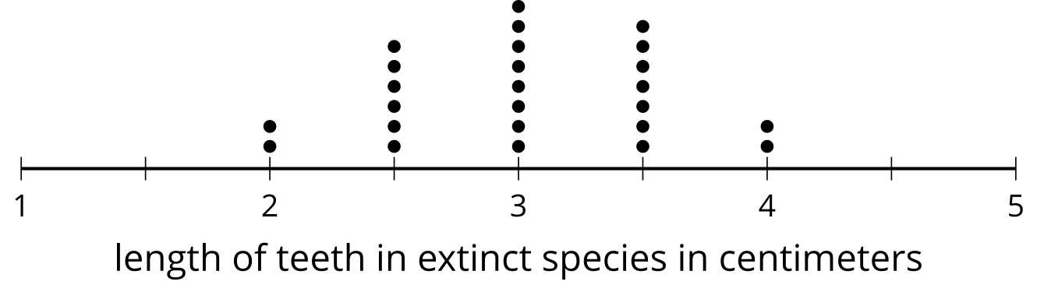
- mean: 3.02 cm
- standard deviation: 0.55 cm
- 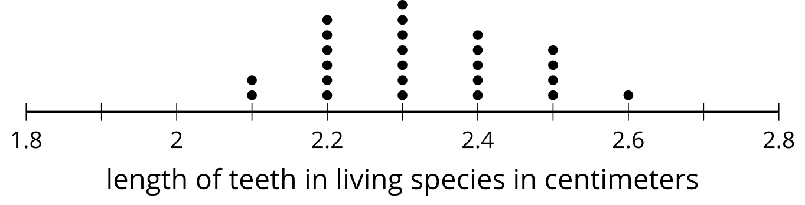
- mean: 2.32 cm
- standard deviation: 0.13 cm
- Compare the two dot plots using the shape of the distribution, measures of center, and measures of variability. Use the situation described in the problem in your explanation.
- (From Unit 1, Lesson 15.)
- Kiran buys supplies for the school’s greenhouse. He buys $f$ bags of fertilizer and $p$ packages of soil. He pays $5 for each bag of fertilizer and $2 for each package of soil, and spends a total of $90. The equation $5f+2p=90$ describes this relationship.
- If Kiran solves the equation for $p$, which equation would result?
  - $2p=90−5f$
  - $p=\frac{5f−90}{2}$
  - $p=45−2.5f$
  - $p=\frac{85f}{2}$
- (From Unit 2, Lesson 8.)
- Elena wanted to find the slope and $y$-intercept of the graph of $25x−20y=100$. She decided to put the equation in slope-intercept form first. Here is her work:
- $\begin{matrix}25x−20y & =100 \\ 20y & =100−25x \\ y & =5−\frac{5}{4}x\end{matrix}$
- She concluded that the slope is $\text{-}\frac{5}{4}$ and the $y$-intercept is $\left(0,5\right)$.
  - What was Elena’s mistake?
  - What are the slope and $y$-intercept of the line? Explain or show your reasoning.
- (From Unit 2, Lesson 11.)
- Find the $x$- and $y$-intercepts of the graph of each equation.
  - $y=10−2x$
  - $4y+9x=18$
  - $6x−2y=44$
  - $2x=4+12y$
- (From Unit 2, Lesson 11.)
- Andre is buying snacks for the track and field team. He buys $a$ pounds of apricots for $6 per pound and $b$ pounds of dried bananas for $4 per pound. He buys a total of 5 pounds of apricots and dried bananas and spends a total of $24.50.
- Which system of equations represents the constraints in this situation?
  - $\left\{\begin{matrix}6a+4b=5 \\ a+b=24.50\end{matrix}\right.$
  - $\left\{\begin{matrix}6a+4b=24.50 \\ a+b=5\end{matrix}\right.$
  - $\left\{\begin{matrix}6a=4b \\ 5\left(a+b\right)=24.50\end{matrix}\right.$
  - $\left\{\begin{matrix}6a+b=4 \\ 5a+b=24.50\end{matrix}\right.$
- (From Unit 2, Lesson 12.)
- Here are two equations:
- Equation 1: $y=3x+8$
Equation 2: $2x−y=\text{-}6$
- Without using graphing technology:
  - Find a point that is a solution to Equation 1 but not a solution to Equation 2.
  - Find a point that is a solution to Equation 2 but not a solution to Equation 1.
  - Graph the two equations.
  - Find a point that is a solution to both equations.
- 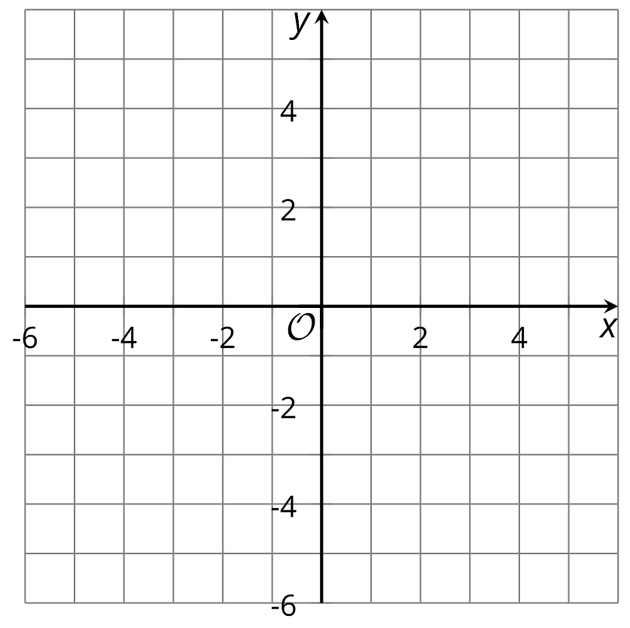
- (From Unit 2, Lesson 12.)
© CC BY 2019 by Illustrative Mathematics®

