Unit 2 Lesson 12: Proofs about Quadrilaterals

1 Play with Parallelograms (Warm up)

Images for Launch
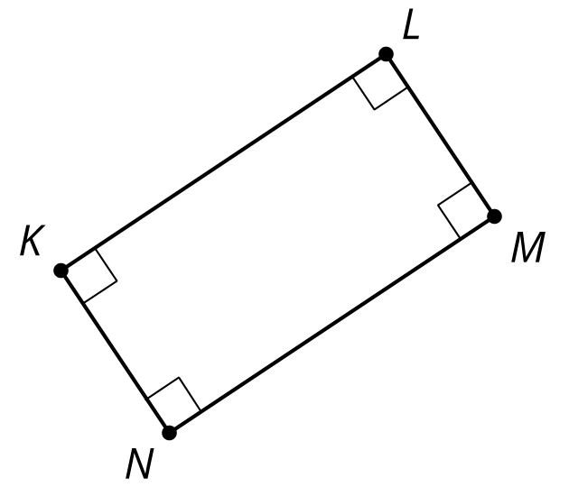

Student Task Statement
- Make several parallelograms with your strips.
- Make several rectangles with your strips.

Activity Synthesis
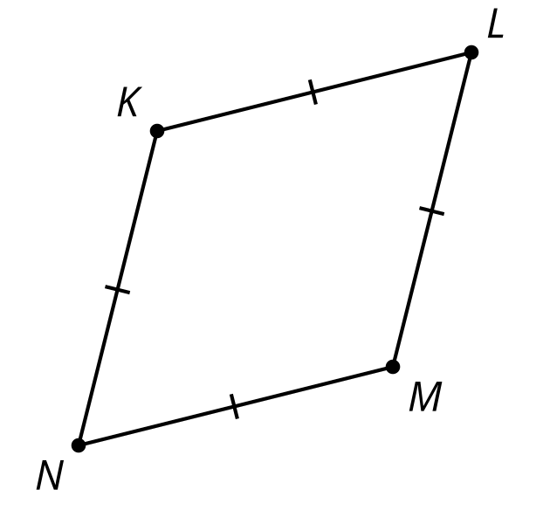

2 From Conjecture to Proof

Student Task Statement
Here are some conjectures:
- All rectangles are parallelograms.
- If a parallelogram has (at least) one right angle, then it is a rectangle.
- If a quadrilateral has 2 pairs of opposite sides that are congruent, then it is a parallelogram.
- If the diagonals of a quadrilateral both bisect each other, then the quadrilateral is a parallelogram.
- If the diagonals of a quadrilateral both bisect each other and they are perpendicular, then the quadrilateral is a rhombus.
- Pick one conjecture and use the strips to convince yourself it is true.
- Re-write the conjecture to identify the given information and the statement to prove.
- Draw a diagram of the situation. Mark the given information and any information you can figure out for sure.
- Write a rough draft of how you might prove your conjecture is true.

3 Checking a Proof

Student Task Statement
Exchange proofs with your partner. Read the rough draft of their proof. If it convinces you, write a detailed proof together following their plan. If it does not convince you, suggest changes that will make the proof convincing.

Activity Synthesis
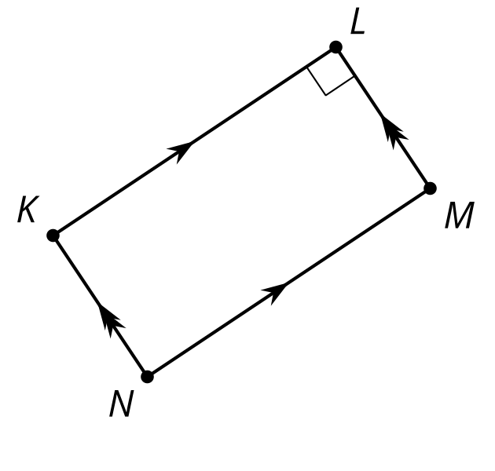
© CC BY 2019 by Illustrative Mathematics®

