Unit 6 Lesson 6: Multi-step Conversion Problems: Metric Liquid Volume

WU Number Talk: Divide by Powers of 10 (Warm up)

Student Task Statement
Find the value of each expression mentally.
- $1,​400÷10$
- $1,​400÷100$
- $1,​400÷1,​000$
- $1,​401÷1,​000$

1 Liquid Volume Conversions

Student Task Statement
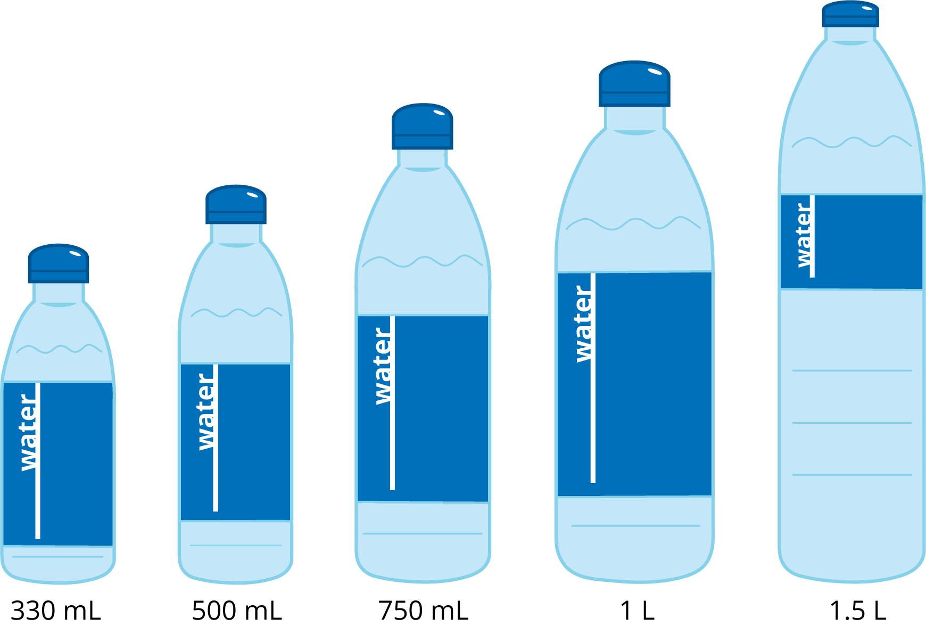
- Complete the table.
- L | - mL
- 5
- 6.3
- 0.95
- ${10}^{2}$
 | - 800,000
 | - ${10}^{6}$
 | - 65
- Decide if the two measurements are equal. If not, choose which one is greater. Explain or show your reasoning.
  - 15 mL and 0.15 L
  - 2,500 mL and 2.5 L
  - 200 mL and $\frac{1}{4}$ L
  - 1 mL and $\frac{1}{1,000}$ L
  - 15,600 mL and 15.5 L

2 Rehydrating Dancers

Student Task Statement
There are 25 dancers in the performance group. During practice, each dancer drinks $1\frac{1}{2}$ bottles of water.
- Each bottle holds 500 mL of water. How many liters of water do the dancers drink? Explain or show your reasoning.
- Each cooler holds 15 L of water. How many coolers does the team need? How much water will they have left over after practice? Explain or show your reasoning.
- 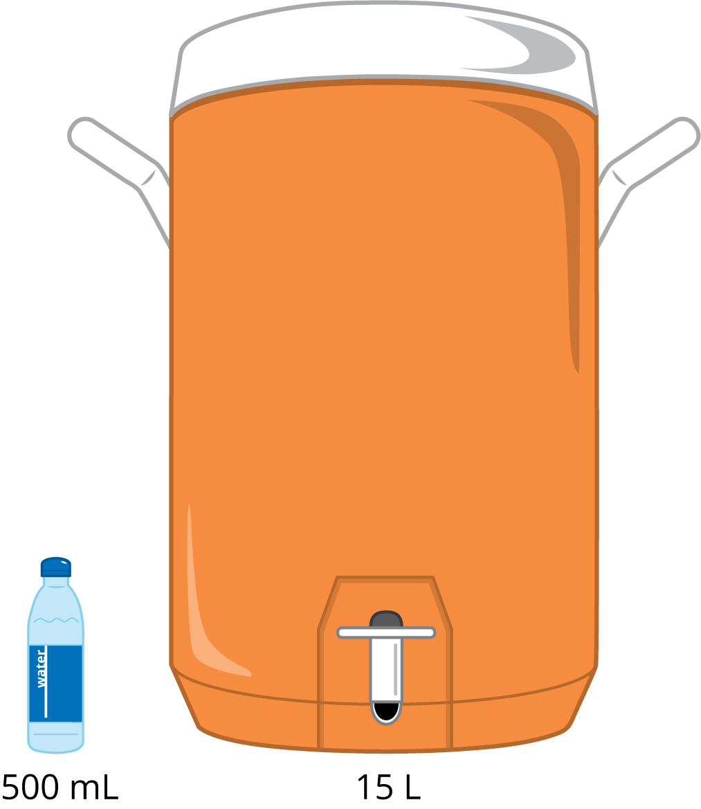
- The dancers can make a sports drink by mixing 30 mL of drink mix with each 500 mL of water. How many liters of drink mix does the team need for their practice? Explain or show your reasoning.
© CC BY 2021 Illustrative Mathematics®

