Lesson 6: Multiply Fractions
- Let’s multiply two non-unit fractions using diagrams and expressions.

Warm-up: Which One Doesn’t Belong: More Pieces
Which one doesn’t belong?
A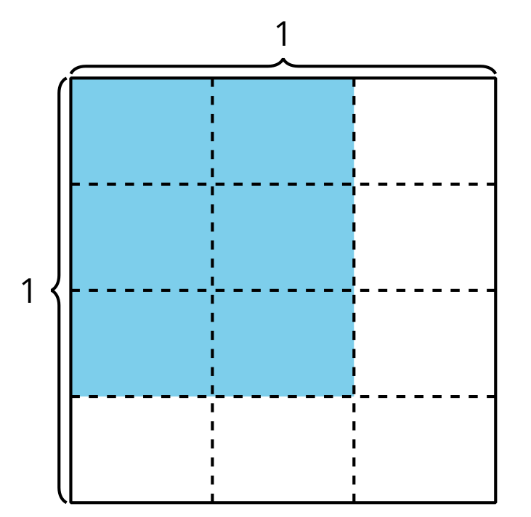
B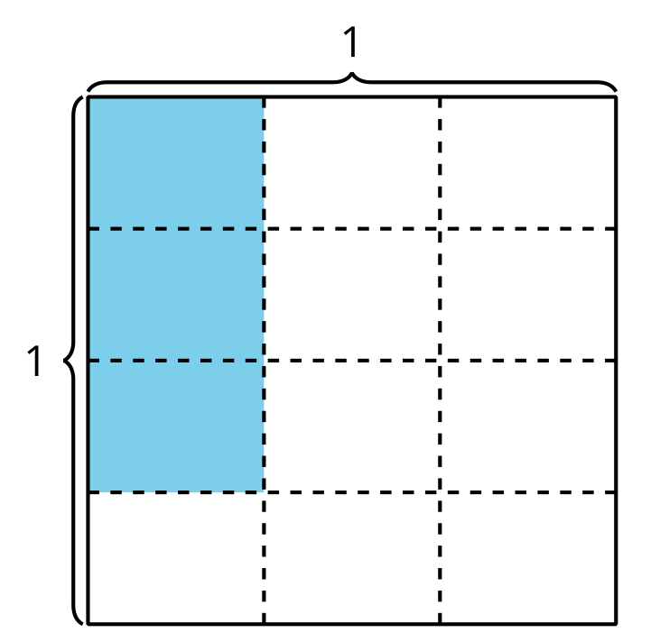
C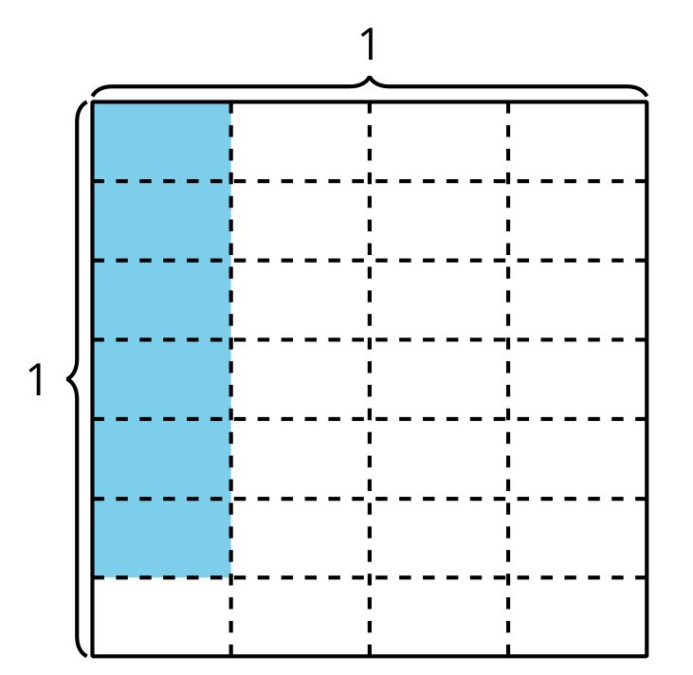
D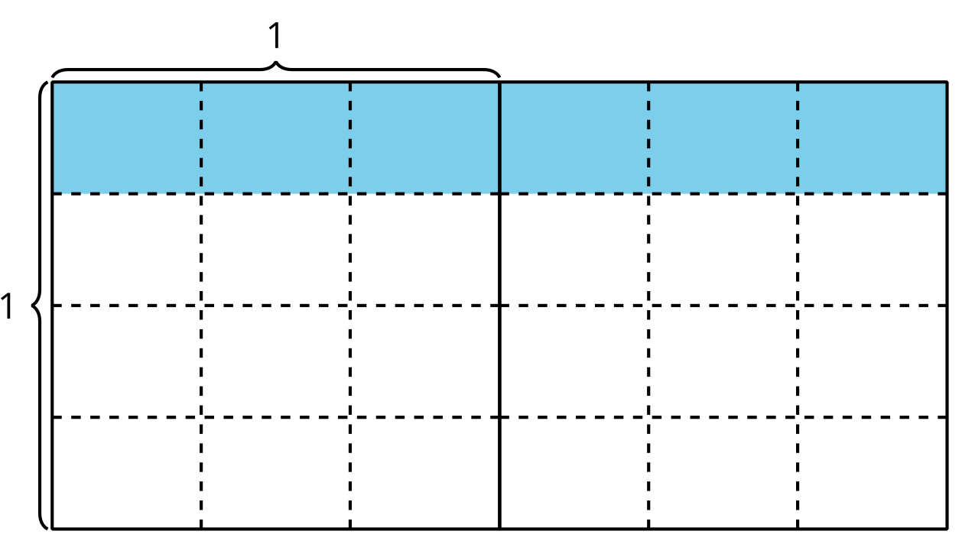

6.1: Many Expressions
Explain or show how each expression can represent the area of the shaded region in square units. Be prepared to share your thinking.
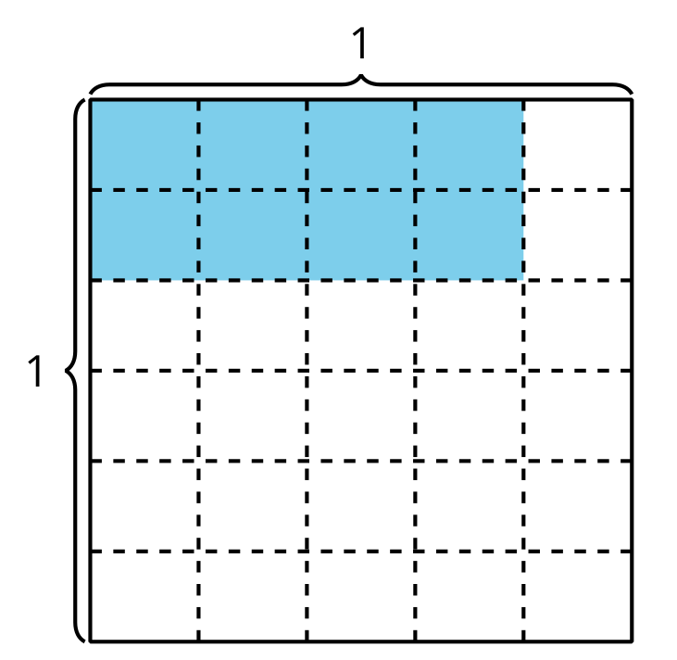
- $\frac{8}{30}$
- $2×4×\left(\frac{1}{5}×\frac{1}{6}\right)$
- $\frac{2}{6}×\frac{4}{5}$

6.2: More Patterns
- Complete the table.
- diagram | - multiplication  expression | - shaded area  (square units)
- A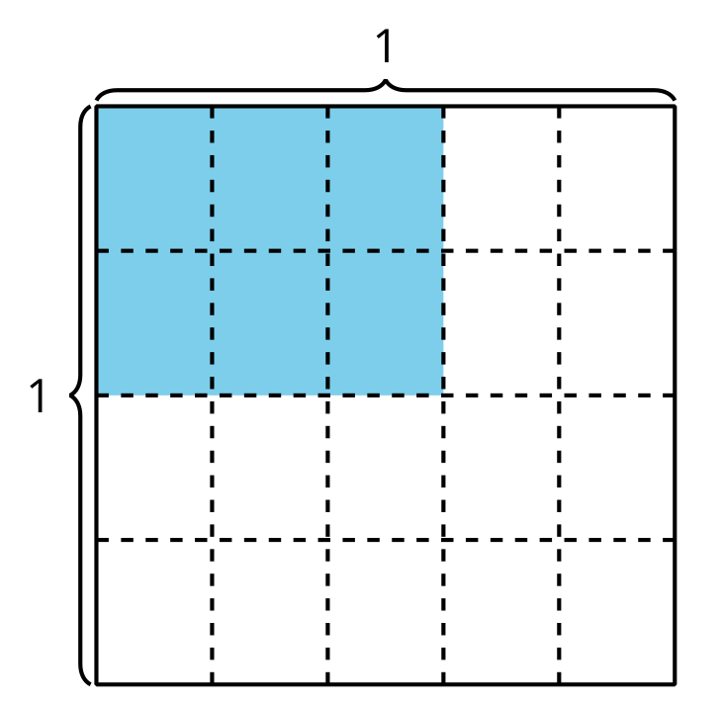
- B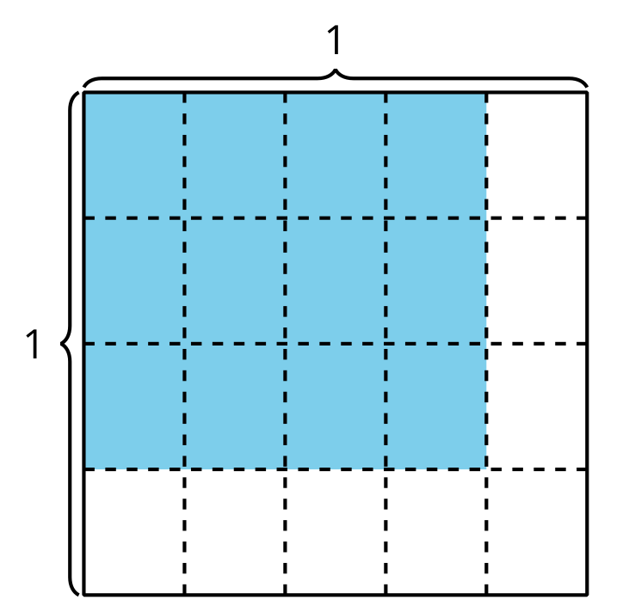

- diagram | - multiplication  expression | - shaded area  (square units)
- C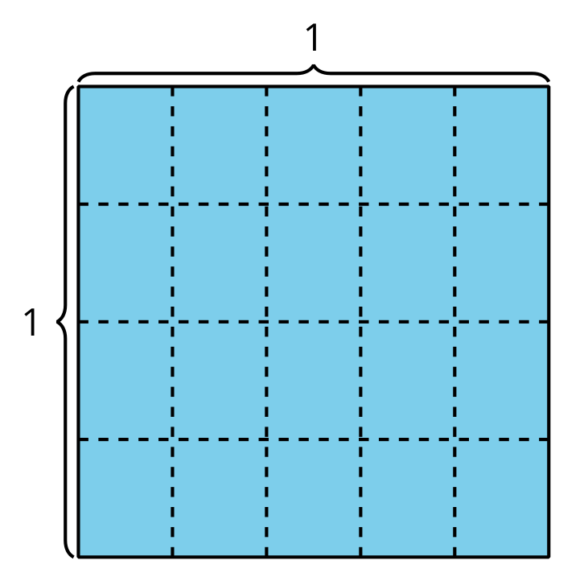
- D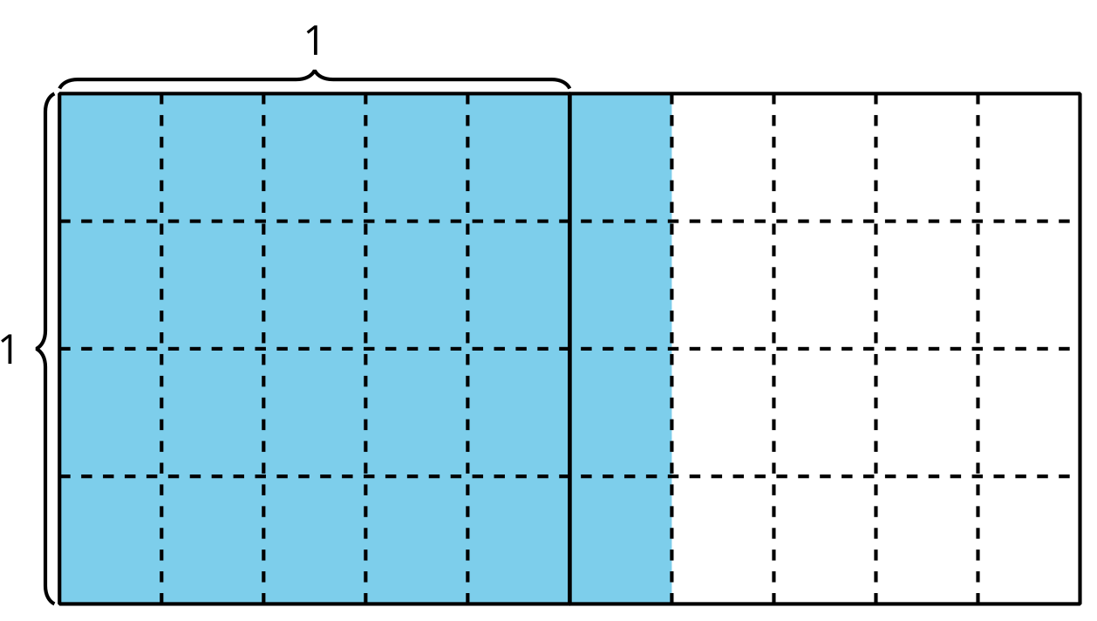
- What patterns do you notice in the table?
- Explain or show how the expression $\frac{6×4}{5×4}$ represents the last diagram in the table.
© CC BY 2021 Illustrative Mathematics®

