Lesson 4: Solid Shapes

Standards Alignments
Addressing | 2.G.A.1

Teacher-facing Learning Goals
- Describe and identify three-dimensional shapes using visible attributes.

Student-facing Learning Goals
- Let’s identify and describe solid shapes.

Lesson Purpose
The purpose of this lesson is for students to recognize and describe three-dimensional (solid) shapes based on their geometric attributes (faces).
In previous lessons, students identified, described, and drew two-dimensional (flat) shapes based on the number of sides and corners. In previous grades, students identified and described the attributes of three-dimensional (solid) shapes.
In this lesson, students identify and describe solid shapes based on their attributes. As students work, they may notice that some solid shapes have faces in common with others, and that some solid shapes can be identified by the number and shape of their faces. For example, students may learn that a cylinder can be identified by its two circular faces, and that cubes have 6 equal-sized square faces (MP7).
This lesson has a Student Section Summary.

Access for:

Students with Disabilities
- Representation (Activity 2)

Instructional Routines
Card Sort (Activity 2), MLR7 Compare and Connect (Activity 1), Notice and Wonder (Warm-up)

Materials to Gather
- Geoblocks: Activity 1
- Scissors: Activity 2
- Tape: Activity 2
- Tools for creating a visual display: Activity 1

Materials to Copy
- Cube Pattern (groups of 2): Activity 2
- Shape Design Card Sort (groups of 2): Activity 2

Required Preparation

Lesson Timeline
Warm-up | 10 min
Activity 1 | 15 min
Activity 2 | 20 min
Lesson Synthesis | 10 min
Cool-down | 5 min

Teacher Reflection Question
As students worked in their small groups today, whose ideas were heard, valued, and accepted? How can you adjust the group structure in future lessons to ensure each student’s ideas are part of the collective learning?

Cool-down
(to be completed at the end of the lesson) 5min
What Shape is This?

Standards Alignments
Addressing | 2.G.A.1

Student-facing Task Statement
- Circle all the images that are composed of 6 shapes of equal size.
- A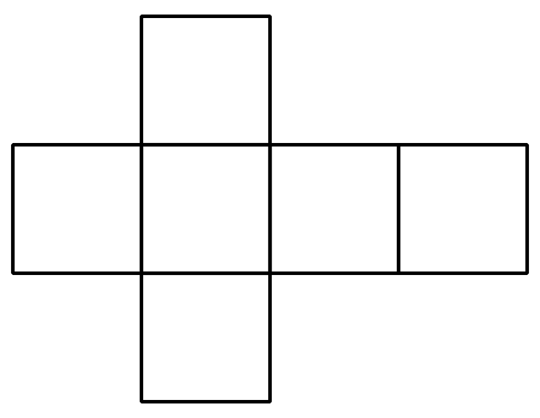
- B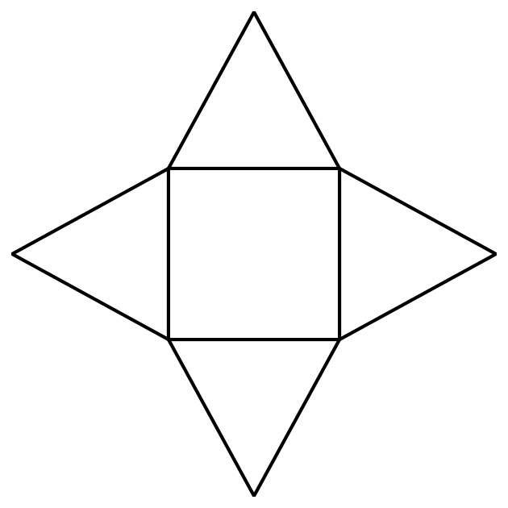
- C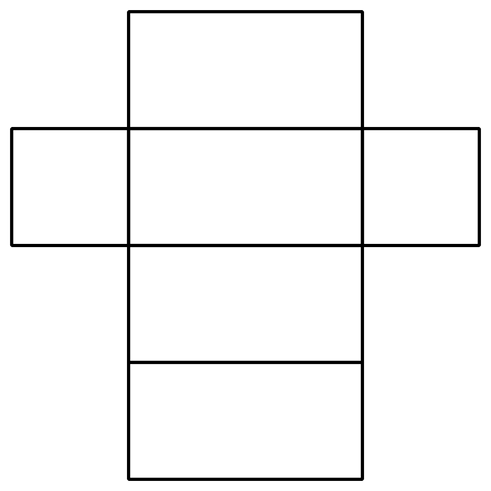
- D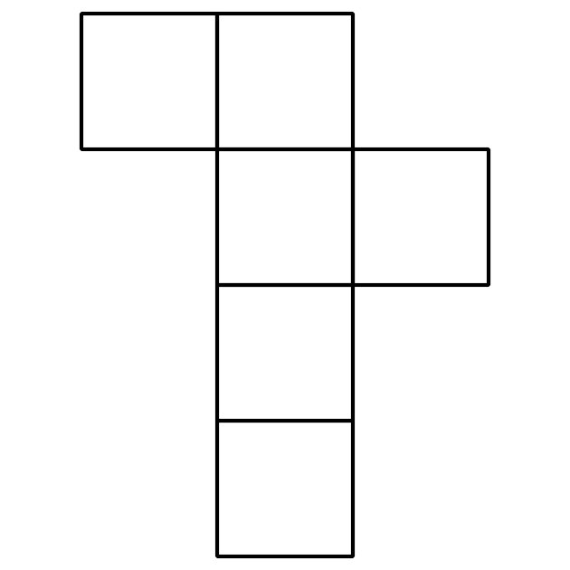
- What is the name for a solid shape with 6 square faces?
- _______________________________

Student Responses
- A and D
- cube

