Unit 4 Lesson 18: Tell Story Problems for Expressions

WU Choral Count: To 50, Count On (Warm up)

Student Task Statement

1 Tell a Story Problem to Match an Expression

Student Task Statement

2 Story Problem and Expression Gallery Walk

Student Task Statement
$\underset{_}{}+\underset{_}{}$
$\underset{_}{}−\underset{_}{}$
$\underset{_}{}+\underset{_}{}$
$\underset{_}{}−\underset{_}{}$
$\underset{_}{}+\underset{_}{}$
$\underset{_}{}−\underset{_}{}$
$\underset{_}{}+\underset{_}{}$
$\underset{_}{}−\underset{_}{}$
$\underset{_}{}+\underset{_}{}$
$\underset{_}{}−\underset{_}{}$
$\underset{_}{}+\underset{_}{}$
$\underset{_}{}−\underset{_}{}$

3 Centers: Choice Time

Student Task Statement
Choose a center.
Find the Value of
Expressions
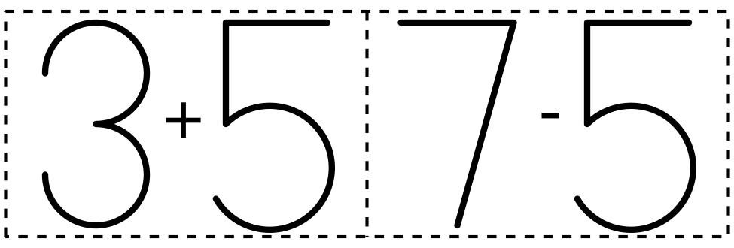
​​​​​​
Roll and Add
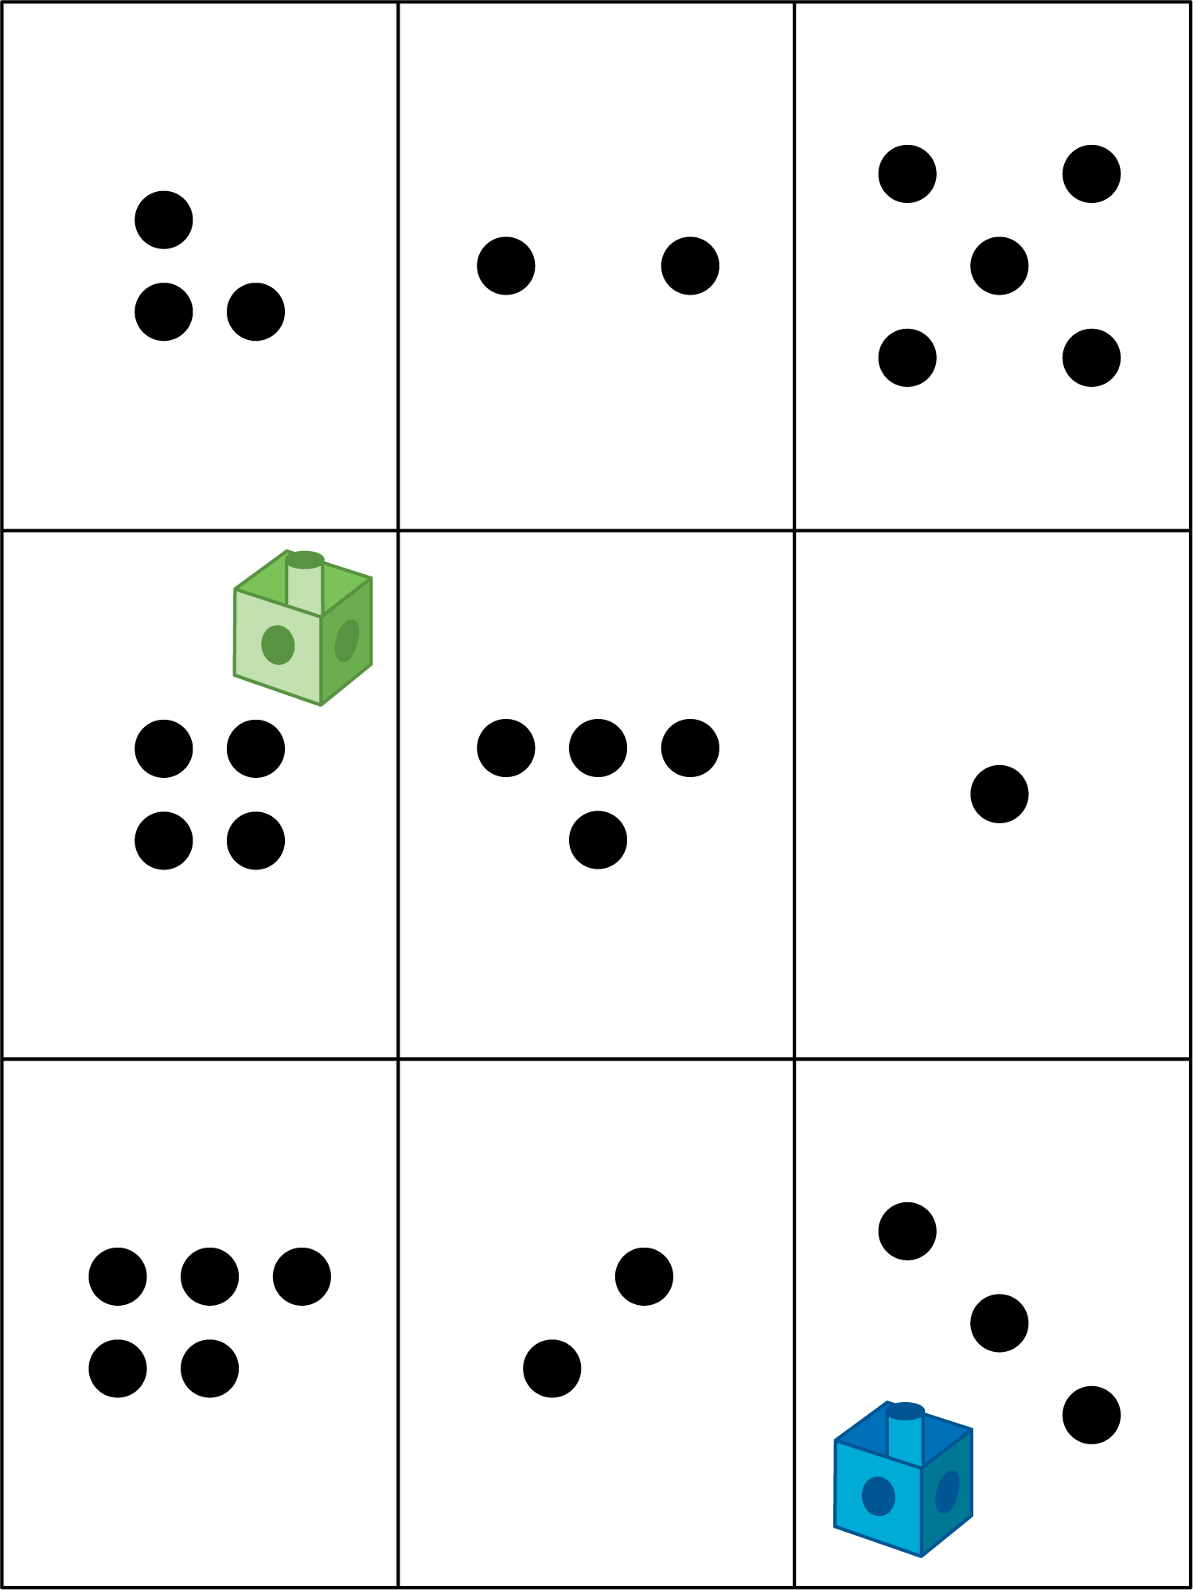
Shake and Spill
Math Stories
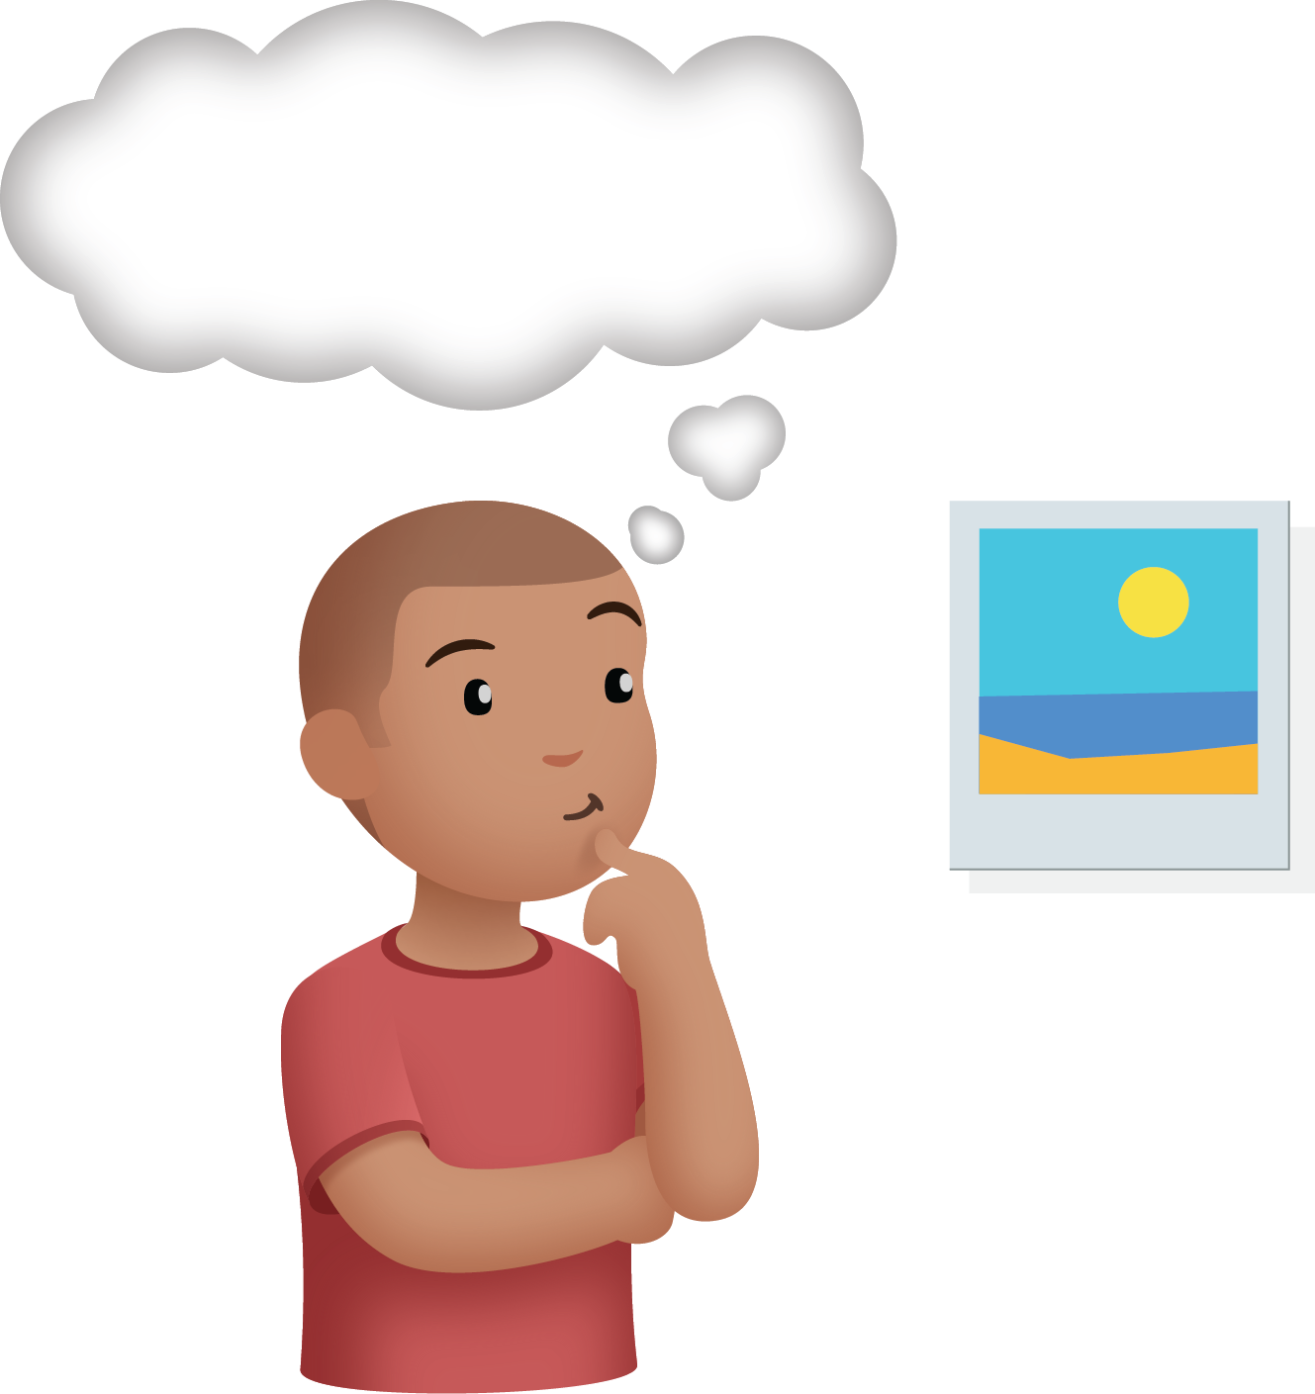
Number Race
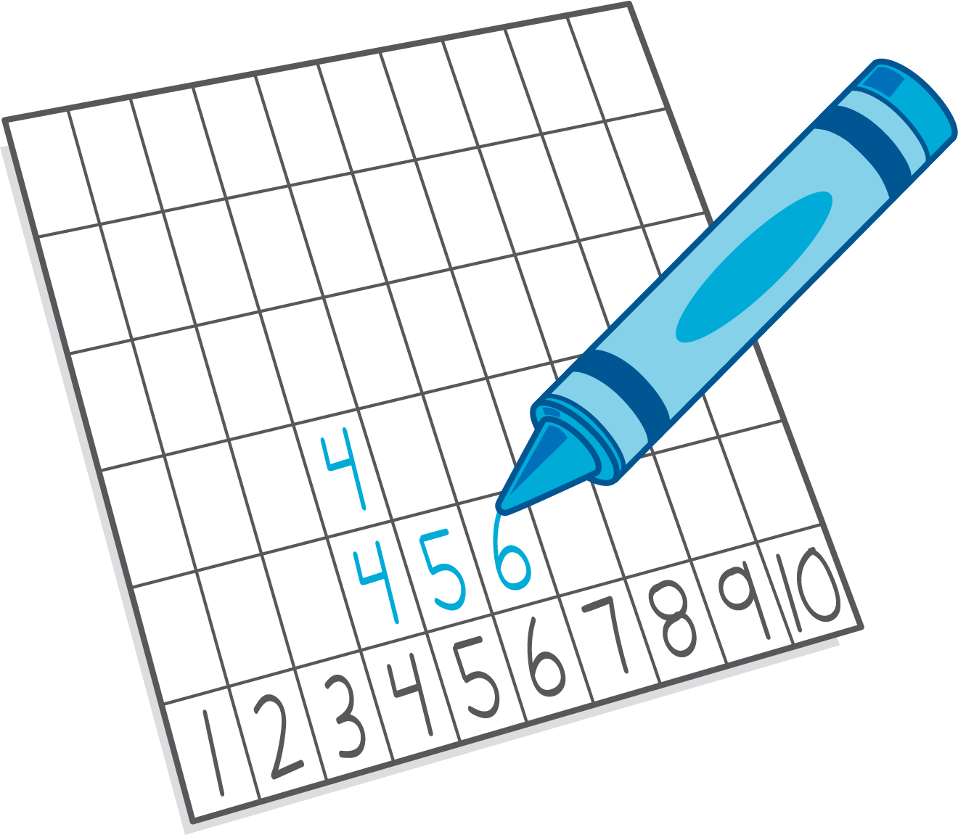
© CC BY 2021 Illustrative Mathematics®

