Lesson 17: Base-ten Diagrams to Represent Division
- Let’s divide using base-ten blocks or diagrams.

Warm-up: Which One Doesn’t Belong: Base-ten Diagrams
Which one doesn’t belong?
A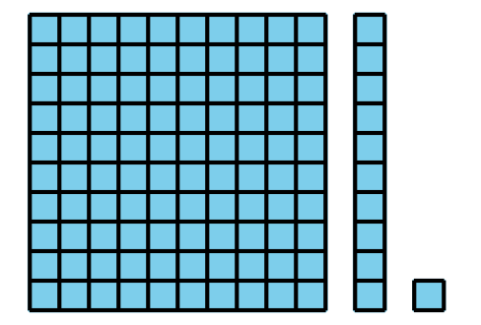
B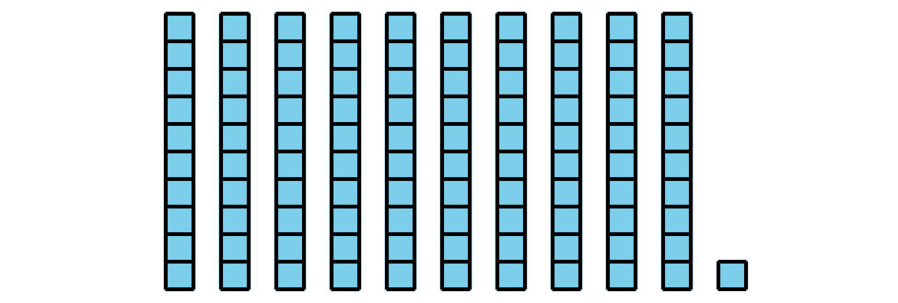
C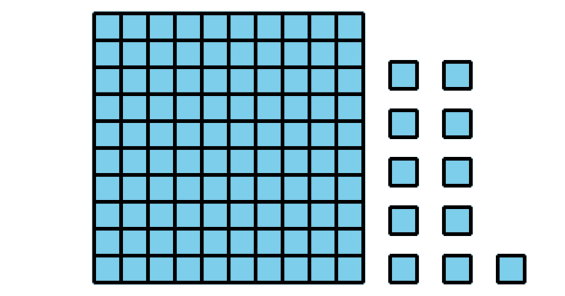
D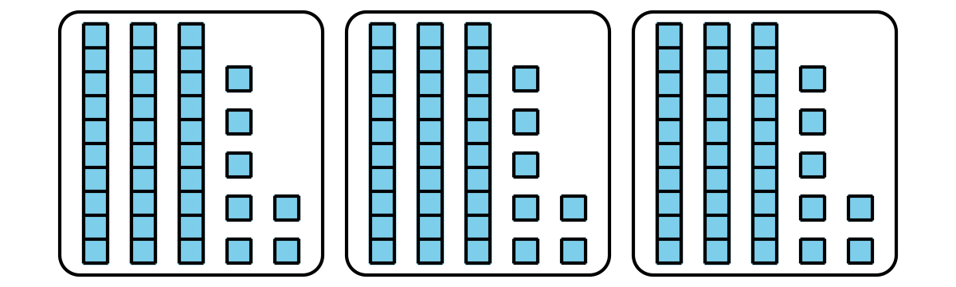

17.1: Divide with Diagrams or Blocks
- Priya draws a base-ten diagram to find the value of $64÷4$. A rectangle represents 10. A small square represents 1.
- Use the diagram (or actual blocks) to help Priya complete the division. Explain or show your reasoning.
- 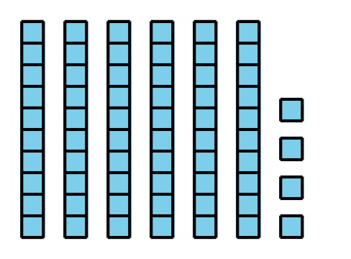
- Use this base-ten diagram (or actual blocks) to find the value of $117÷3$.
- 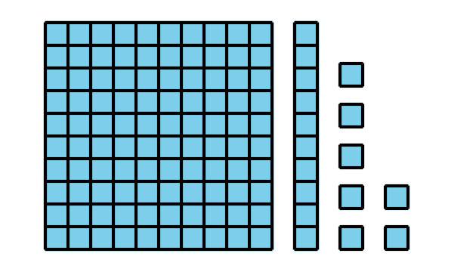

17.2: Help Noah Get Unstuck
- This diagram represents 235.
- 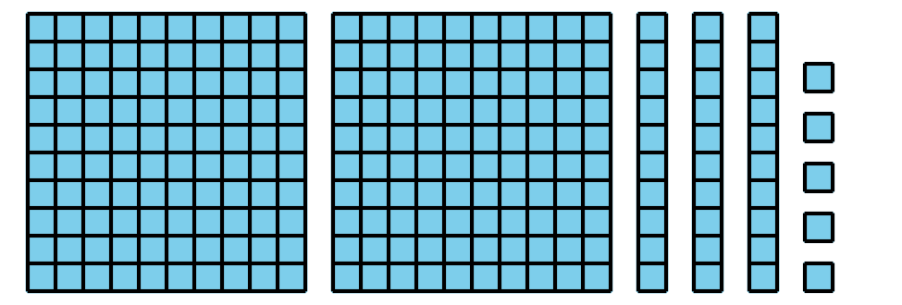
- To find $235÷5$, Noah draws the following diagram but then gets stuck.
- 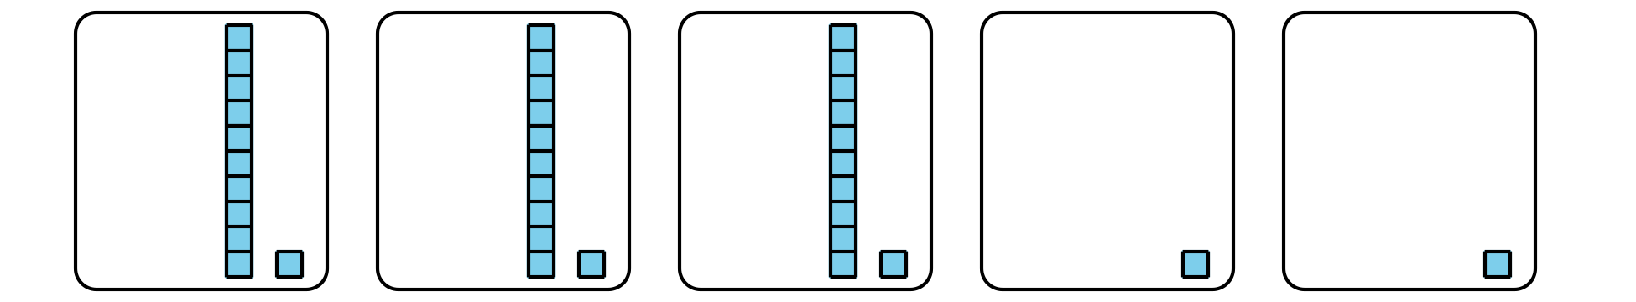
- He says, “There are not enough of the hundreds or the tens pieces to put into 5 groups.”
- Explain or show how Noah could find $235÷5$ with his diagram.
- Find the value of $432÷6$. Show your reasoning. Use base-ten diagrams or blocks if you find them helpful.
© CC BY 2021 Illustrative Mathematics®

