Unit 5 Lesson 7: Expressing Transformations of Functions Algebraically

1 Describing Translations (Warm up)

Student Task Statement
Let $g(x)=\sqrt{x}$. Complete the table. Be prepared to explain your reasoning.
words (the graph of $y=g(x)$ is...) | function notation | expression
translated left 5 units | $g(x+5)$
translated left 5 units and down 3 units |  | $\sqrt{x+5}−3$
 | $g(\text{-}x)$ | $\sqrt{\text{-}x}$
translated left 5 units, then down 3 units,
then reflected across the $y$-axis

2 Translating Vertex Form

Student Task Statement
Let $f$ be the function given by $f(x)=x^{2}$.
- Write an equation for the function $g$ whose graph is the graph of $f$ translated 3 units left and up 5 units.
- What is the vertex of the graph of $g$? Explain how you know.
- Write an equation for a quadratic function $h$ whose graph has a vertex at $(1.5,2.6)$.
- Write an equation for a quadratic function $k$ whose graph opens downward and has a vertex at $(3.2,\text{-}4.7)$.

3 An Even Better Fit

Student Task Statement
In an earlier lesson, we looked at the temperature $T$, in degrees Fahrenheit, of a bottle of soda water left outside for $h$ hours. Let’s model this data with a function. This time, we will start with the function $f(h)=33(0.6)^{h}$. This graph has a shape that fits the data well.
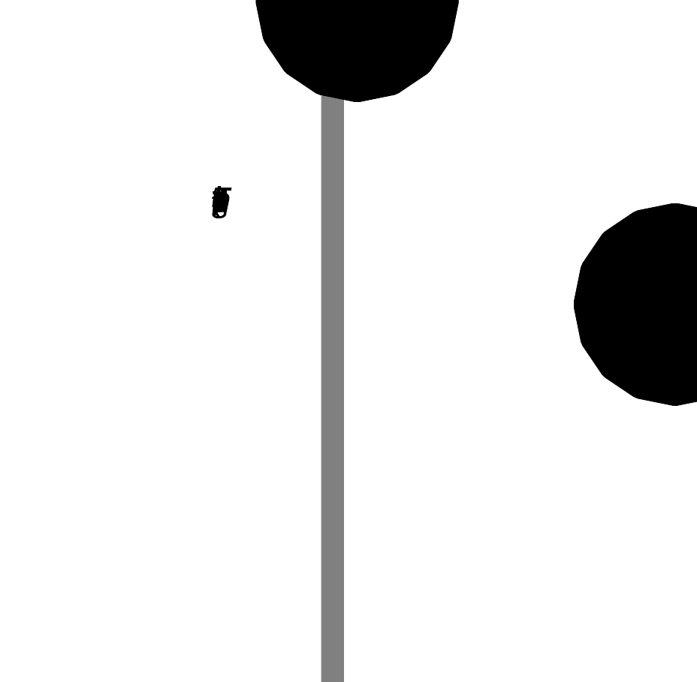
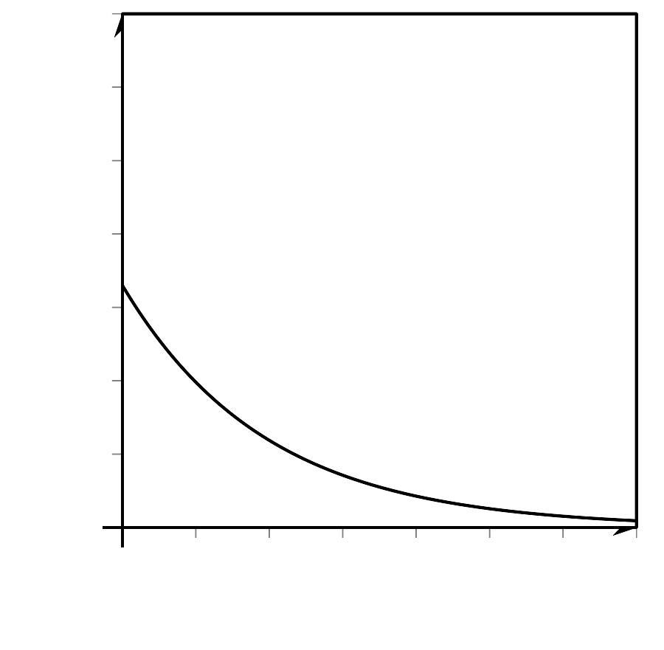
- Describe a translation of this graph that fits the data.
- Write an equation defining a function $g$ that models the data.
- What does your function tell you about the temperature outside?
© CC BY 2019 by Illustrative Mathematics®

