Unit 7 Lesson 13 Cumulative Practice Problems
- Evaluate each expression. Use scientific notation to express your answer.
  - $(1.5×{10}^{2})(5×{10}^{10})$
  - $\frac{4.8×{10}^{\text{-}8}}{3×{10}^{\text{-}3}}$
  - $(5×{10}^{8})(4×{10}^{3})$
  - $(7.2×{10}^{3})÷(1.2×{10}^{5})$
- How many bucketloads would it take to bucket out the world’s oceans? Write your answer in scientific notation.
- Some useful information:
  - The world’s oceans hold roughly $1.4×{10}^{9}$ cubic kilometers of water.
  - A typical bucket holds roughly 20,000 cubic centimeters of water.
  - There are ${10}^{15}$ cubic centimeters in a cubic kilometer.
- The graph represents the closing price per share of stock for a company each day for 28 days.
  - What variable is represented on the horizontal axis?
  - In the first week,
was the stock price generally increasing
or decreasing?
  - During which period did the closing price of the stock decrease for at least 3 days in a row?
- 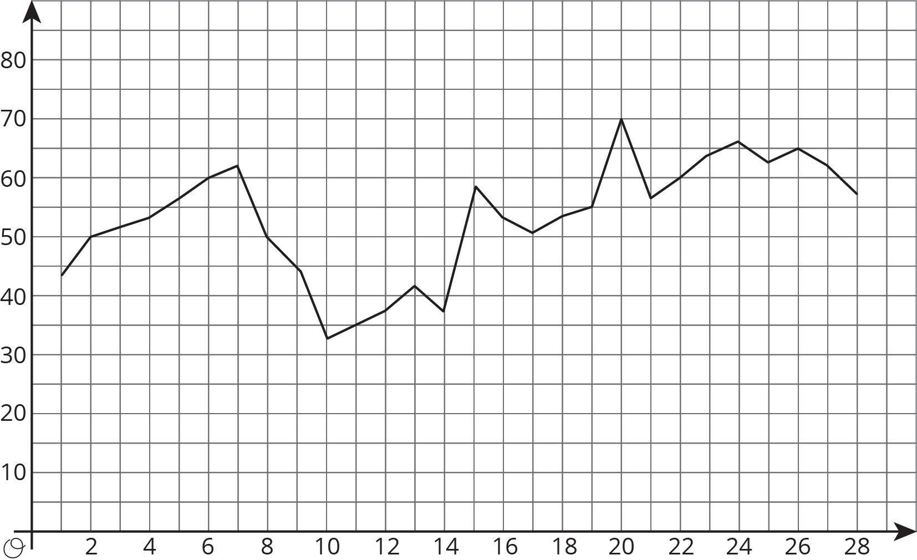
- (From Unit 6, Lesson 5.)
- Write an equation for the line that passes through $(\text{-}8.5,11)$ and $(5,\text{-}2.5)$.
- (From Unit 5, Lesson 9.)
- The point $(\text{-}3,6)$ is on a line with a slope of 4.
  - Find two more points on the line.
  - Write an equation for the line.
- (From Unit 5, Lesson 10.)
- Explain why triangle $ABC$ is similar to triangle $CFE$.
- 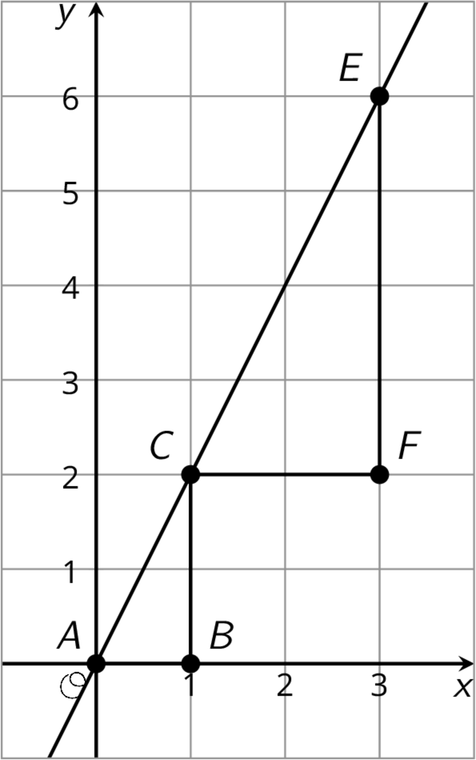
- (From Unit 2, Lesson 11.)
- Two students join a puzzle solving club and get faster at finishing the puzzles as they get more practice. Student A improves their times faster than Student B.
- 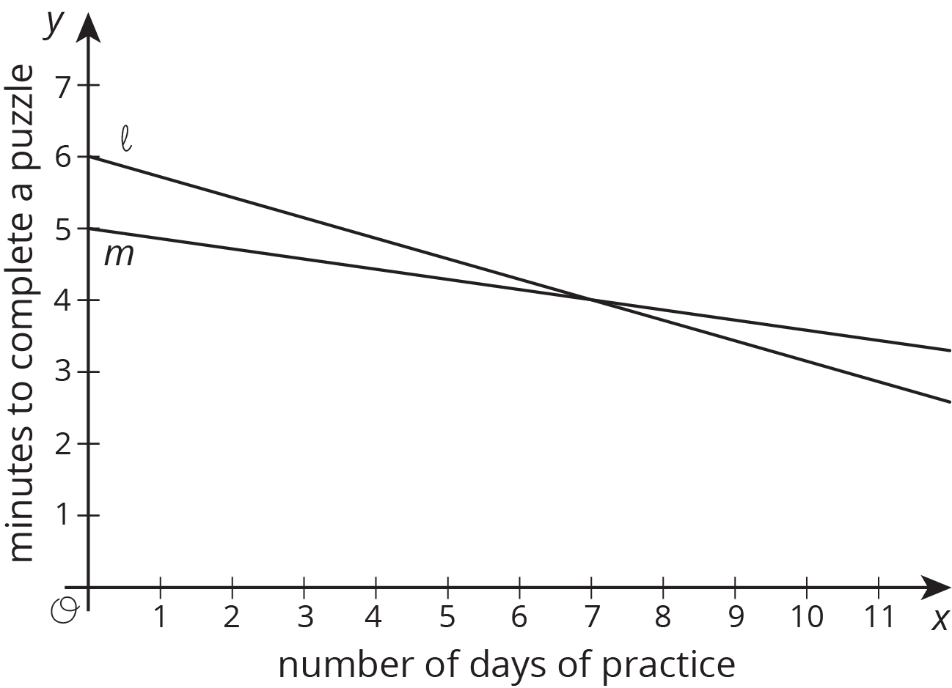
  - Match the students to the Lines $ℓ$ and $m$.
  - Which student was faster at puzzle solving before practice?
- (From Unit 6, Lesson 8.)
© CC BY Open Up Resources. Adaptations CC BY IM.

