Unit 8 Lesson 4 Cumulative Practice Problems
- A carnival game has 160 rubber ducks floating in a pool. The person playing the game takes out one duck and looks at it.
  - If there’s a red mark on the bottom of the duck, the person wins a small prize.
  - If there’s a blue mark on the bottom of the duck, the person wins a large prize.
  - Many ducks do not have a mark.
- After 50 people have played the game, only 3 of them have won a small prize, and none of them have won a large prize.
- Estimate the number of the 160 ducks that you think have red marks on the bottom. Then estimate the number of ducks you think have blue marks. Explain your reasoning.
- Lin wants to know if flipping a quarter really does have a probability of $\frac{1}{2}$ of landing heads up, so she flips a quarter 10 times. It lands heads up 3 times and tails up 7 times. Has she proven that the probability is not $\frac{1}{2}$? Explain your reasoning.
- A spinner has four equal sections, with one letter from the word “MATH” in each section.
  - You spin the spinner 20 times. About how many times do you expect it will land on A?
  - You spin the spinner 80 times. About how many times do you expect it will land on something other than A? Explain your reasoning.
- A spinner is spun 40 times for a game. Here is a graph showing the fraction of games that are wins under some conditions.
- 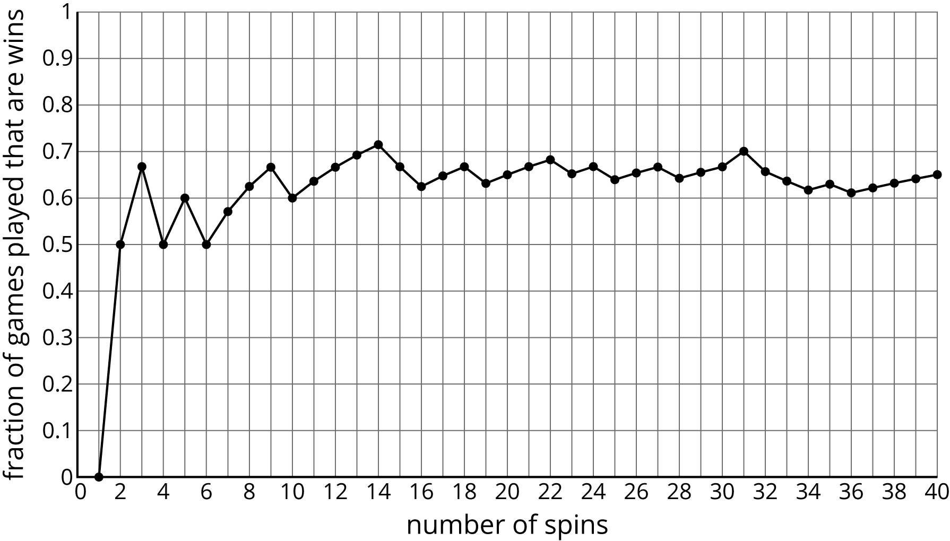
- Estimate the probability of a spin winning this game based on the graph.
- Which event is more likely: rolling a standard number cube and getting an even number, or flipping a coin and having it land heads up?
- (From Unit 8, Lesson 2.)
- Noah will select a letter at random from the word “FLUTE.” Lin will select a letter at random from the word “CLARINET.”
- Which person is more likely to pick the letter “E?” Explain your reasoning.
- (From Unit 8, Lesson 3.)
© CC BY Open Up Resources. Adaptations CC BY IM.

