Lesson 18: Applications of Expressions
- Let’s use expressions to solve problems.

18.1: Algebra Talk: Equivalent to $0.75t−21$
Decide whether each expression is equivalent to $0.75t−21$. Be prepared to explain how you know.
$\frac{3}{4}t−21$
$\frac{3}{4}\left(t−21\right)$
$0.75\left(t−28\right)$
$t−0.25t−21$

18.2: Two Ways to Calculate
Usually when you want to calculate something, there is more than one way to do it. For one or more of these situations, show how the two different ways of calculating are equivalent to each other.
- Estimating the temperature in Fahrenheit when you know the temperature in Celsius
  - Double the temperature in Celsius, then add 30.
  - Add 15 to the temperature in Celsius, then double the result.
- Calculating a 15% tip on a restaurant bill
  - Take 10% of the bill amount, take 5% of the bill amount, and add those two values together.
  - Multiply the bill amount by 3, divide the result by 2, and then take $\frac{1}{10}$ of that result.
- Changing a distance in miles to a distance in kilometers
  - Take the number of miles, double it, then decrease the result by 20%.
  - Divide the number of miles by 5, then multiply the result by 8.

18.3: Which Way?
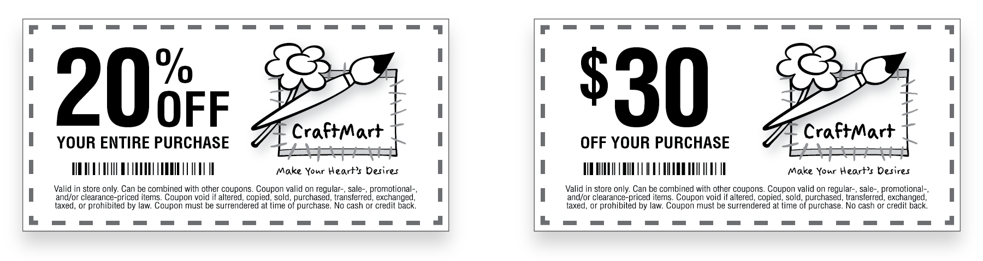
You have two coupons to the same store: one for 20% off and one for $30 off. The cashier will let you use them both, and will let you decide in which order to use them.
- Mai says that it doesn’t matter in which order you use them. You will get the same discount either way.
- Jada says that you should apply the 20% off coupon first, and then the $30 off coupon.
- Han says that you should apply the $30 off coupon first, and then the 20% off coupon.
- Kiran says that it depends on how much you are spending.
Do you agree with any of them? Explain your reasoning.
© CC BY Open Up Resources. Adaptations CC BY IM.

