Unit 1 Lesson 16: Represent Our Collections

WU Questions About Us: Attendance Display (Warm up)

Student Task Statement

1 Counting Collections: Show How Many

Student Task Statement
Show how many objects are in your collection.

2 Answer How Many Questions (Optional)

Student Task Statement

3 Centers: Choice Time

Student Task Statement
Choose a center.
Geoblocks
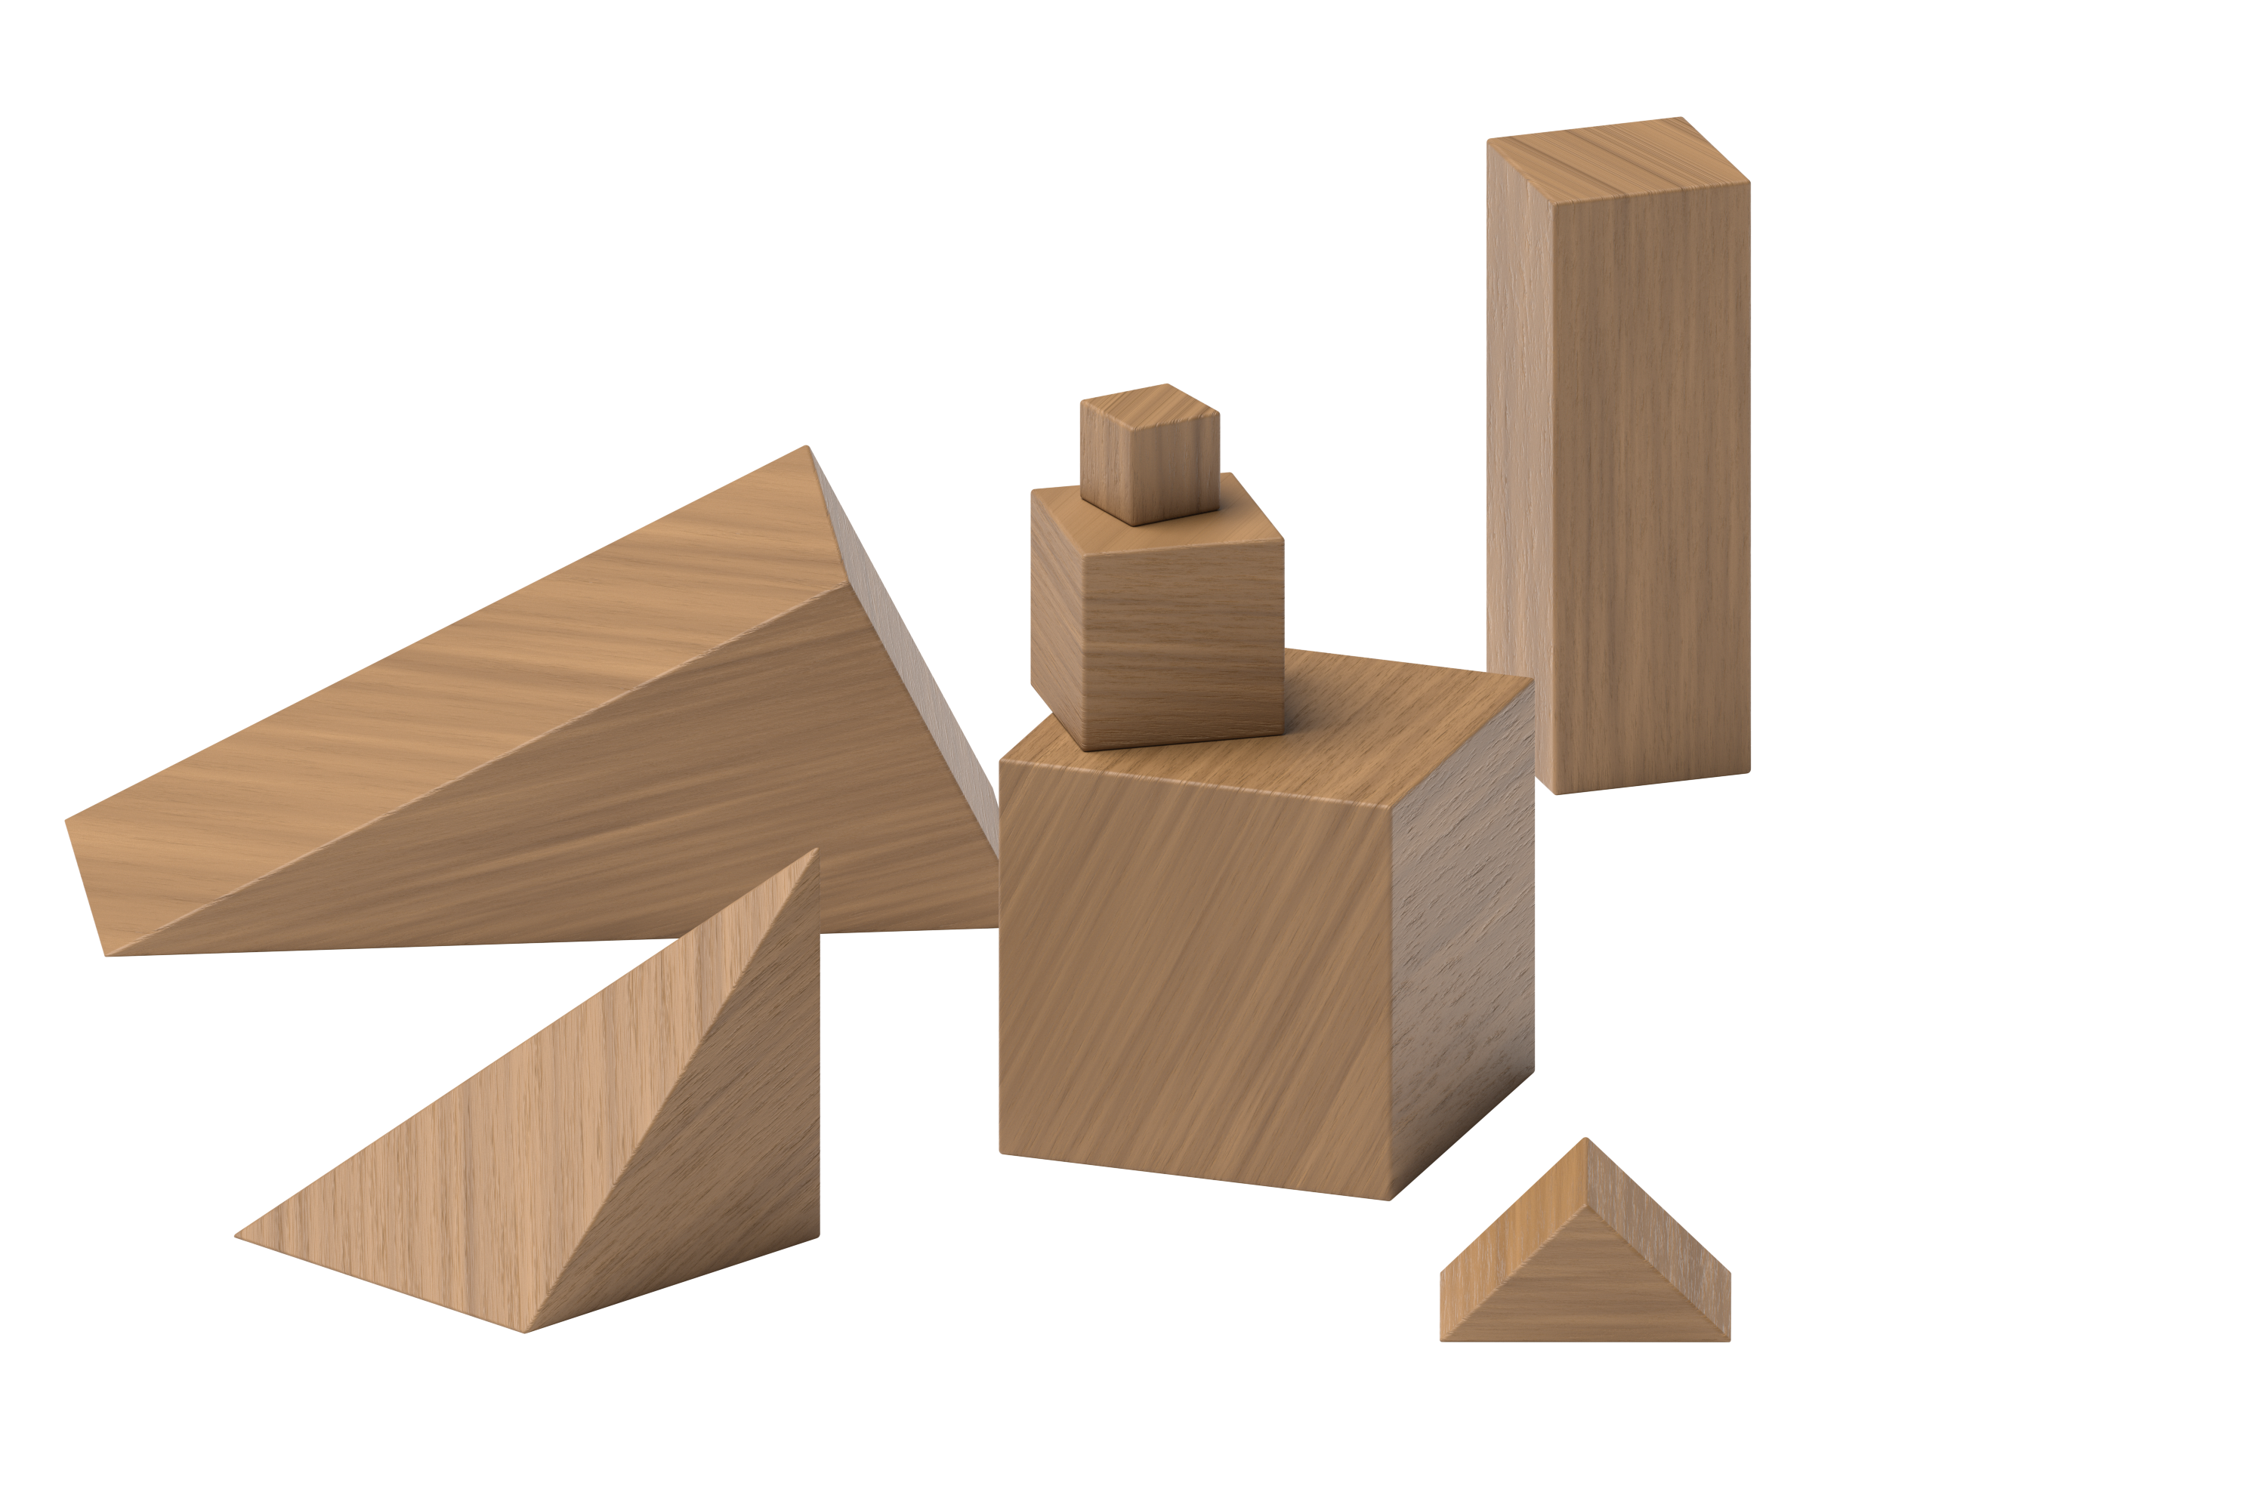
Connecting Cubes
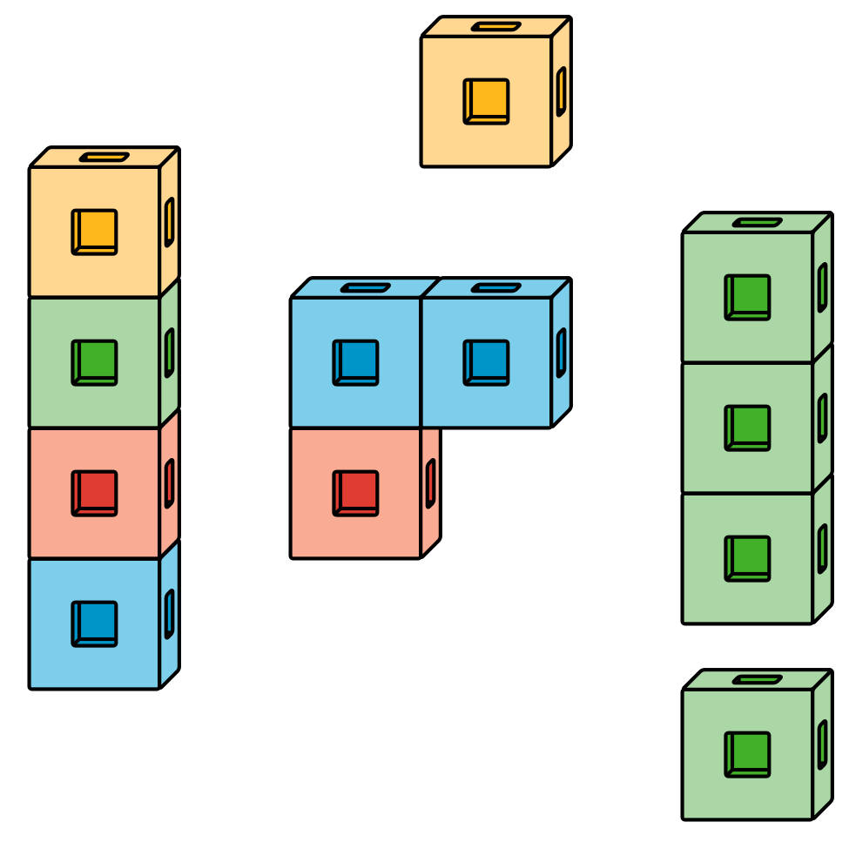
Pattern Blocks
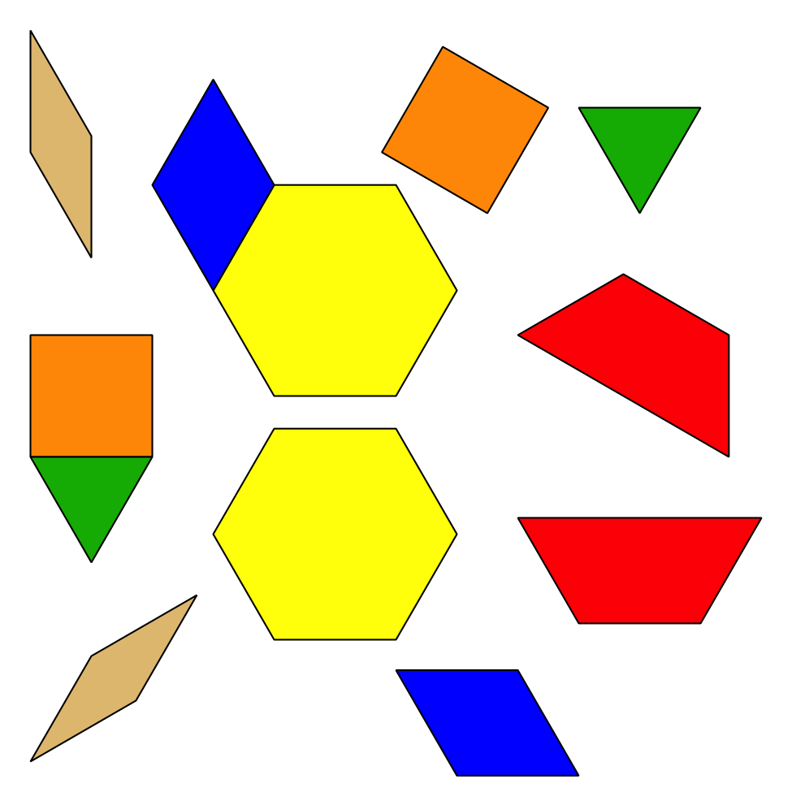
Picture Books
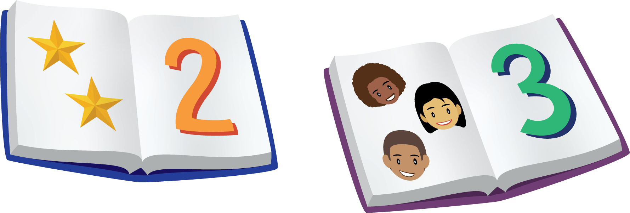
© CC BY 2021 Illustrative Mathematics®

