Lesson 19: Find the Number that Makes 10
- Let’s add to make 10.

Warm-up: How Many Do You See: Make 10
How many do you see?
How do you see them?
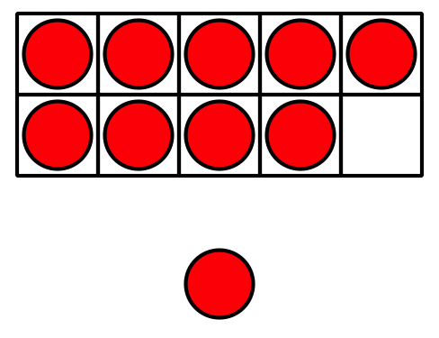

19.1: Color the Number to Make 10
- Partner A: Color in 1 number.
- Partner B: Color in the number that makes 10 with the same color.
- Switch colors and roles and repeat.
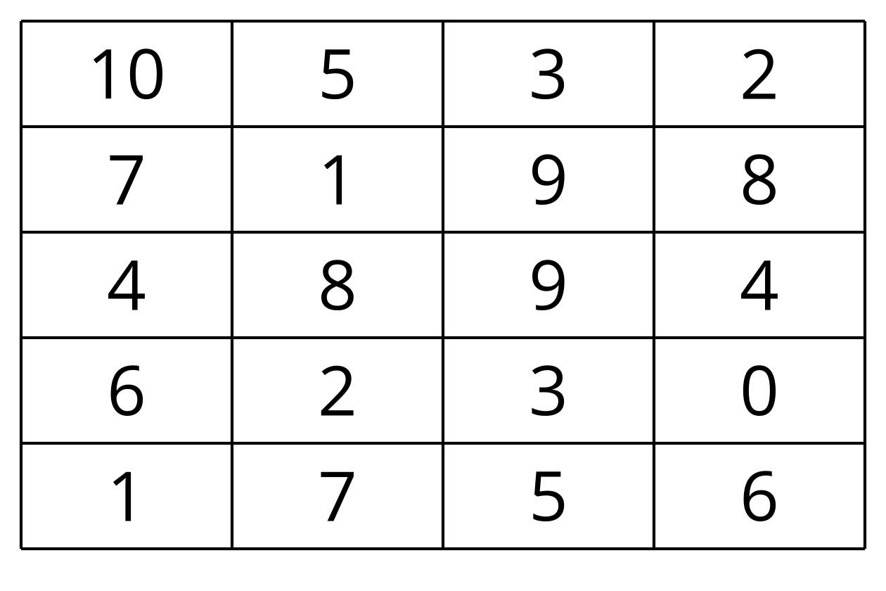
Choose your favorite way to make 10.
Fill in the equation.
$10=\underset{_}{}+\underset{_}{}$

19.2: Add to Make 10
Fill in the equation to show ways to make 10.
- $10=9+\underset{_}{}$
- $10=3+\underset{_}{}$
- $10=5+\underset{_}{}$
- $10=4+\underset{_}{}$
- $10=8+\underset{_}{}$
- $10=7+\underset{_}{}$

19.3: Centers: Choice Time
Choose a center.
Shake and Spill
Number Race
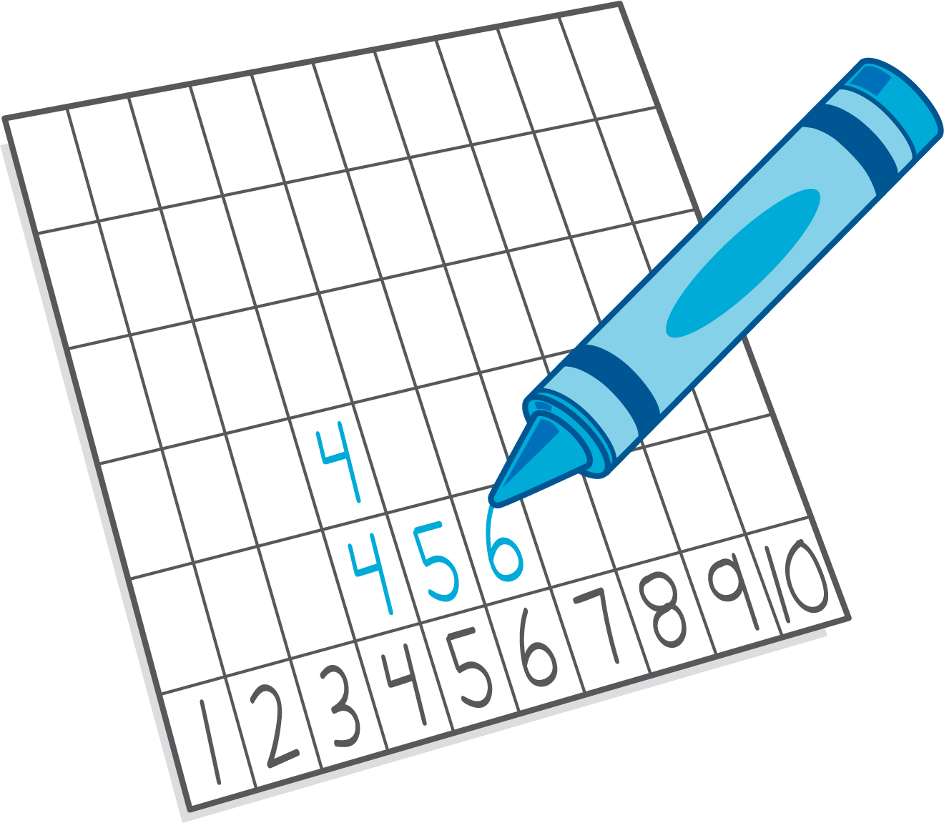
Grab and Count
What's Behind My Back?
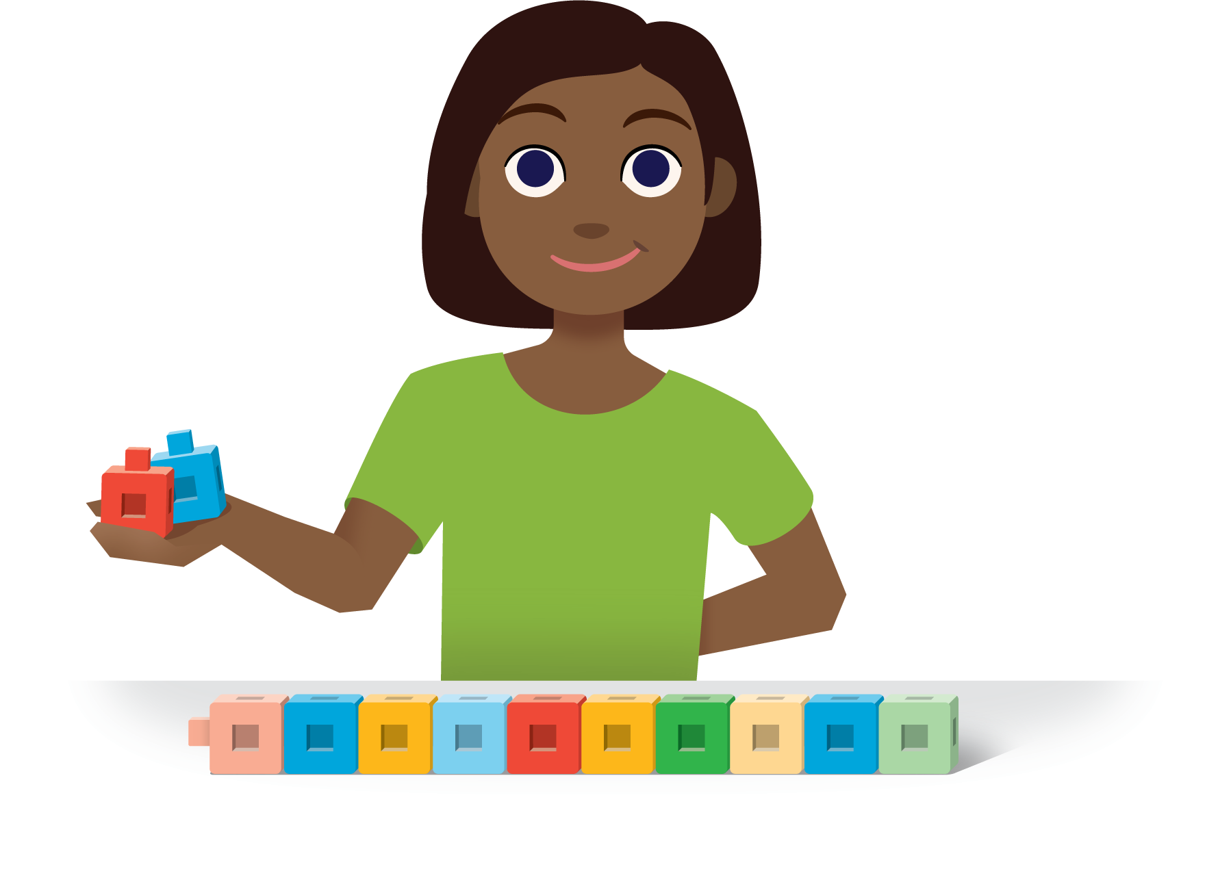
Pattern Blocks
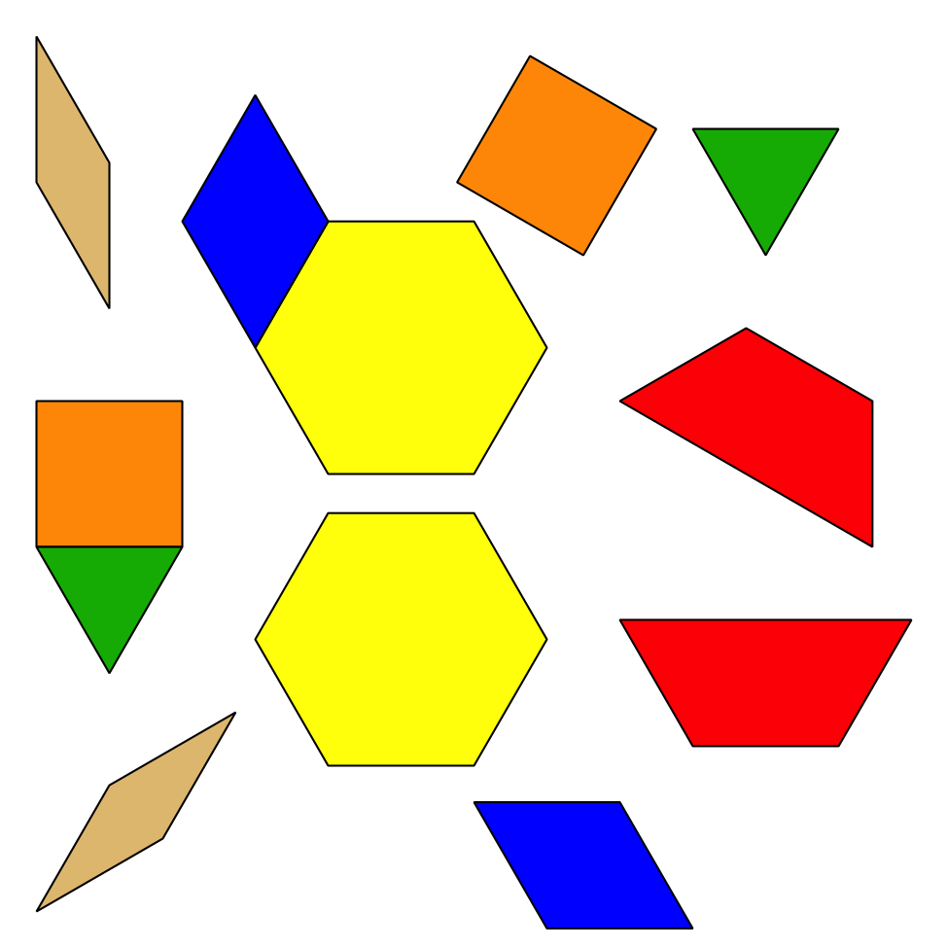
© CC BY 2021 Illustrative Mathematics®

