Lesson 8 Practice Problems
- A pattern of dots grows exponentially. The table shows the number of dots at each step of the pattern.
- step number | - 0 | - 1 | - 2 | - 3
- number of dots | - 1 | - 5 | - 25 | - 125
  - Write an equation to represent the relationship between the step number, $n$, and the number of dots, $y$.
  - At one step, there are 9,765,625 dots in the pattern. At what step number will that happen? Explain how you know.
- A bacteria population is modeled by the equation $p\left(h\right)=10,​000⋅2^{h}$, where $h$ is the number of hours since the population was measured.
- About how long will it take for the population to reach 100,000? Explain your reasoning.
- Complete the table.
- $x$ |  |  | - -2 | - 0 | - $\frac{1}{3}$ | - 1
- ${10}^{x}$ | - $\frac{1}{10,000}$ | - $\frac{1}{1,000}$ | - $\frac{1}{100}$ |  |  |  | - 1,000 | - 1,000,000,000
- Here is a graph of $y=3^{x}$.
- What is the approximate value of $x$ satisfying $3^{x}=10,​000$? Explain how you know.
- 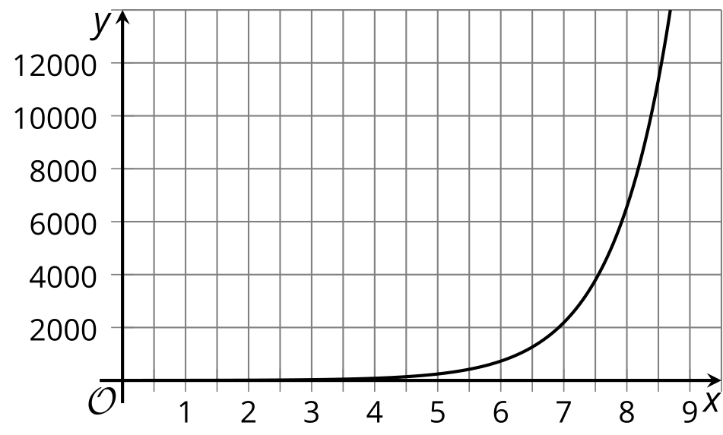
- One account doubles every 2 years. A second account triples every 3 years. Assuming the accounts start with the same amount of money, which account is growing more rapidly?
- How would you describe the output of this graph for:
  - inputs from 0 to 1
  - inputs from 3 to 4
- 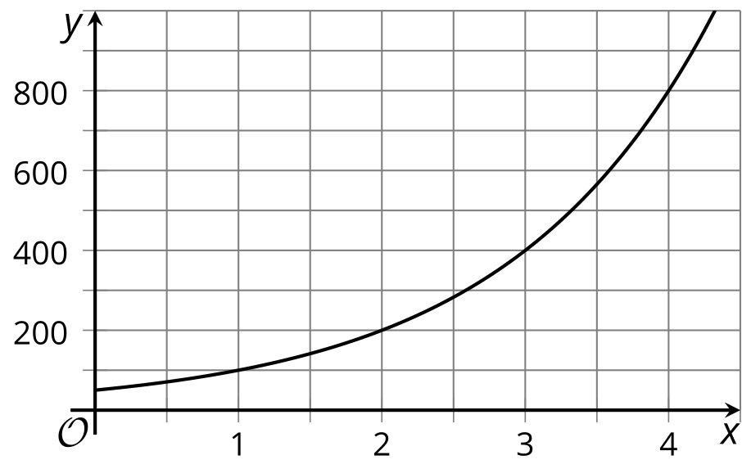
- (From Unit 4, Lesson 1.)
- The half-life of carbon-14 is about 5730 years.
  - Complete the table, which shows the amount of carbon-14 remaining in a plant fossil at the different times since the plant died.
  - About how many years will it be until there is 0.1 picogram of carbon-14 remaining in the fossil? Explain how you know.
- years | - picograms
- 0 | - 3
- 5730
- $2⋅5730$
- $3⋅5730$
- $4⋅5730$
- (From Unit 4, Lesson 7.)
© CC BY 2019 by Illustrative Mathematics®

