Lesson 1: Moving in Circles
Let’s think about moving in circles.

1.1: Which One Doesn't Belong: Reading Clocks
Which one doesn’t belong?

A
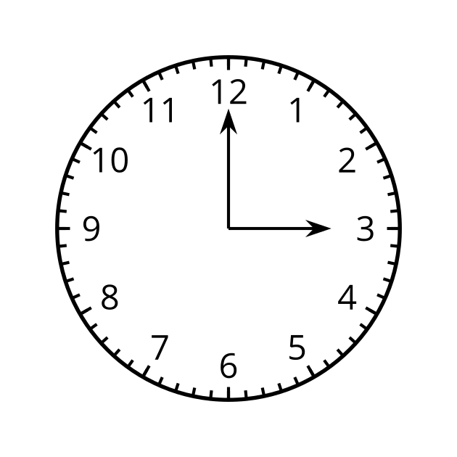

B
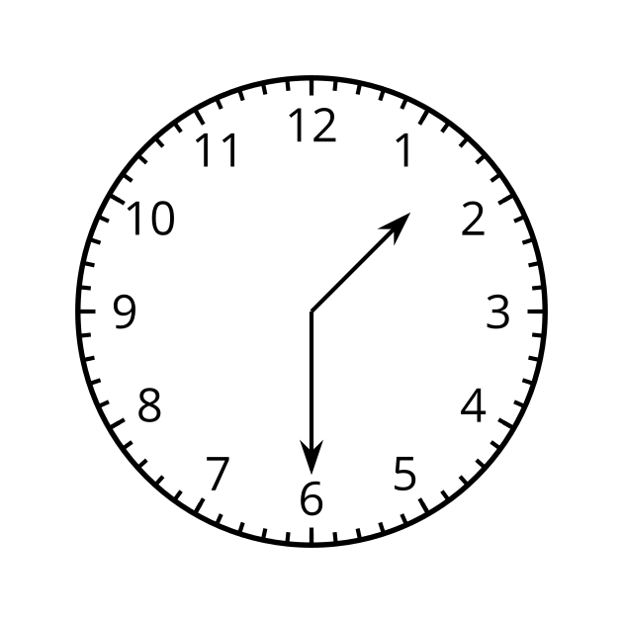

C
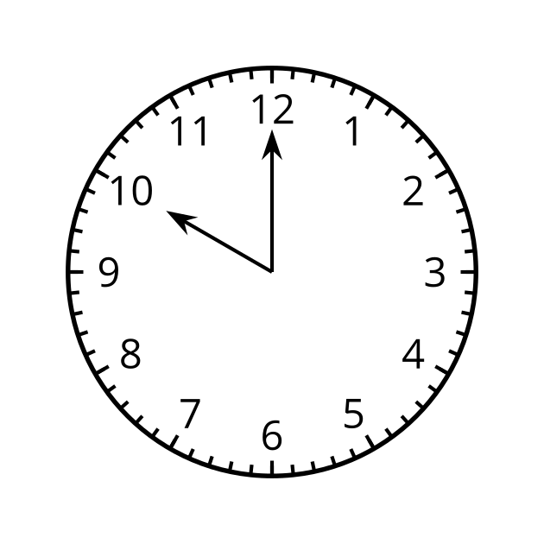

D
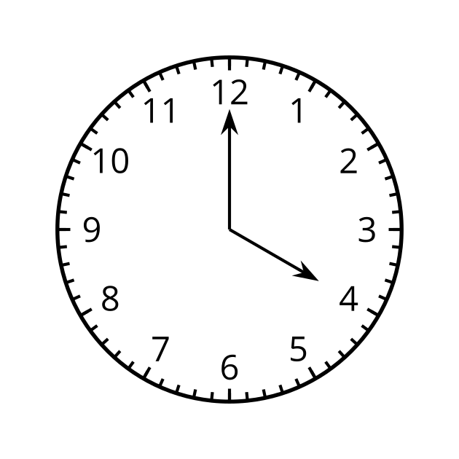

1.2: Around and Around
A ladybug lands on the end of a clock’s second hand when the hand is pointing straight up. The second hand is 1 foot long and when it rotates and points directly to the right, the ladybug is 10 feet above the ground.
- How far above the ground is the ladybug after 0, 30, 45, and 60 seconds have passed?
Pause here for a class discussion.
- Estimate how far above the ground the ladybug is after 10, 20, and 40 seconds. Be prepared to explain your reasoning.
- If the ladybug stays on the second hand, describe how its distance from the ground will change over the next minute. What about the minute after that?
- At exactly 3:15, the ladybug flies from the second hand to the minute hand, which is 9 inches long.
  - How far off the ground is the ladybug now?
  - At what time will the ladybug be at that height again if it stays on the minute hand? Be prepared to explain your reasoning.

1.3: Where is the Point?
- What is the radius of the circle?
- 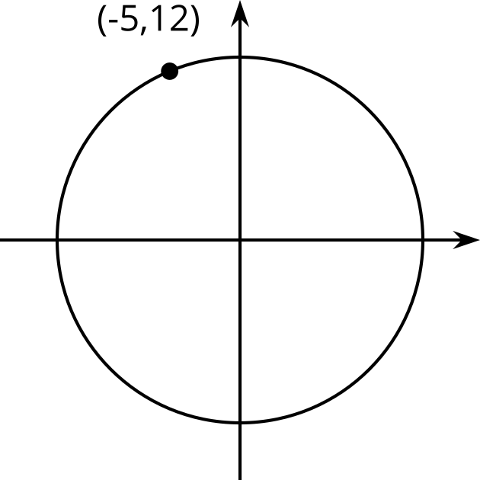
- If $Q$ has a $y$-coordinate of -4, what is the $x$-coordinate?
- 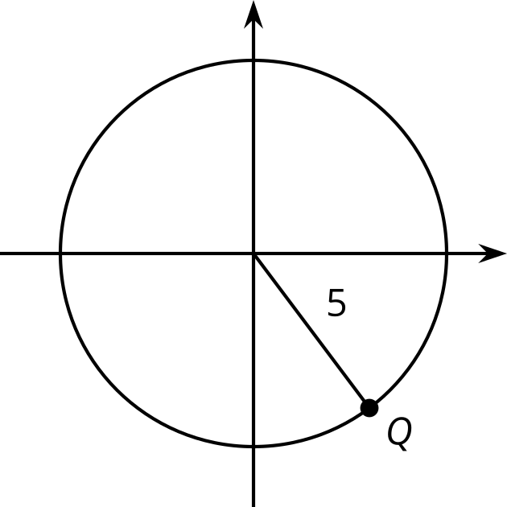
- If $B$ has a $y$-coordinate of 4, what is the $x$-coordinate?
- 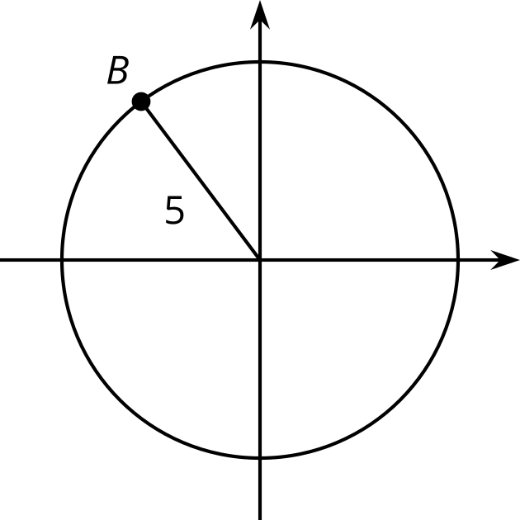
- A circle centered at $\left(0,0\right)$ has a radius of 10. Point $S$ on the circle has an $x$-coordinate of 6. What is the $y$-coordinate of point $S$? Explain or show your reasoning.

Are you ready for more?
- How many times a day do the minute hand and the hour hand on a clock point in the same direction?
- At what times do they point in the same direction?

Lesson 1 Summary
Consider the height of the end of a second hand on a clock over a full minute. It starts pointing up, then rotates to point down, then rotates until it is pointing straight up again. This motion repeats once every minute.
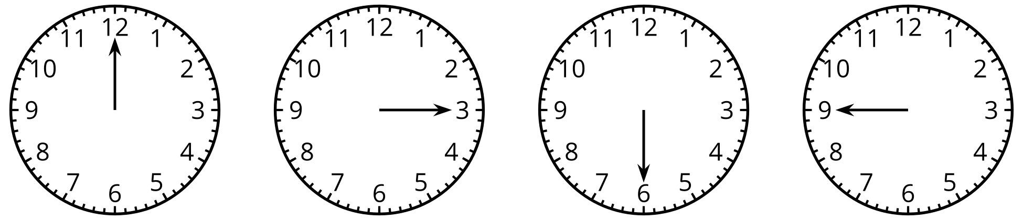
If we imagine the clock centered at $\left(0,0\right)$ on the coordinate plane, then we can study the movement of the end of the second hand by thinking about its $\left(x,y\right)$ coordinates on the plane. Over one minute, the $y$-coordinate starts at its highest value (when the hand is pointing up), decreases to its lowest value (when the hand is pointing down), and then returns to its highest value. This happens once every minute that passes.
While we have worked with many types of functions, such as rational or exponential, none of them are characterized by output values that repeat over and over again, so we can’t use them to model the height of the end of the second hand. This means we need to use a new type of function. A function whose values repeat at regular intervals is called a periodic function, and the length of the interval at which a periodic function repeats is called the period. We will study several types of periodic functions in this unit.
© CC BY 2019 by Illustrative Mathematics®

