Unit 2 Lesson 9: Which Variable to Solve for? (Part 2)

1 Faces, Vertices, and Edges (Warm up)

Student Task Statement
In an earlier lesson, you saw the equation $V+F−2=E$, which relates the number of vertices, faces, and edges in a Platonic solid.
- Write an equation that makes it easier to find the number of vertices in each of the Platonic solids described:
  - An octahedron (shown here), which has 8 faces.
  - An icosahedron, which has 30 edges.
- A Buckminsterfullerene (also called a “Buckyball”) is a polyhedron with 60 vertices. It is not a Platonic solid, but the numbers of faces, edges, and vertices are related the same way as those in a Platonic solid.
- Write an equation that makes it easier to find the number of faces a Buckyball has if we know how many edges it has.

2 Cargo Shipping

Student Task Statement
An automobile manufacturer is preparing a shipment of cars and trucks on a cargo ship that can carry 21,600 tons.
The cars weigh 3.6 tons each and the trucks weigh 7.5 tons each.
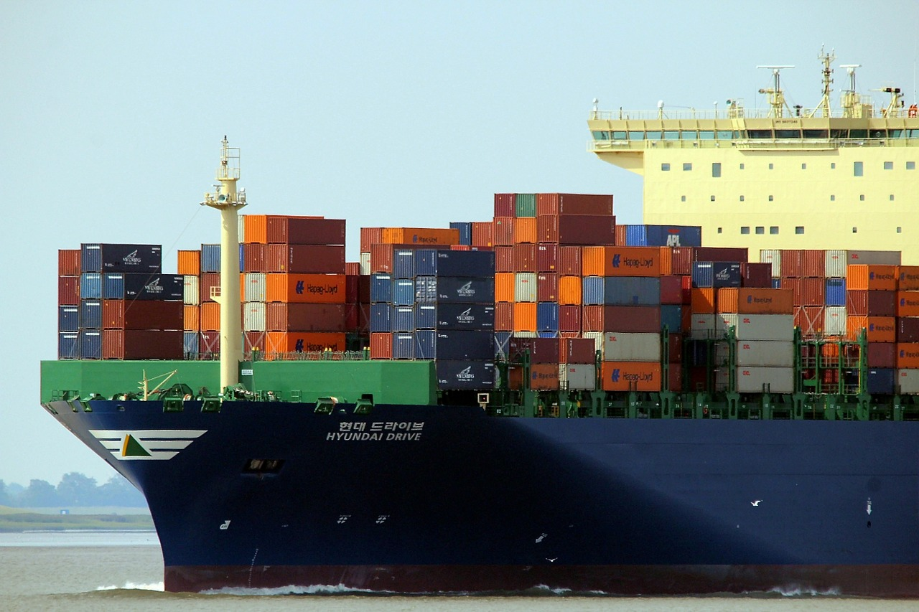
- Write an equation that represents the weight constraint of a shipment. Let $c$ be the number of cars and $t$ be the number of trucks.
- For one shipment, trucks are loaded first and cars are loaded afterwards. (Even though trucks are bulkier than cars, a shipment can consist of all trucks as long as it is within the weight limit.)
- Find the number of cars that can be shipped if the cargo already has:
  - 480 trucks
  - 1,500 trucks
  - 2,736 trucks
  - $t$ trucks
- For a different shipment, cars are loaded first, and then trucks are loaded afterwards.
  - Write an equation you could enter into a calculator or a spreadsheet tool to find the number of trucks that can be shipped if the number of cars is known.
  - Use your equation and a calculator or a computer to find the number of trucks that can be shipped if the cargo already has 1,000 cars. What if the cargo already has 4,250 cars?

3 Streets and Staffing

Student Task Statement
The Department of Streets of a city has a budget of $1,962,800 for resurfacing roads and hiring additional workers this year.
The cost of resurfacing a mile of 2-lane road is estimated at $84,000. The average starting salary of a worker in the department is $36,000 a year.
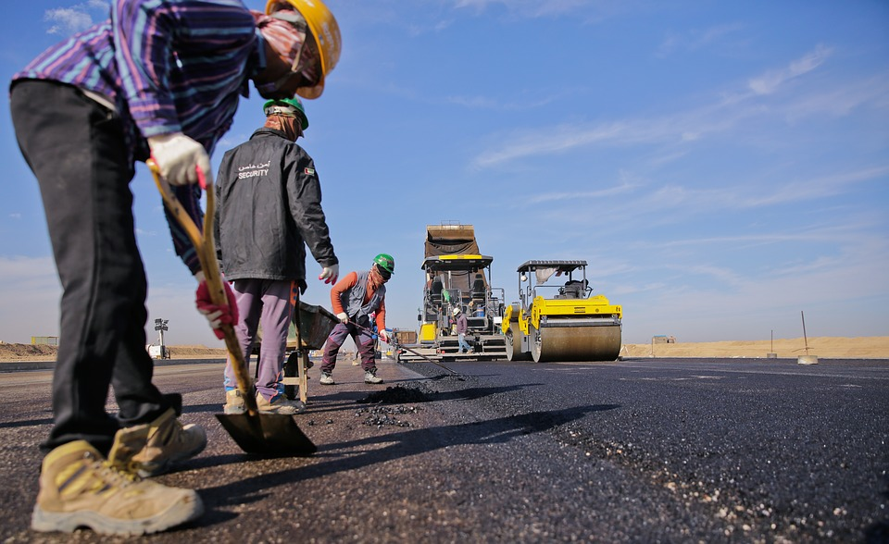
- Write an equation that represents the relationship between the miles of 2-lane roads the department could resurface, $m$, and the number of new workers it could hire, $p$, if it spends the entire budget.
- Take the equation you wrote in the first question and:
  - Solve for $p$. Explain what the solution represents in this situation.
  - Solve for $m$. Explain what the solution represents in this situation.
- The city is planning to hire 6 new workers and to use its entire budget.
  - Which equation should be used to find out how many miles of 2-lane roads it could resurface? Explain your reasoning.
  - Find the number of miles of 2-lane roads the city could resurface if it hires 6 new workers.
© CC BY 2019 by Illustrative Mathematics®

