Lesson 11: Modeling Exponential Behavior
Let’s use exponential functions to model real life situations.

11.1: Wondering about Windows
Here is a graph of a function $f$ defined by $f(x)=400⋅(0.2)^{x}$.
- Identify the approximate graphing window shown.
- Suggest a new graphing window that would:
  - make the graph more informative or meaningful
  - make the graph less informative or meaningful
- Be prepared to explain your reasoning.

11.2: Beholding Bounces
Here are measurements for the maximum height of a tennis ball after bouncing several times on a concrete surface.
$n$, bounce number | $h$, height (centimeters)
0 | 150
1 | 80
2 | 43
3 | 20
4 | 11
- Which is more appropriate for modeling the maximum height $h$, in centimeters, of the tennis ball after $n$ bounces: a linear function or an exponential function? Use data from the table to support your answer.
- Regulations say that a tennis ball, dropped on concrete, should rebound to a height between 53% and 58% of the height from which it is dropped. Does the tennis ball here meet this requirement? Explain your reasoning.
- Write an equation that models the bounce height $h$ after $n$ bounces for this tennis ball.
- About how many bounces will it take before the rebound height of the tennis ball is less than 1 centimeter? Explain your reasoning.

11.3: Which is the Bounciest of All?
Your teacher will give your group three different kinds of balls.
Your goal is to measure the rebound heights, model the relationship between the number of bounces and the heights, and compare the bounciness of the balls.
- Complete the table. Make sure to note which ball goes with which column.
- n, number of bounces | - a, height for ball 1 (cm) | - b, height for ball 2 (cm) | - c, height for ball 3 (cm)
- 0
- 1
- 2
- 3
- 4
- Which one appears to be the bounciest? Which one appears to be the least bouncy? Explain your reasoning.
- For each one, write an equation expressing the bounce height in terms of the bounce number $n$.
- Explain how the equations could tell us which one is the most bouncy.
- If the bounciest one were dropped from a height of 300 cm, what equation would model its bounce height $h$?

Are you ready for more?
- If Ball 1 were dropped from a point that is twice as high, would its bounciness be greater, less, or the same? Explain your reasoning.
- Ball 4 is half as bouncy as the least bouncy ball. What equation would describe its height $h$ in terms of the number of bounces $n$?
- Ball 5 was dropped from a height of 150 centimeters. It bounced up very slightly once or twice and then began rolling. How would you describe its rebound factor? Explain your reasoning.

11.4: Beholding More Bounces
The table shows some heights of a ball after a certain number of bounces.
bounce number | height in centimeters
0
1
2 | 73.5
3 | 51.5
4 | 36
- Is this ball more or less bouncy than the tennis ball in the earlier task? Explain or show your reasoning.
- From what height was the ball dropped? Explain or show your reasoning.
- Write an equation that represents the bounce height of the ball, $h$, in centimeters after $n$ bounces.
- Which graph would more appropriately represent the equation for $h$: Graph A or Graph B? Explain your reasoning.

- A
- 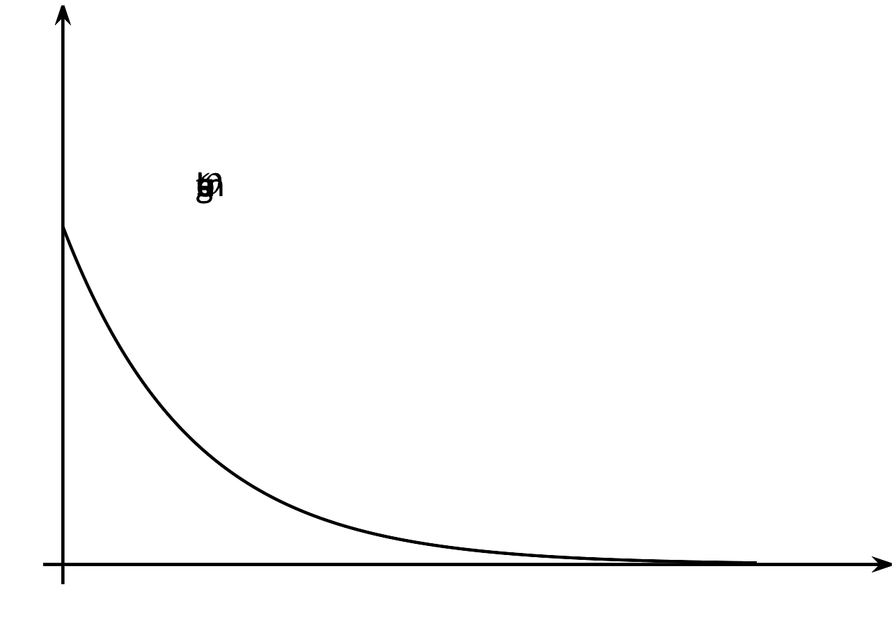

- B
- 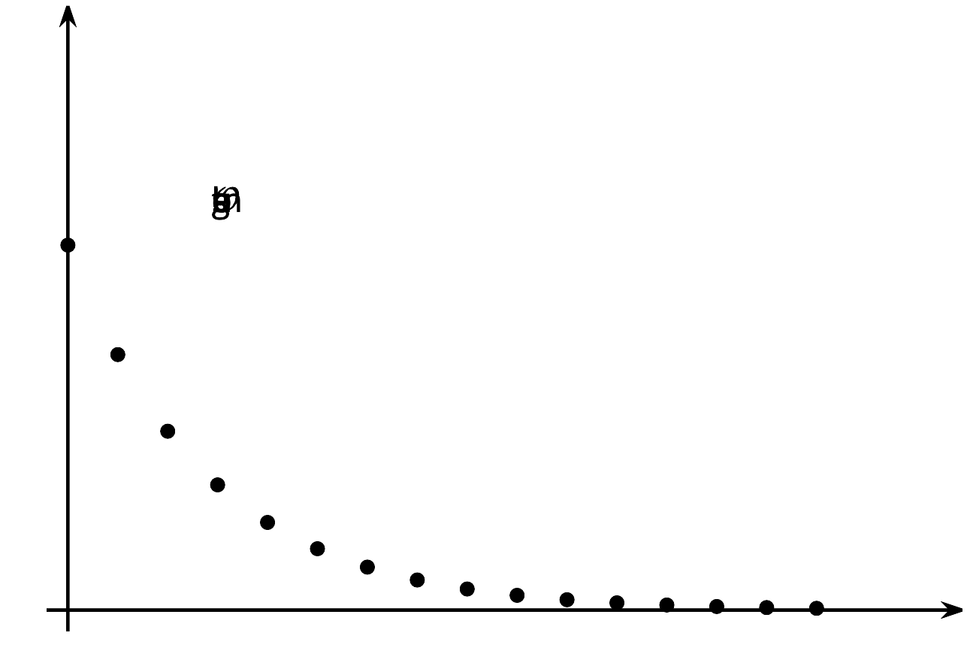
- Will the $n$-th bounce of this ball be lower than the $n$-th bounce of the tennis ball? Explain your reasoning.

Lesson 11 Summary
Sometimes data suggest an exponential relationship. For example, this table shows the bounce heights of a certain ball. We can see that the height decreases with each bounce.
To find out what fraction of the height remains after each bounce, we can divide two consecutive values: $\frac{61}{95}$ is about 0.642, $\frac{39}{61}$ is about 0.639, and $\frac{26}{39}$ is about 0.667.
All of these quotients are close to $\frac{2}{3}$. This suggests that there is an exponential relationship between the number of bounces and the height of the bounce, and that the height is decreasing with a factor of about $\frac{2}{3}$ for each successive bounce.
bounce number | bounce height  in centimeters
1 | 95
2 | 61
3 | 39
4 | 26
The height $h$ of the ball, in cm, after $n$ bounces can be modeled by the equation:
$h=142⋅{\left(\frac{2}{3}\right)}^{n}$
Here is a graph of the equation.
This graph shows both the points from the data and the points generated by the equation, which can give us new insights. For example, the height from which the ball was dropped is not given but can be determined. If $\frac{2}{3}$ of the initial height is about 95 centimeters, then that initial height is about 142.5 centimeters, because $95÷\frac{2}{3}=142.5$. For a second example, we can see that it will take 7 bounces before the rebound height is less than 10 centimeters.
© CC BY 2019 by Illustrative Mathematics®

