Lesson 17 Practice Problems
- Here is a system of equations: $\left\{\begin{matrix}3x−y=17 \\ x+4y=10\end{matrix}\right.$
  - Solve the system by graphing the equations (by hand or using technology).
  - Explain how you could tell, without graphing, that there is only one solution to the system.
- Consider this system of linear equations: $\left\{\begin{matrix}y=\frac{4}{5}x−3 \\ y=\frac{4}{5}x+1\end{matrix}\right.$
  - Without graphing, determine how many solutions you would expect this system of equations to have. Explain your reasoning.
  - Try solving the system of equations algebraically and describe the result that you get. Does it match your prediction?
- How many solutions does this system of equations have? Explain how you know.
- $\left\{\begin{matrix}9x−3y=\text{-}6 \\ 5y=15x+10\end{matrix}\right.$
- Select all systems of equations that have no solutions.
  - $\left\{\begin{matrix}y=5−3x \\ y=\text{-}3x+4\end{matrix}\right.$
  - $\left\{\begin{matrix}y=4x−1 \\ 4y=16x−4\end{matrix}\right.$
  - $\left\{\begin{matrix}5x−2y=3 \\ 10x−4y=6\end{matrix}\right.$
  - $\left\{\begin{matrix}3x+7y=42 \\ 6x+14y=50\end{matrix}\right.$
  - $\left\{\begin{matrix}y=5+2x \\ y=5x+2\end{matrix}\right.$
- Solve each system of equations without graphing.
  - $\left\{\begin{matrix}2v+6w=\text{-}36 \\ 5v+2w=1\end{matrix}\right.$
  - $\left\{\begin{matrix}6t−9u=10 \\ 2t+3u=4\end{matrix}\right.$
- (From Unit 2, Lesson 16.)
- Select all the dot plots that appear to contain outliers.
  - 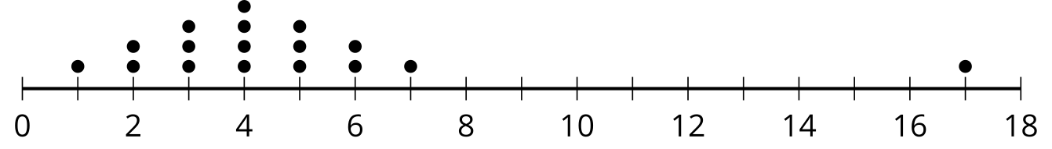
  - 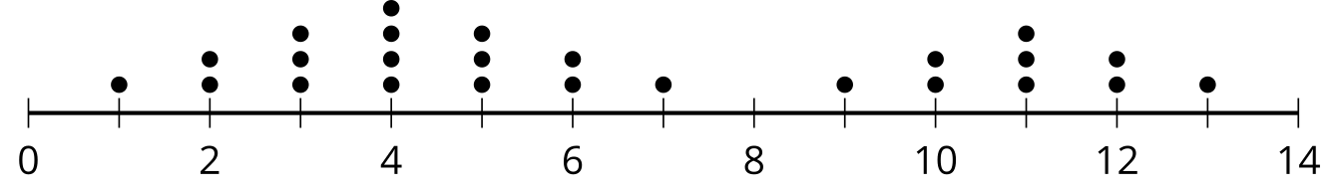
  - 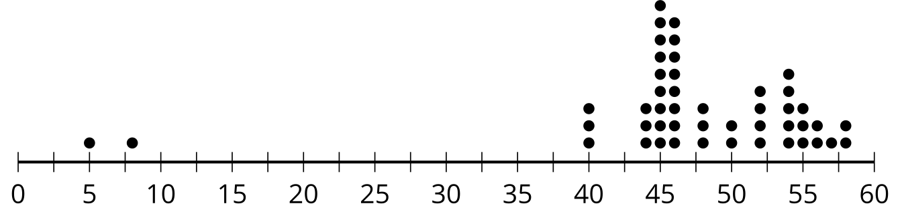
  - 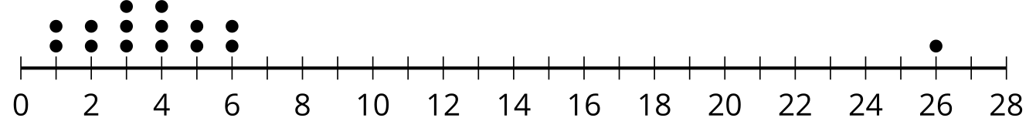
  - 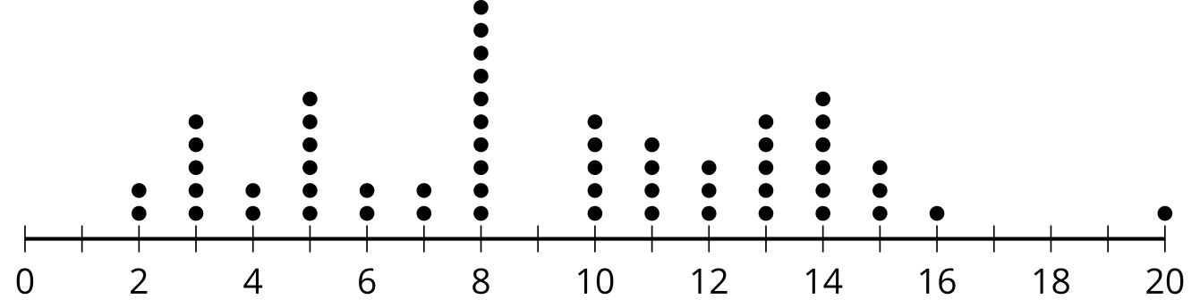
- (From Unit 1, Lesson 14.)
- Here is a system of equations: $\left\{\begin{matrix}\text{-}x+6y=9 \\ x+6y=\text{-}3\end{matrix}\right.$
- Would you rather use subtraction or addition to solve the system? Explain your reasoning.
- (From Unit 2, Lesson 14.)
- Here is a system of linear equations: $\left\{\begin{matrix}6x−y=18 \\ 4x+2y=26\end{matrix}\right.$
- Select all the steps that would help to eliminate a variable and enable solving.
  - Multiply the first equation by 2, then subtract the second equation from the result.
  - Multiply the first equation by 4 and the second equation by 6, then subtract the resulting equations.
  - Multiply the first equation by 2, then add the result to the second equation.
  - Divide the second equation by 2, then add the result to the first equation.
  - Multiply the second equation by 6, then subtract the result from the first equation.
- (From Unit 2, Lesson 16.)
- Consider this system of equations, which has one solution: $\left\{\begin{matrix}\begin{matrix}2x+2y & =180 \\ 0.1x+7y & = 78\end{matrix}\end{matrix}\right.$
- Here are some equivalent systems. Each one is a step in solving the original system.
- Step 1:
- $\left\{\begin{matrix}\begin{matrix}7x+7y & =630 \\ 0.1x+7y & = 78\end{matrix}\end{matrix}\right.$
- Step 2:
- $\left\{\begin{matrix}\begin{matrix}6.9x & =552 \\ 0.1x+7y & = 78\end{matrix}\end{matrix}\right.$
- Step 3:
- $\left\{\begin{matrix}\begin{matrix}x & =80 \\ 0.1x+7y & =78\end{matrix}\end{matrix}\right.$
  - Look at the original system and the system in Step 1.
    - What was done to the original system to get the system in Step 1?
    - Explain why the system in Step 1 shares a solution with the original system.
  - Look at the system in Step 1 and the system in Step 2.
    - What was done to the system in Step 1 to get the system in Step 2?
    - Explain why the system in Step 2 shares a solution with that in Step 1.
  - What is the solution to the original system?
- (From Unit 2, Lesson 16.)
© CC BY 2019 by Illustrative Mathematics®

