Lesson 20: Changes over Equal Intervals
Let's explore how linear and exponential functions change over equal intervals.

20.1: Writing Equivalent Expressions
For each given expression, write an equivalent expression with as few terms as possible.
- $7p−3+2\left(p+1\right)$
- $[4\left(n+1\right)+10]−4\left(n+1\right)$
- $9^{5}⋅9^{2}⋅9^{x}$
- $\frac{2^{4n}}{2^{n}}$

20.2: Outputs of A Linear Function
Here is a graph of $y=f\left(x\right)$ where $f\left(x\right)=2x+5$.

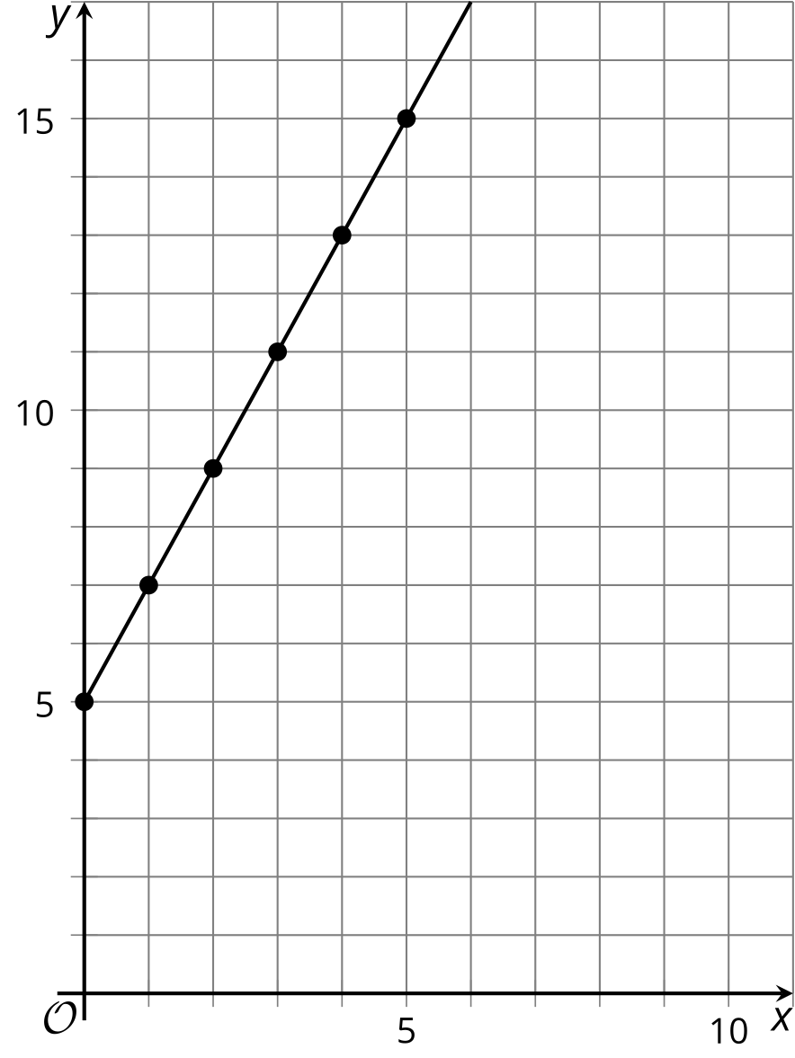

- How do the values of $f$ change whenever $x$ increases by 1, for instance, when it increases from 1 to 2, or from 19 to 20? Be prepared to explain or show how you know.
- Here is an expression we can use to find the difference in the values of $f$ when the input changes from $x$ to $x+1$.
- $[2\left(x+1\right)+5]−[2x+5]$
- Does this expression have the same value as what you found in the previous questions? Show your reasoning.

  - How do the values of $f$ change whenever $x$ increases by 4? Explain or show how you know.
  - Write an expression that shows the change in the values of $f$ when the input value changes from $x$ to $x+4$.
  - Show or explain how that expression has a value of 8.

20.3: Outputs of An Exponential Function
Here is a table that shows some input and output values of an exponential function $g$. The equation $g\left(x\right)=3^{x}$ defines the function.
$x$ | $g\left(x\right)$
3 | 27
4 | 81
5 | 243
6 | 729
7 | 2,187
8 | 6,561
$x$
$x+1$
- How does $g\left(x\right)$ change every time $x$ increases by 1? Show or explain your reasoning.
- Choose two new input values that are consecutive whole numbers and find their output values. Record them in the table. How do the output values change for those two input values?
- Complete the table with the output when the input is $x$ and when it is $x+1$.
- Look at the change in output values as the $x$ increases by 1. Does it still agree with your findings earlier? Show your reasoning.
- Pause here for a class discussion. Then, work with your group on the next few questions.
- Choose two $x$-values where one is 3 more than the other (for example, 1 and 4). How do the output values of $g$ change as $x$ increases by 3? (Each group member should choose a different pair of numbers and study the outputs.)
- Complete this table with the output when the input is $x$ and when it is $x+3$. Look at the change in output values as $x$ increases by 3. Does it agree with your group's findings in the previous question? Show your reasoning.
- $x$ | - $g\left(x\right)$
- $x$
- $x+3$

Are you ready for more?
For integer inputs, we can think of multiplication as repeated addition and exponentiation as repeated multiplication:
$3⋅5=3+3+3+3+3 \text{ and } 3^{5}=3⋅3⋅3⋅3⋅3$
We could continue this process with a new operation called tetration. It uses the symbol $↑↑$, and is defined as repeated exponentiation:
$3↑↑5=3^{3^{3^{3^{3}}}}.$
Compute $2↑↑3$ and $3↑↑2$. If $f\left(x\right)=3↑↑x$, what is the relationship between $f\left(x\right)$ and $f\left(x+1\right)$?

Lesson 20 Summary
Linear and exponential functions each behave in a particular way every time their input value increases by the same amount.
Take the linear function $f$ defined by $f\left(x\right)=5x+3$. The graph of this function has a slope of 5. That means that each time $x$ increases by 1, $f\left(x\right)$ increases by 5. For example, the points $\left(7,38\right)$ and $\left(8,43\right)$ are both on the graph. When $x$ increases by 1 (from 7 to 8), $y$ increases by 5 (because $43−38=5$). We can show algebraically that this is always true, regardless of what value $x$ takes.
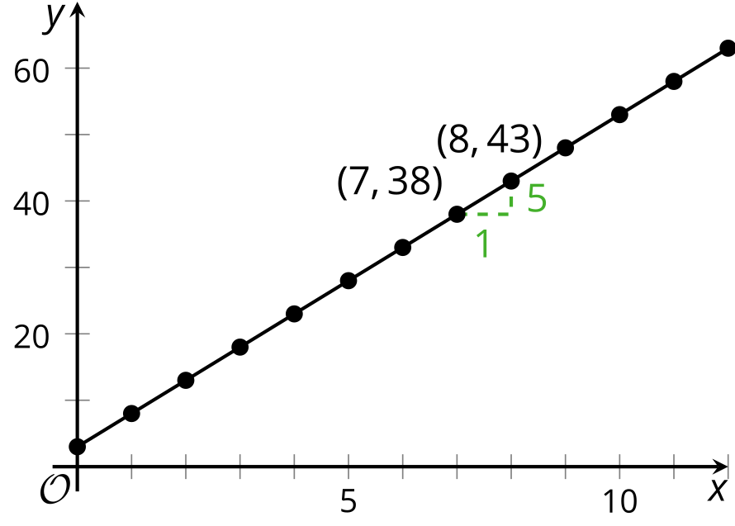
The value of $f$ when $x$ increases by 1, or $f\left(x+1\right)$, is $5\left(x+1\right)+3$. Subtracting $f\left(x+1\right)$ and $f\left(x\right)$, we have:
$\begin{matrix}f\left(x+1\right)−f\left(x\right)=5\left(x+1\right)+3−\left(5x+3\right) \\ =5x+5+3−5x−3 \\ =5\end{matrix}$
This tells us that whenever $x$ increases by 1, the difference in the output is always 5. In the lesson, we also saw that when $x$ increases by an amount other than 1, the output always increases by the same amount if the function is linear.
Now let's look at an exponential function $g$ defined by $g\left(x\right)=2^{x}$. If we graph $g$, we see that each time $x$ increases by 1, the value $g\left(x\right)$ doubles. We can show algebraically that this is always true, regardless of what value $x$ takes.
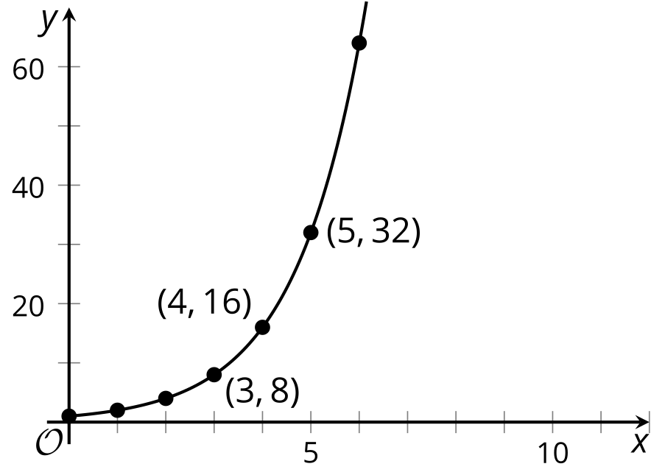
The value of $g$ when $x$ increases by 1, or $g\left(x+1\right)$, is $2^{x+1}$. Dividing $g\left(x+1\right)$ by $g\left(x\right)$, we have:
$\begin{matrix}\frac{g\left(x+1\right)}{g\left(x\right)}=\frac{2^{\left(x+1\right)}}{2^{x}} \\ =2^{x+1−x} \\ =2^{1} \\ =2\end{matrix}$
This means that, whenever $x$ increases by 1, the value of $g$ always increases by a multiple of 2. In the lesson, we also saw that when $x$ increases by an amount other than 1, the output always increases by the same factor if the function is exponential.
A linear function always increases (or decreases) by the same amount over equal intervals. An exponential function increases (or decreases) by equal factors over equal intervals.
© CC BY 2019 by Illustrative Mathematics®

