Unit 6 Lesson 10: All Sorts of Denominators

WU How Many Do You See: Fraction Sum (Warm up)

Student Task Statement
H​​​​ow many do you see? How do you see them?
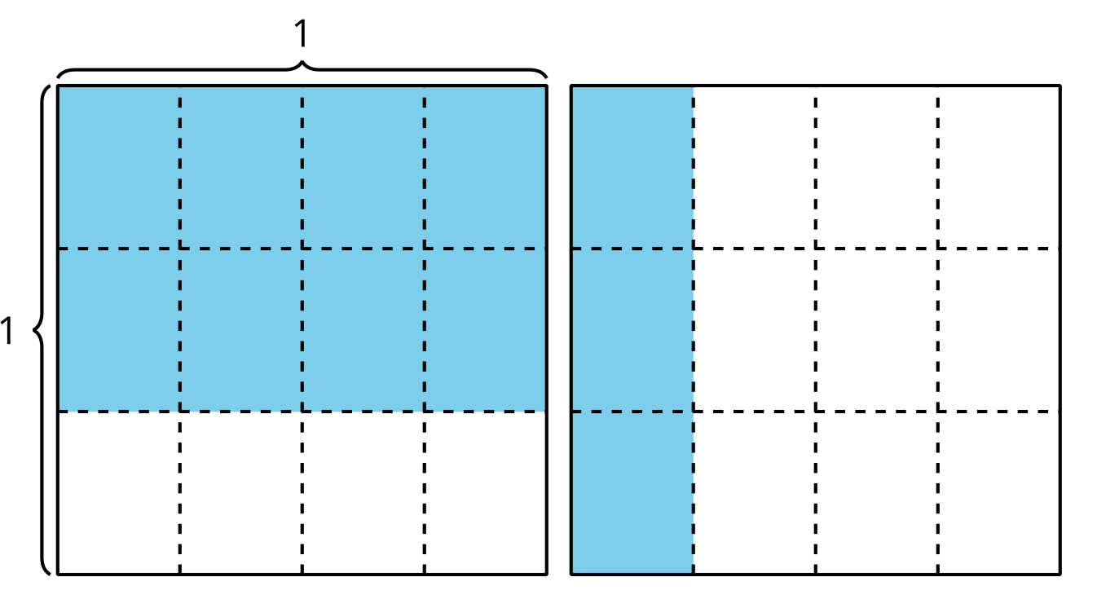

1 Different Denominators

Student Task Statement
Find the value of each expression. Explain or show your thinking.
- $\frac{3}{4}+\frac{7}{8}$
- $\frac{3}{4}+\frac{4}{6}$
- $\frac{3}{4}−\frac{2}{5}$

2 Multiply Denominators

Student Task Statement
- Here is Lin’s strategy for finding the value of $\frac{2}{5}+\frac{4}{9}$: “I know $5×9$ is a common denominator so I’ll use that.” Does Lin’s strategy for finding a common denominator work? Explain or show your thinking and then find the value of $\frac{2}{5}+\frac{4}{9}$.
- Find the value of each expression using a method that makes sense to you.
  - $\frac{3}{8}+\frac{1}{5}$
  - $\frac{7}{10}−\frac{2}{3}$
  - $\frac{7}{20}+\frac{41}{50}$
  - $\frac{2}{9}−\frac{1}{6}$
© CC BY 2021 Illustrative Mathematics®

