Lesson 10: Concepts of Division
- Let’s think about the size of quotients.

Warm-up: Number Talk: Same Dividend, Different Divisor
Find the value of each expression mentally.
- $120÷12$
- $120÷6$
- $120÷3$
- $120÷2$

10.1: Share Pretzels
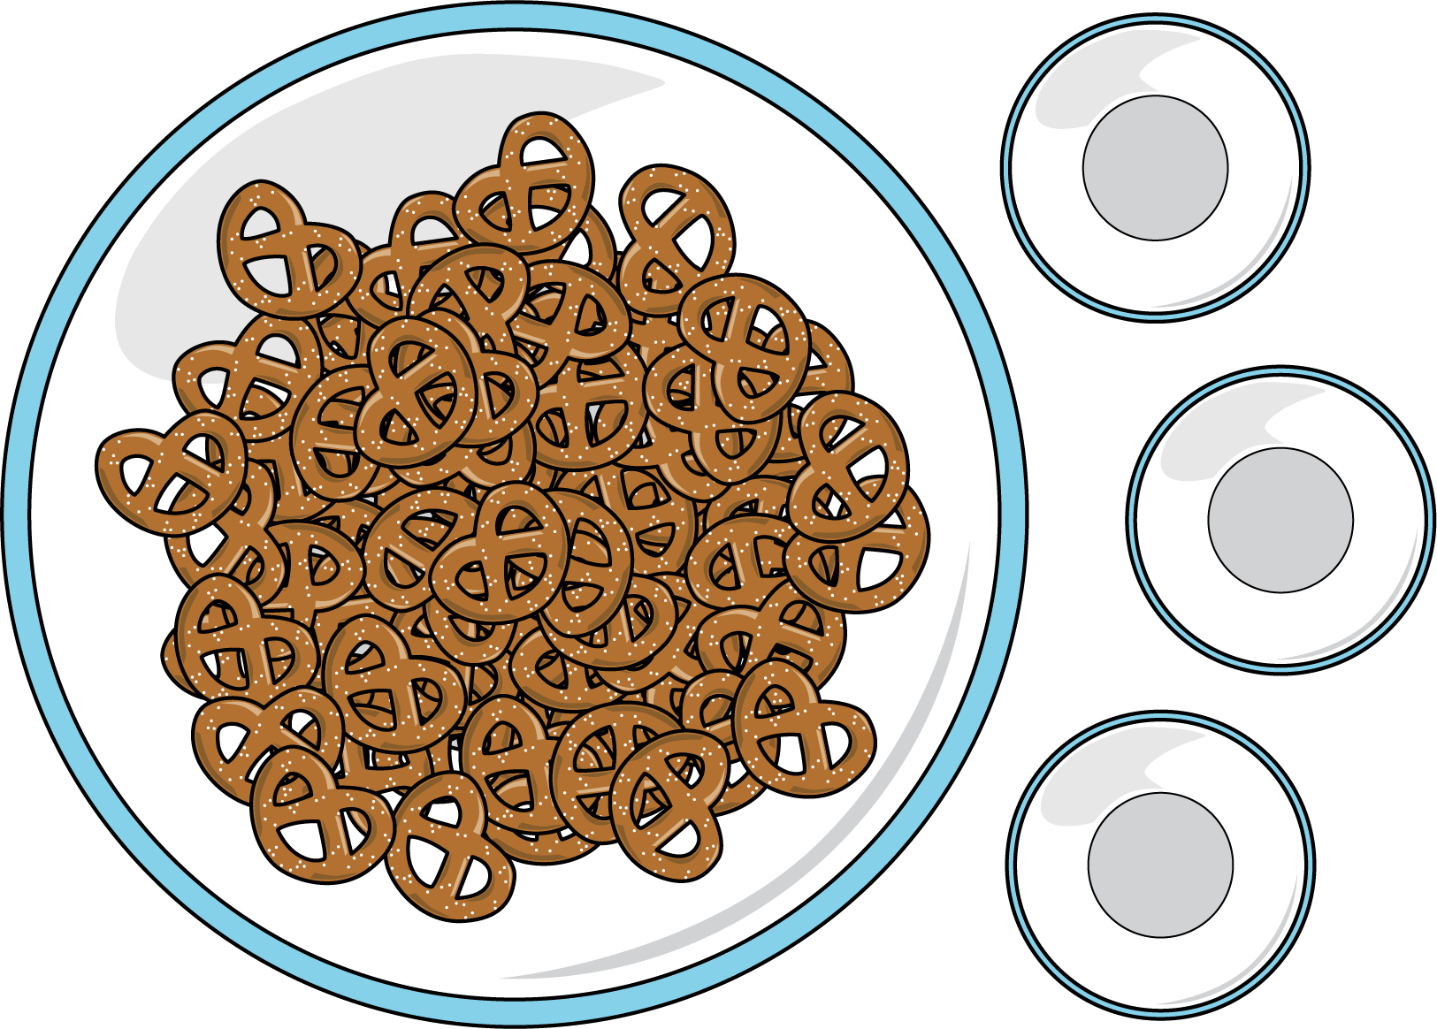
Order the situations from greatest to least based on the number of pretzels each student will get. Be prepared to explain your reasoning.
3 students equally share 42 pretzels.
14 students equally share 42 pretzels.
3 students equally share 24 pretzels.
3 students equally share 45 pretzels.
7 students equally share 42 pretzels.
3 students equally share 6 pretzels.
6 students equally share 42 pretzels.

10.2: Division Patterns
- Find the value of each expression.
  - $36÷3$
  - $12÷3$
  - $9÷3$
  - $6÷3$
  - $3÷3$
  - $1÷3$
- What patterns do you notice?
- Why is the quotient getting smaller?
- What do you know about this expression: $\frac{1}{3}÷3$?
- Draw a diagram to represent $\frac{1}{3}÷3$.
© CC BY 2021 Illustrative Mathematics®

