Lesson 6: Compare Story Problems
- Let’s solve compare story problems.

Warm-up: Which One Doesn’t Belong: Equations
Which one doesn’t belong?
- $10=6+4$
- $16−5=11$
- $11=6+4+1$
- $3+8=11$

6.1: The School Carnival
Solve each problem.
Show your thinking using drawings, numbers, or words.
- Lin has 7 tickets for rides.
Mai has 12 tickets.
How many more tickets does Mai have than Lin?
- The cotton candy booth sold 17 bags of blue cotton candy.
They sold 7 bags of pink cotton candy.
How many more bags of blue candy did they sell than pink candy?
- Tyler is picking out a prize.
There are 13 toys and 9 stuffed animals.
How many fewer stuffed animals are there than toys?
- The ferris wheel can hold 20 people.
The swings can hold 14 people.
How many fewer people can the swings hold than the ferris wheel?
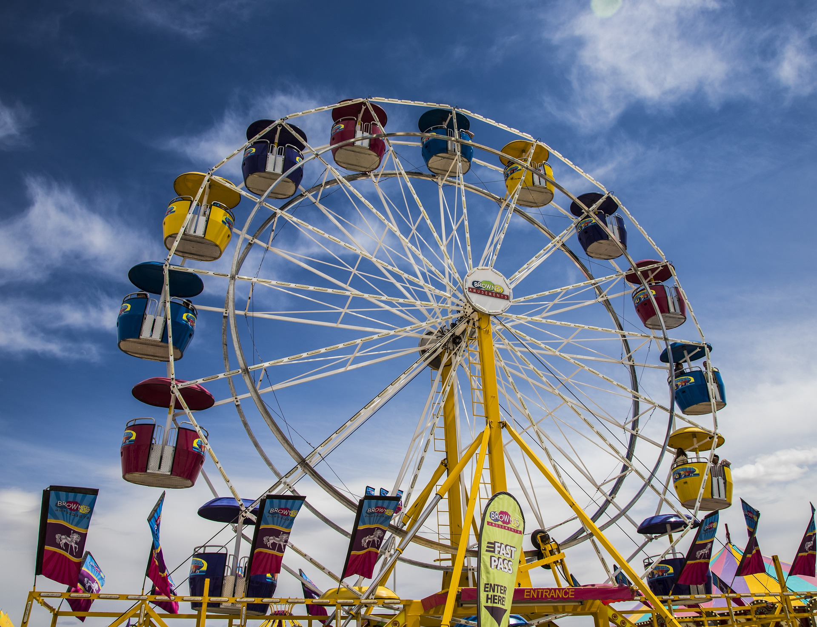

6.2: How Many Rides?
Write and answer 2 questions using the information.
Use the picture for the first one if it is helpful.
- Diego went on 7 rides.
Priya went on 11 rides.
- Jada went on 3 rides.
Kiran went on 6 rides.
Noah went on 9 rides.
© CC BY 2021 Illustrative Mathematics®

