Lesson 16: Subtract Within 1,000
- Let’s subtract in a way that makes sense.

Warm-up: True or False: Equations Based on Place Value
Decide if each statement is true or false. Be prepared to explain your reasoning.
- 2 hundreds $+$ 3 tens $+$ 4 ones $=$ 2 hundreds $+$ 3 tens $+$ 14 ones
- 2 hundreds $+$ 3 tens $+$ 4 ones $=$ 1 hundred $+$ 13 tens $+$ 4 ones
- 1 hundred $+$ 13 tens $+$ 4 ones $=$ 1 hundred $+$ 12 tens $+$ 14 ones

16.1: Jada’s Thinking
Lin’s diagram:
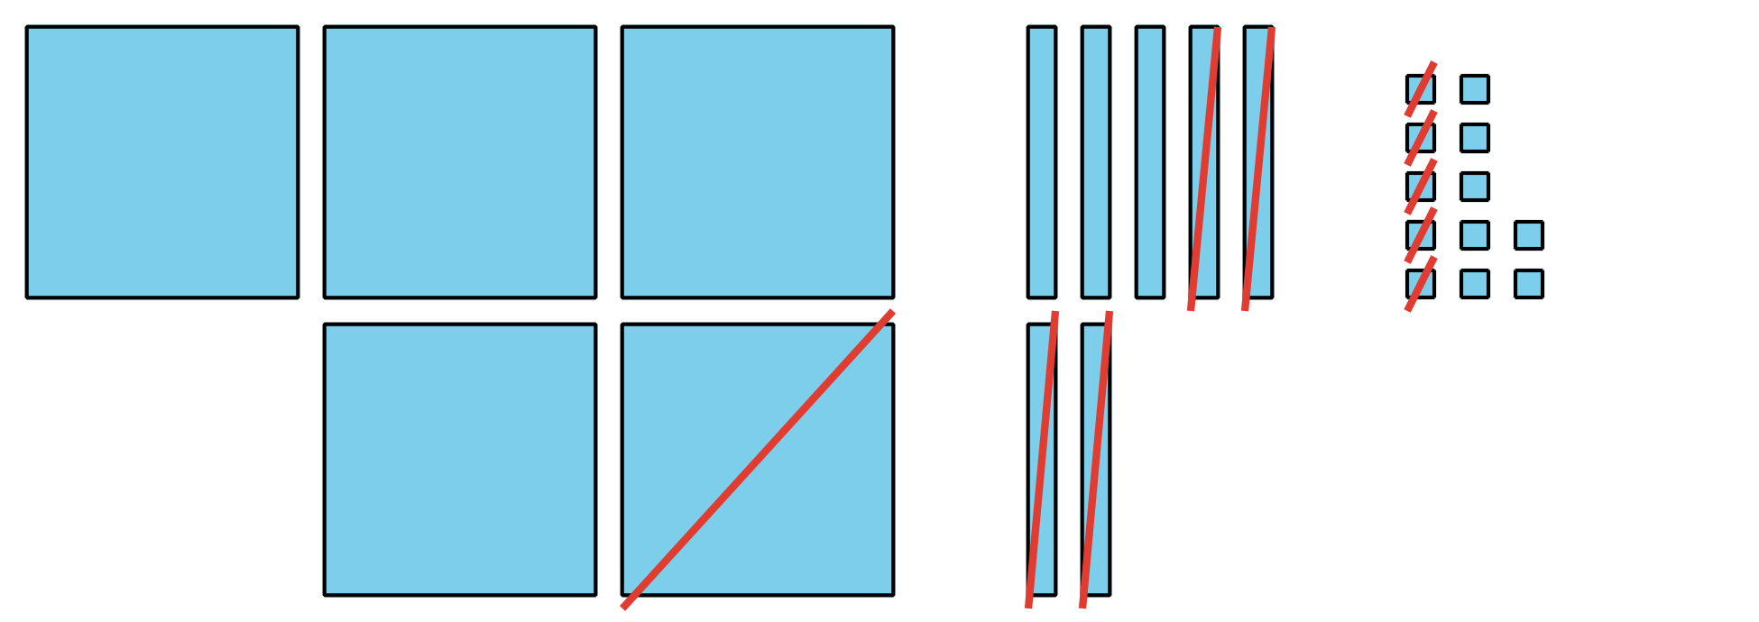
Jada’s equations:
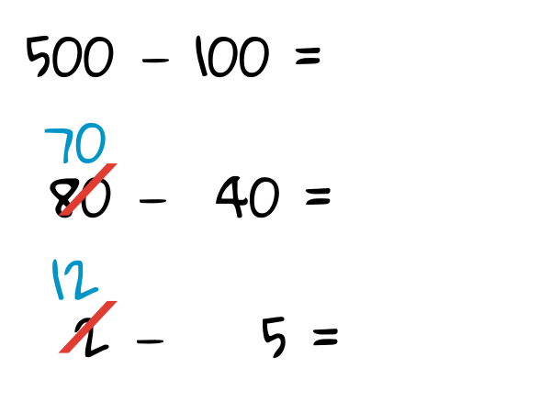

  - Discuss how Jada’s equations match Lin’s diagram.
  - Finish Jada’s work to find the value of $582−145.$
- Jada is thinking about how to find the value of $402−298.$
  - Jada says she knows a way to count on to find the difference. She showed her thinking using a number line.
  - 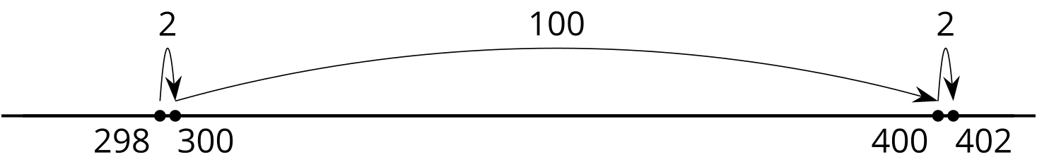
  - Explain Jada’s thinking.
  - Jada says you can’t decompose to find the value of $402−298$ because there aren’t any tens. Do you agree with Jada? Use base-ten blocks, diagrams, or other representations to show your thinking.

16.2: Find It Your Way
Find the value of each expression in a way that makes sense to you. Show your thinking. Organize it so it can be followed by others.
- $535−214$
- $700−589$
- $683−398$
- $918−608$
- $735−457$
- $602−487$

Section Summary
Section Summary
In this section of the unit, we learned many different ways to subtract three-digit numbers using what we know about place value. We used base-ten blocks, diagrams, and equations to show subtracting hundreds from hundreds, tens from tens, and ones from ones. We learned that when you subtract by place, you may decompose a hundred, a ten, or both. We learned that it is helpful to look closely at the numbers in an expression to plan how to decompose or to choose a method that helps us use friendly numbers or the relationship between addition and subtraction.
Base-ten Diagram for $256−64$
Unit Form for $726−558$
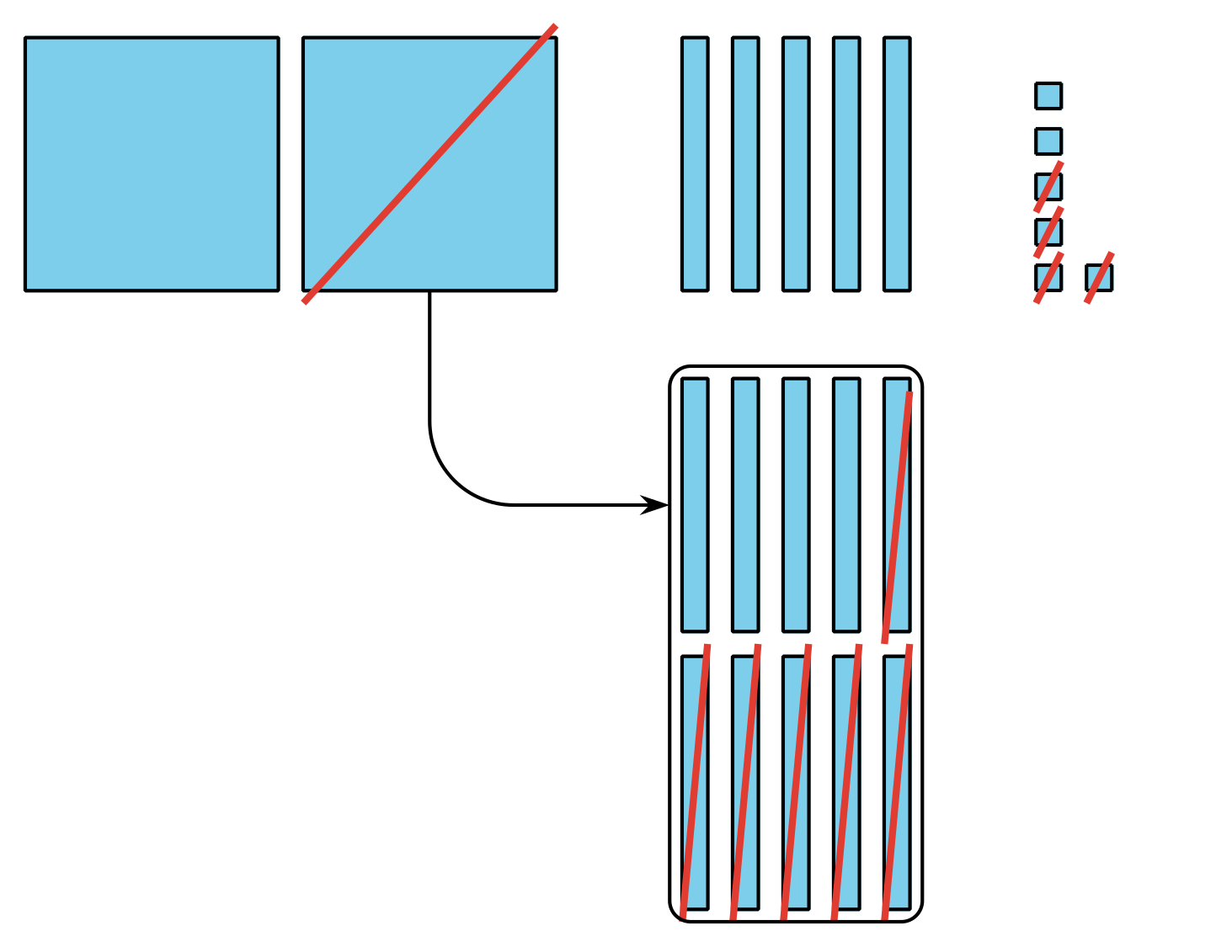
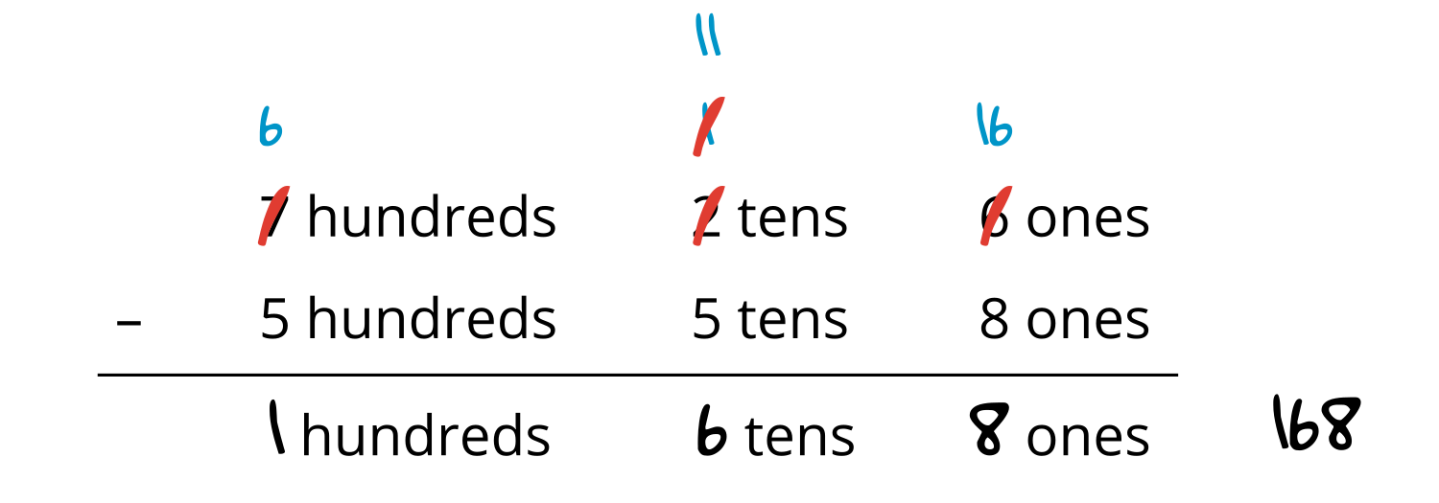
© CC BY 2021 Illustrative Mathematics®

