Unit 1 Lesson 1: Make Sense of Data

WU Notice and Wonder: Graphs (Warm up)

Student Task Statement
What do you notice? What do you wonder?
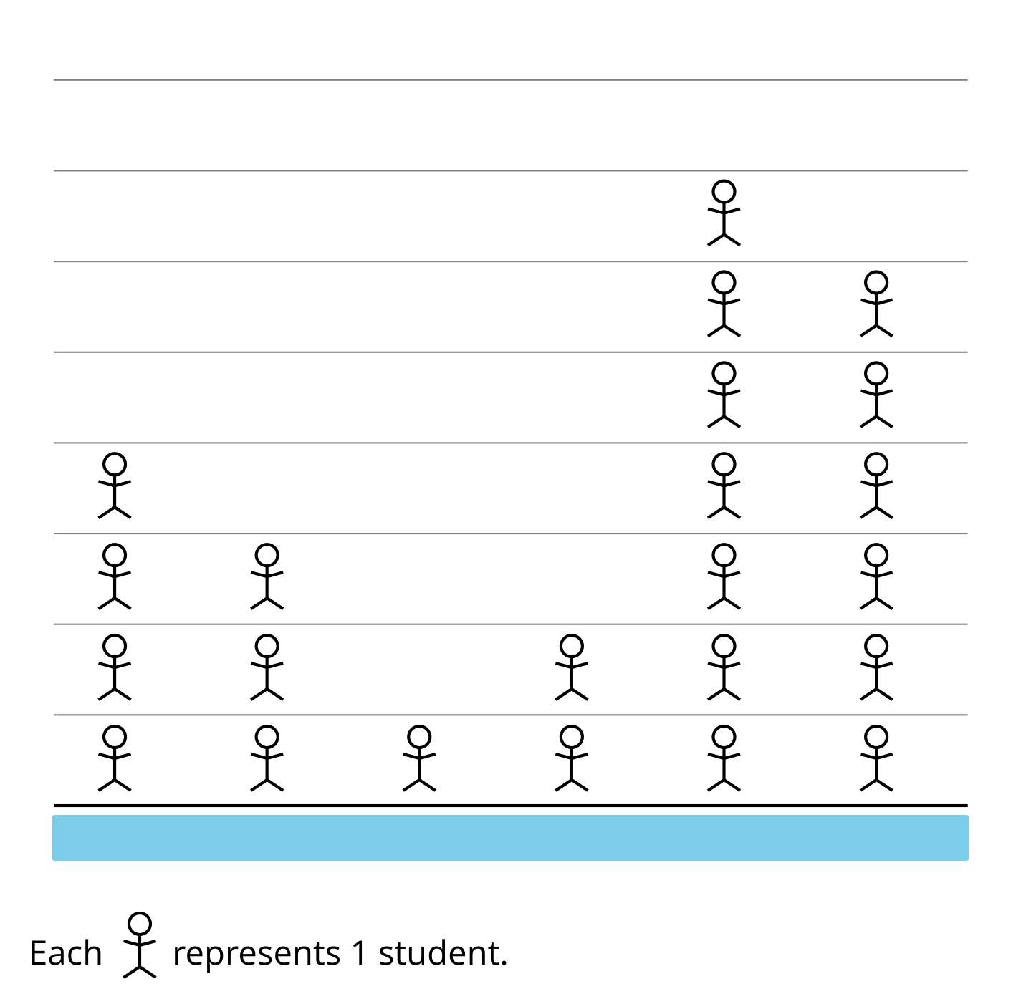

1 Picture Time

Student Task Statement
What could the categories be for this picture graph?
Be prepared to explain your reasoning.
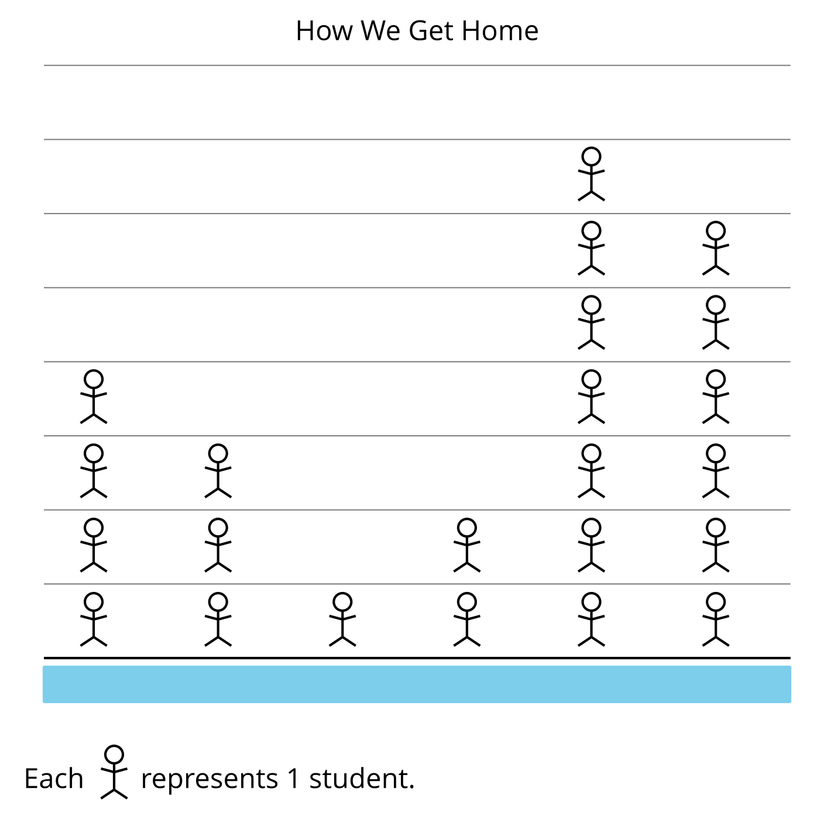

2 Picture Graphs and Bar Graphs

Student Task Statement
A group of students were asked, “How do you get home?” Their responses are shown in a picture graph and a bar graph.
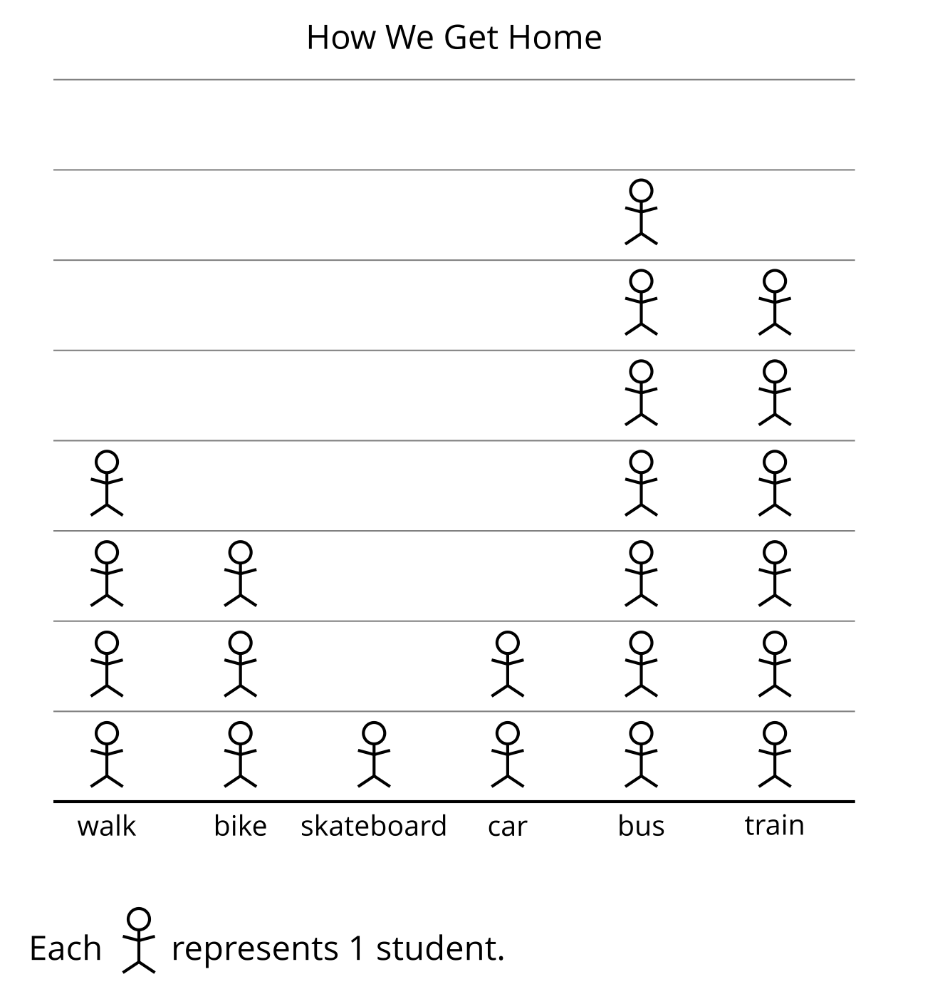
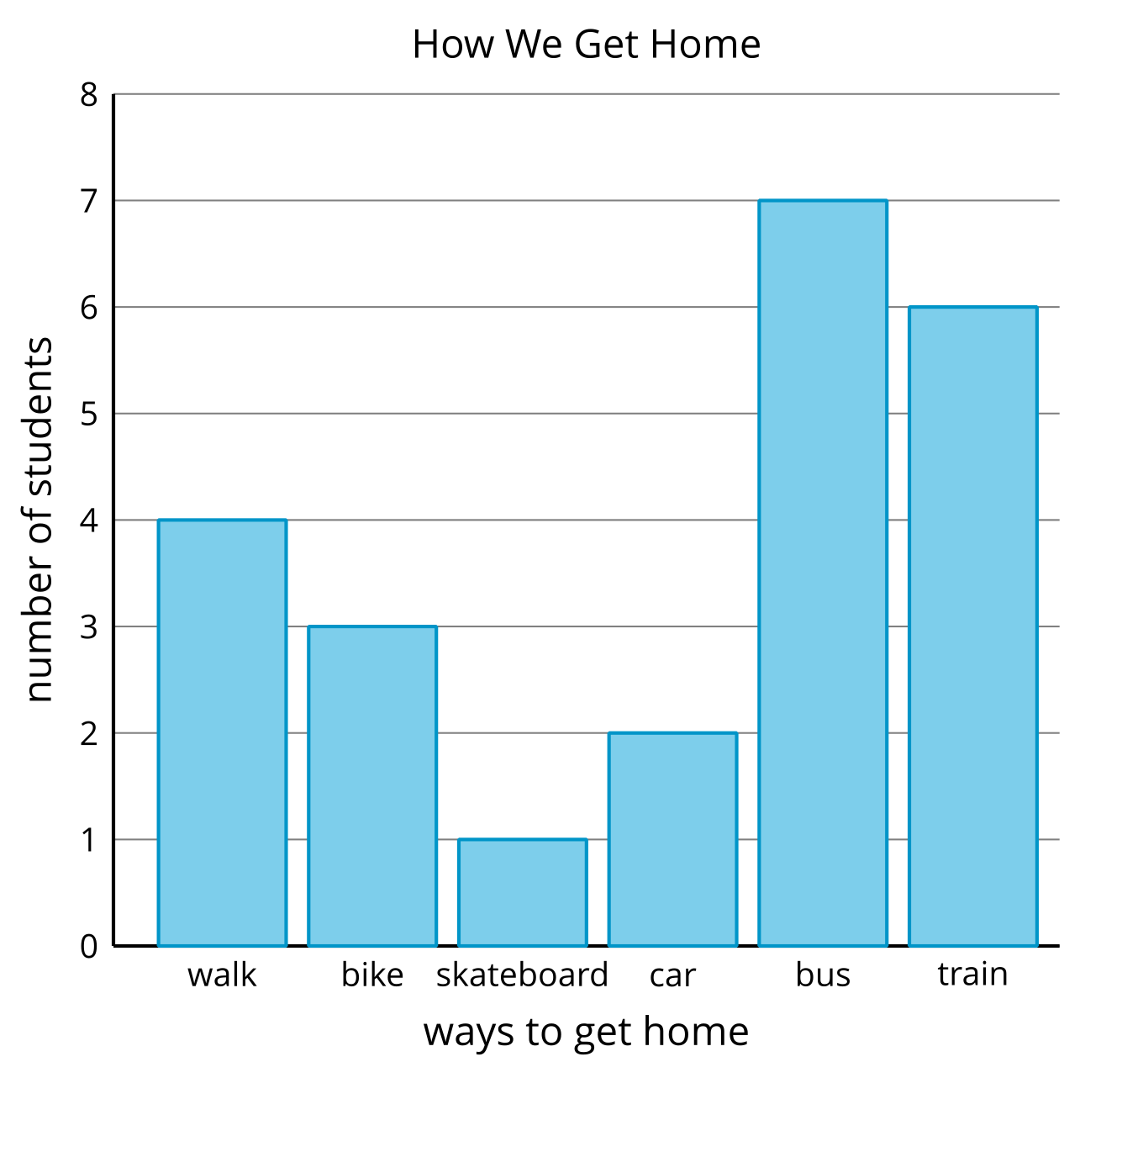
- How are the graphs the same? How are they different?
- What can we learn about how students get home based on the graphs?
- Write two questions you could ask about how students get home based on the graphs.
© CC BY 2021 Illustrative Mathematics®

