## Unit 8 Lesson 6: Finding Side Lengths of Triangles

### 1 Which One Doesn’t Belong: Triangles (Warm up)

#### Student Task Statement

Which triangle doesn’t belong?

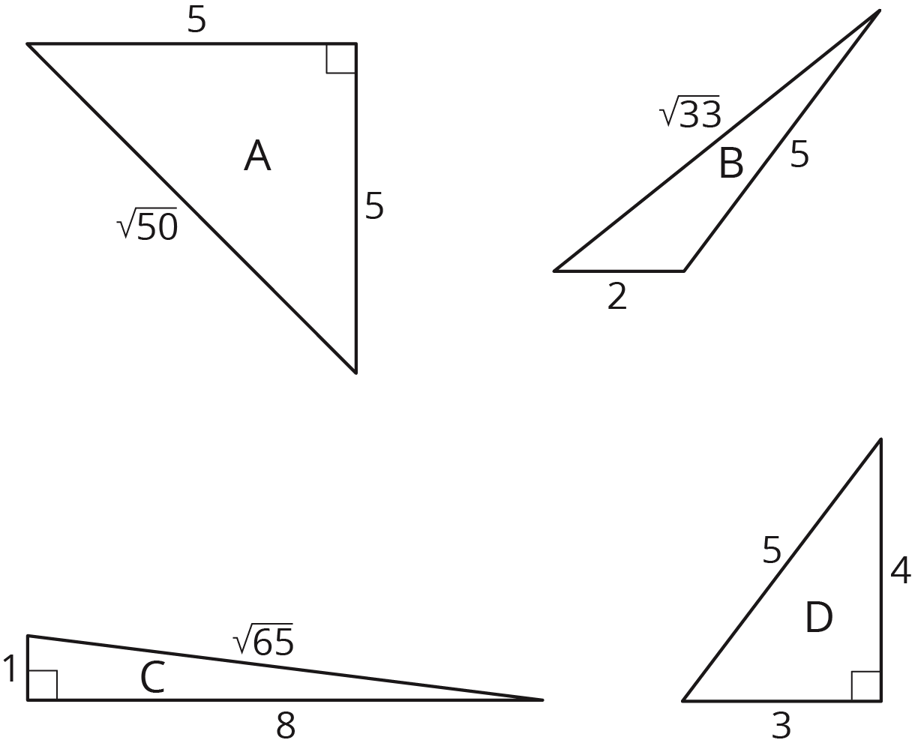

### 2 A Table of Triangles

#### Images for Launch

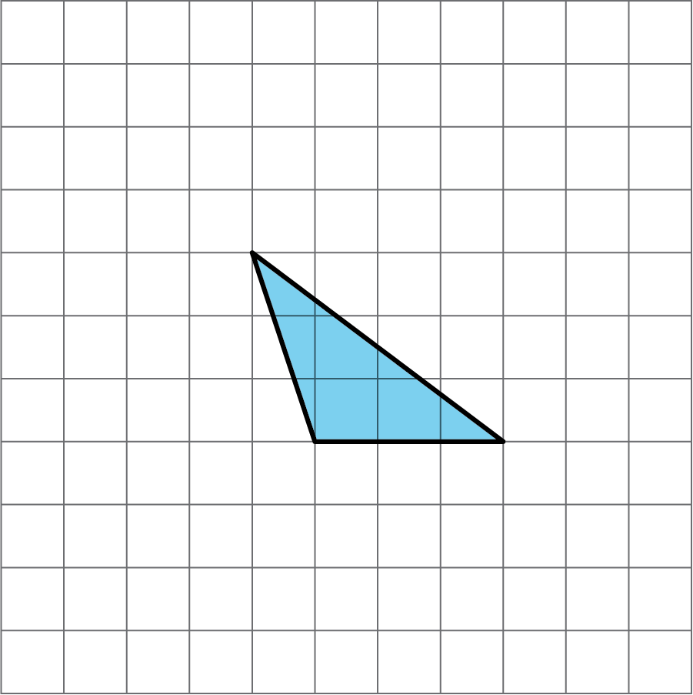

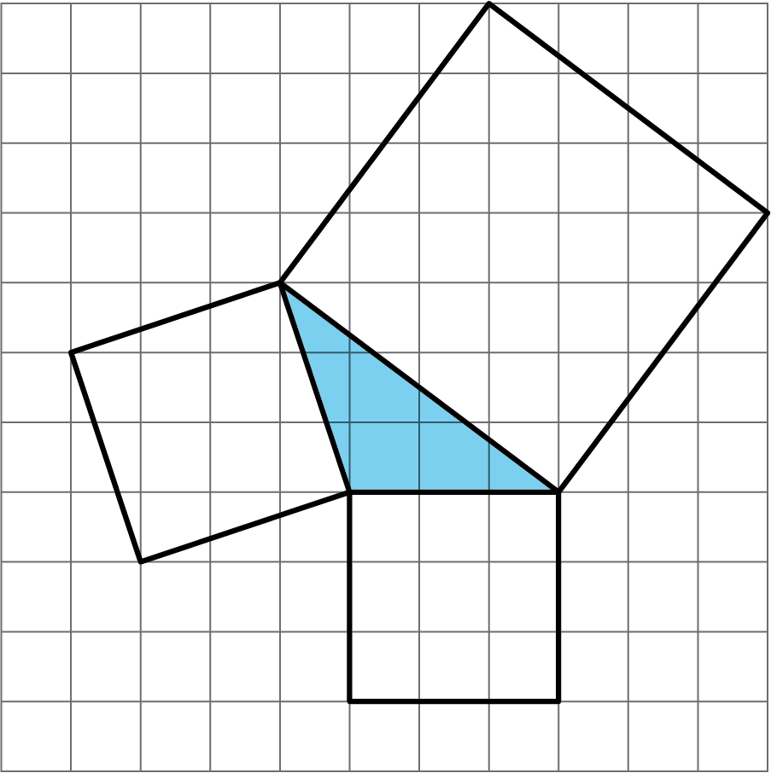

#### Student Task Statement

1. Complete the tables for these three triangles:

* 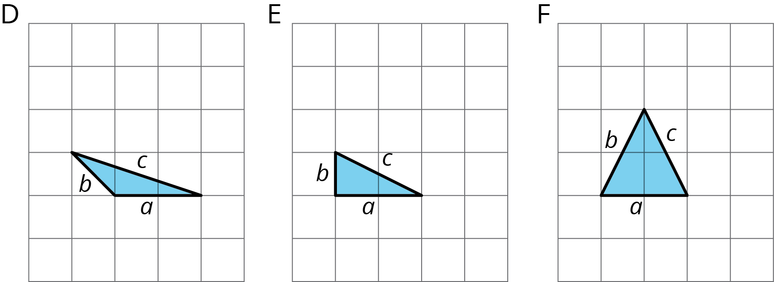

|  |  |  |  |
| --- | --- | --- | --- |
| * triangle |  |  |  |
| * D |  |  |  |
| * E |  |  |  |
| * F |  |  |  |

|  |  |  |  |
| --- | --- | --- | --- |
| * triangle |  |  |  |
| * D |  |  |  |
| * E |  |  |  |
| * F |  |  |  |

1. What do you notice about the values in the table for Triangle E but not for Triangles D and F?
2. Complete the tables for these three more triangles:

* 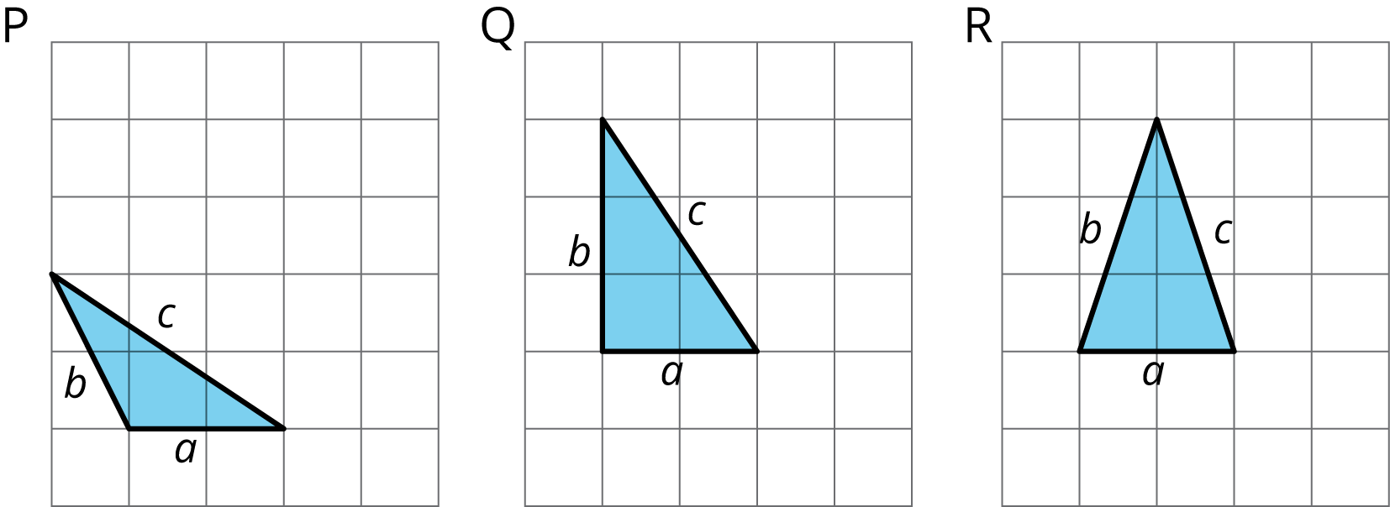

|  |  |  |  |
| --- | --- | --- | --- |
| * triangle |  |  |  |
| * P |  |  |  |
| * Q |  |  |  |
| * R |  |  |  |

|  |  |  |  |
| --- | --- | --- | --- |
| * triangle |  |  |  |
| * P |  |  |  |
| * Q |  |  |  |
| * R |  |  |  |

1. What do you notice about the values in the table for Triangle Q but not for Triangles P and R?
2. What do Triangle E and Triangle Q have in common?

### 3 Meet the Pythagorean Theorem

#### Student Task Statement

1. Find the missing side lengths. Be prepared to explain your reasoning.
2. For which triangles does ?

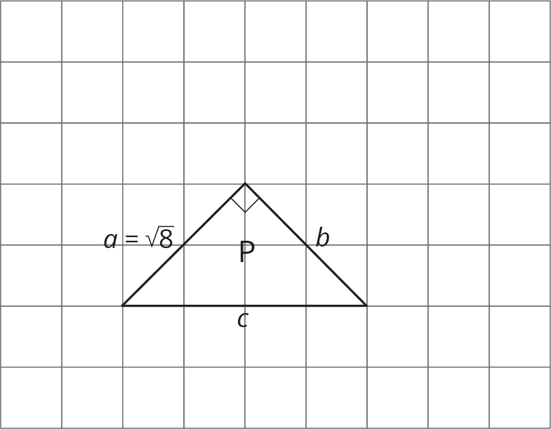

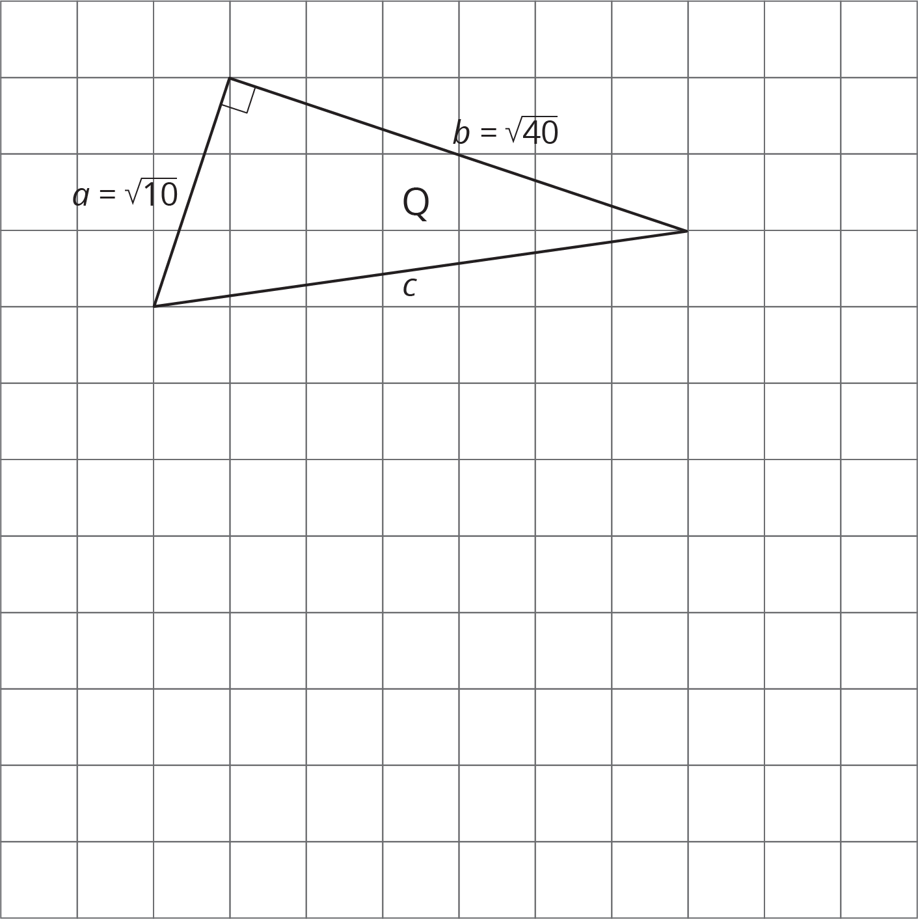

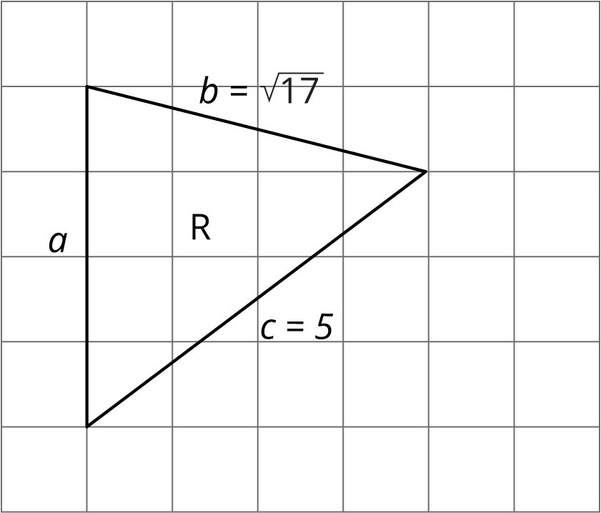



© CC BY Open Up Resources. Adaptations CC BY IM.