Unit 1 Lesson 9 Cumulative Practice Problems
- An image of a book shown on a website is 1.5 inches wide and 3 inches tall on a computer monitor. The actual book is 9 inches wide.
  - What scale is being used for the image?
  - How tall is the actual book?
- The flag of Colombia is a rectangle that is 6 ft long with three horizontal strips.
- 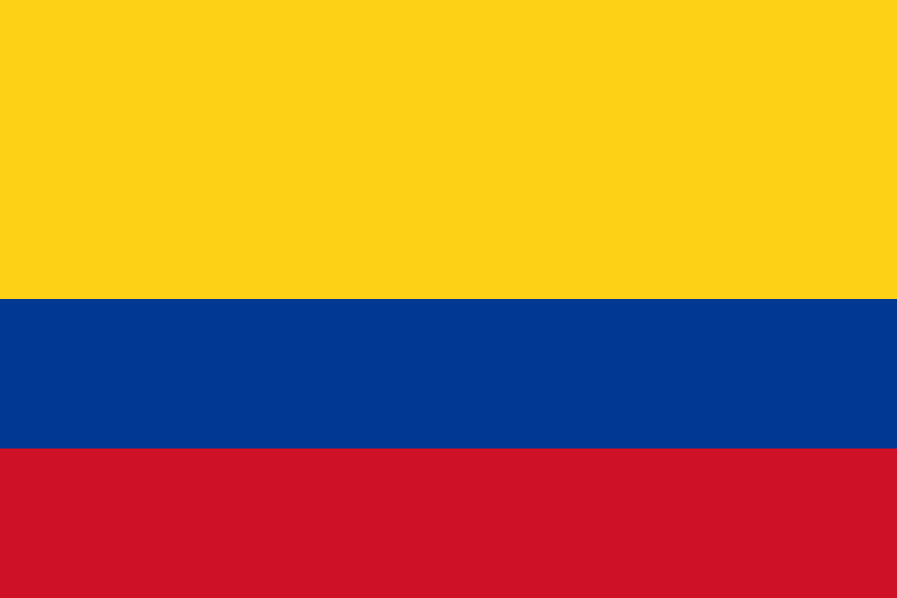
  - The top stripe is 2 ft tall and is yellow.
  - The middle stripe is 1 ft tall and is blue.
  - The bottom stripe is also 1 ft tall and is red.
  - Create a scale drawing of the Colombian flag with a scale of 1 cm to 2 ft.
  - Create a scale drawing of the Colombian flag with a scale of 2 cm to 1 ft.
- These triangles are scaled copies of each other.
- 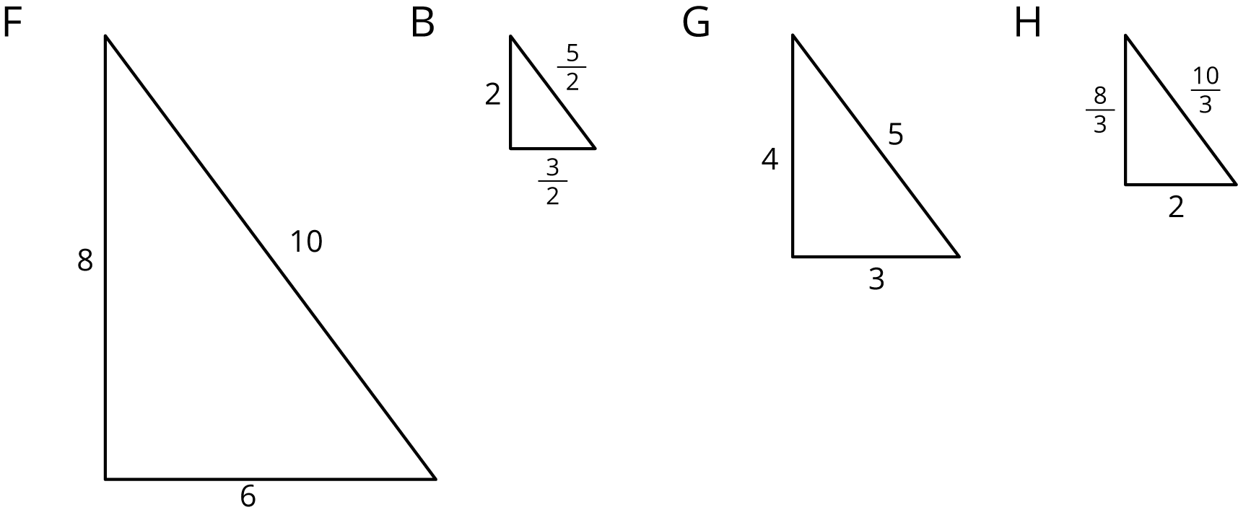
- For each pair of triangles listed, the area of the second triangle is how many times larger than the area of the first?
  - Triangle G and Triangle F
  - Triangle G and Triangle B
  - Triangle B and Triangle F
  - Triangle F and Triangle H
  - Triangle G and Triangle H
  - Triangle H and Triangle B
- (From Unit 1, Lesson 6.)
- Here is an unlabeled rectangle, followed by other quadrilaterals that are labeled.
- 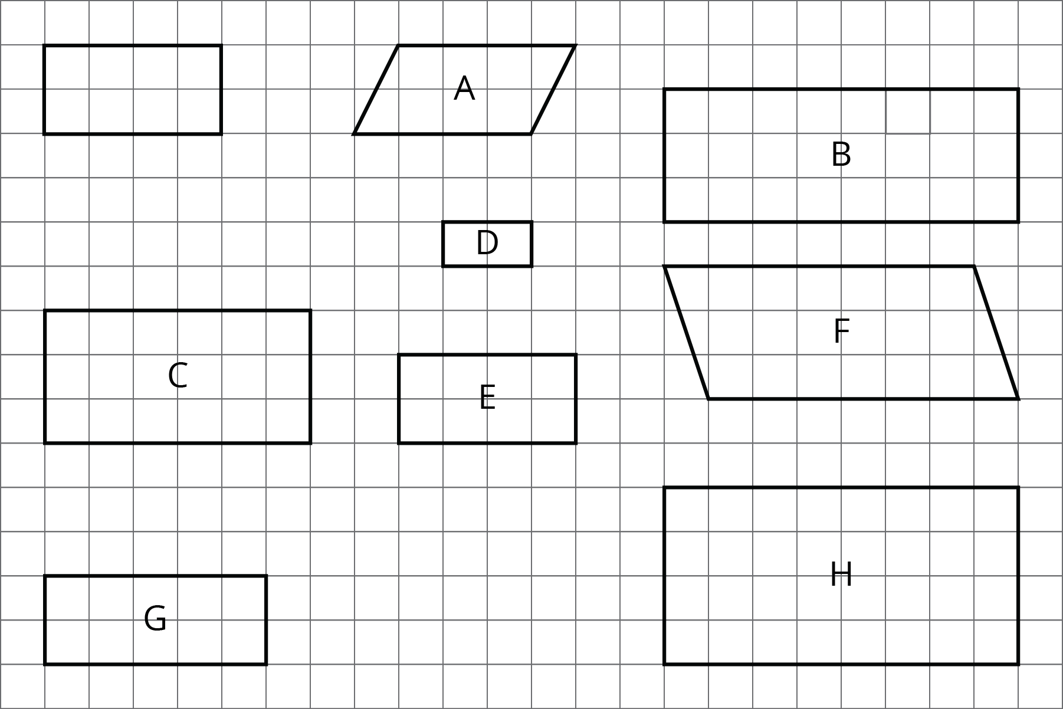
  - Select all quadrilaterals that are scaled copies of the unlabeled rectangle. Explain how you know.
  - On graph paper, draw a different scaled version of the original rectangle.
- (From Unit 1, Lesson 3.)
© CC BY Open Up Resources. Adaptations CC BY IM.

