Unit 1 Lesson 13: How Many Are There? (Part 2)

WU Questions About Us: Attendance (Warm up)

Student Task Statement

1 Counting Collections

Student Task Statement

2 Pair Objects and Numbers (Optional)

Student Task Statement

3 Centers: Choice Time

Student Task Statement
Choose a center.
Geoblocks
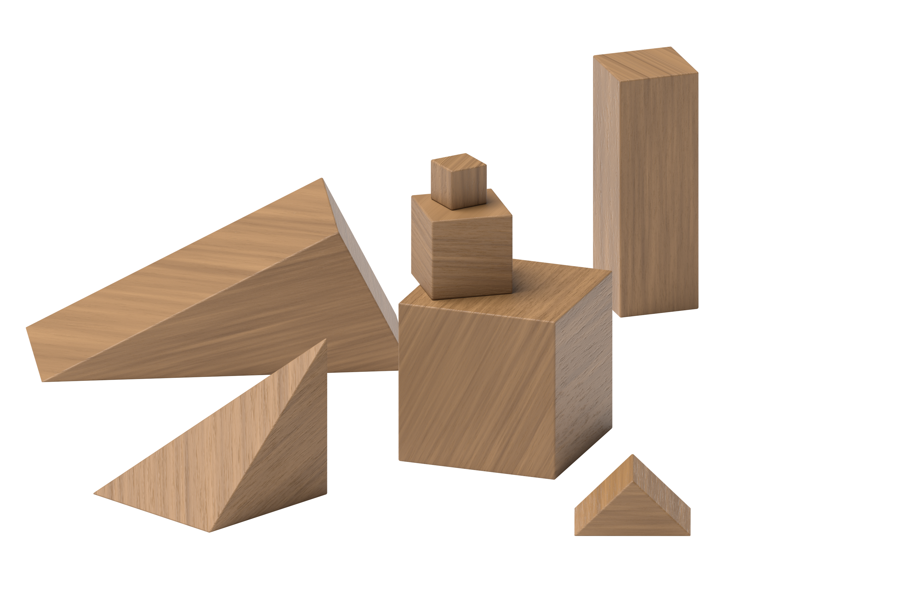
Connecting Cubes
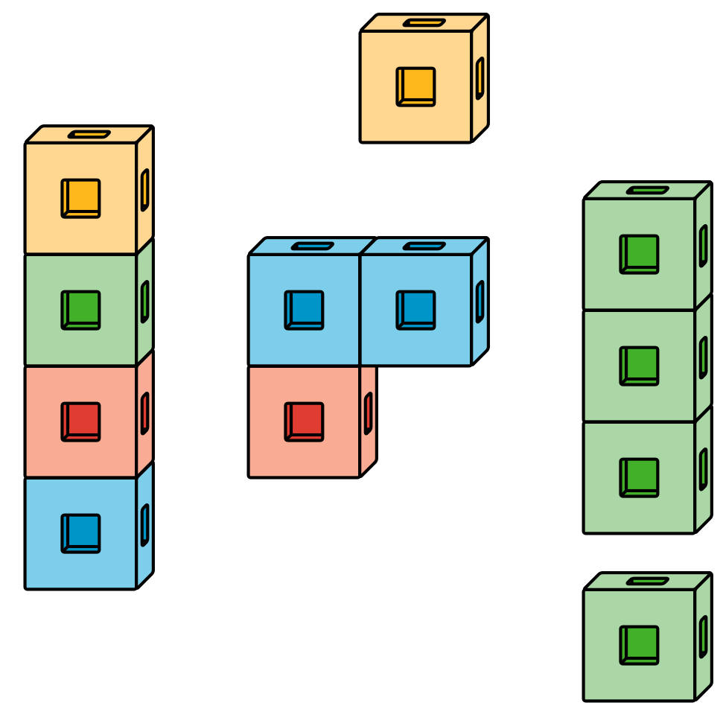
Pattern Blocks
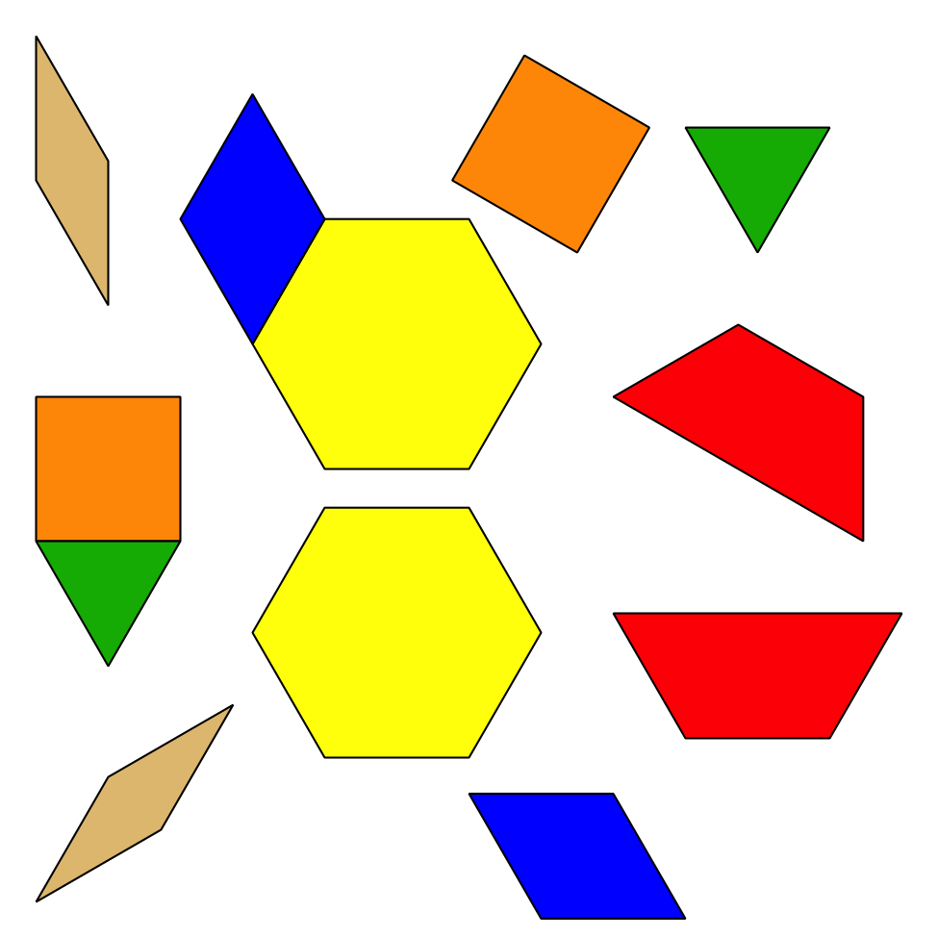
Picture Books
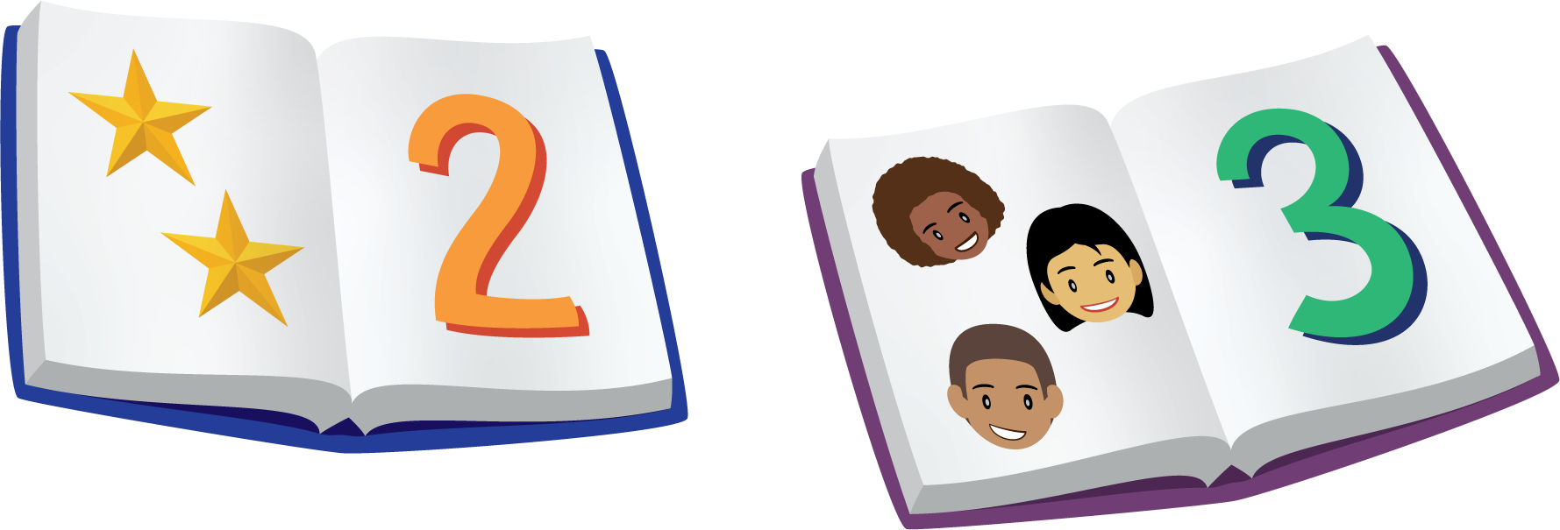
© CC BY 2021 Illustrative Mathematics®

