Lesson 11: Count Images (Part 1)
- Let’s find 10 shapes and figure out how many shapes there are.

11.1: Find 10 Ones to Count
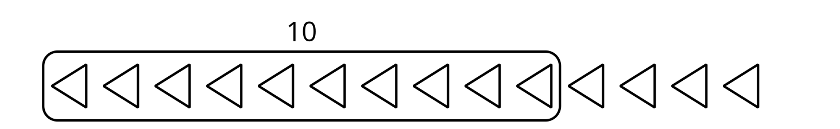

- There are _______________ squares.

- 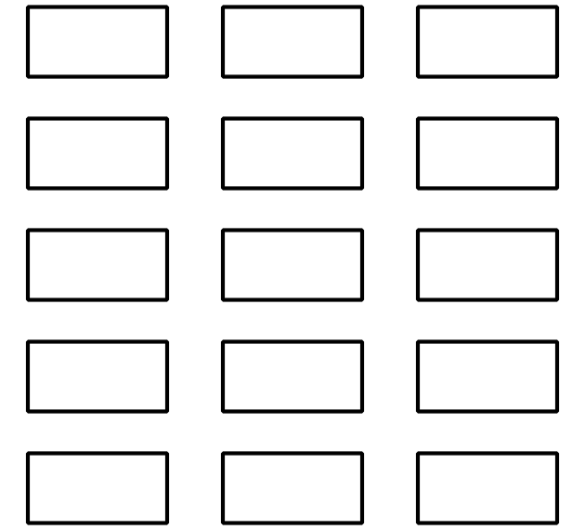
- There are _______________ rectangles.

- 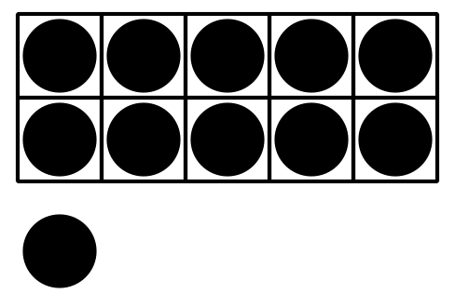
- There are _______________ dots.

- 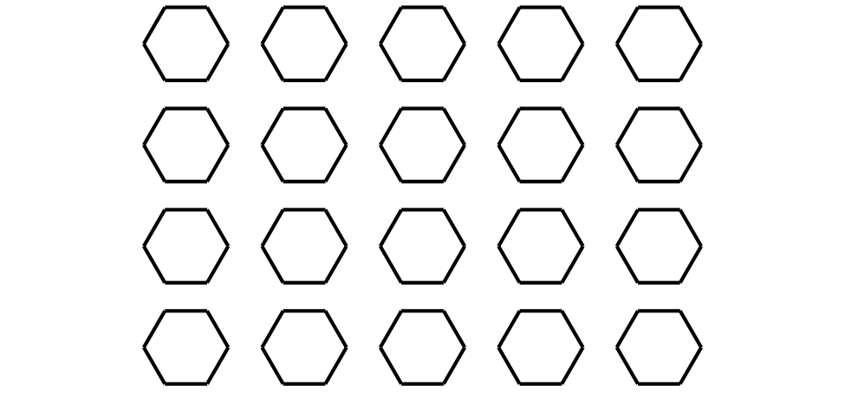
- There are _______________ hexagons.

- 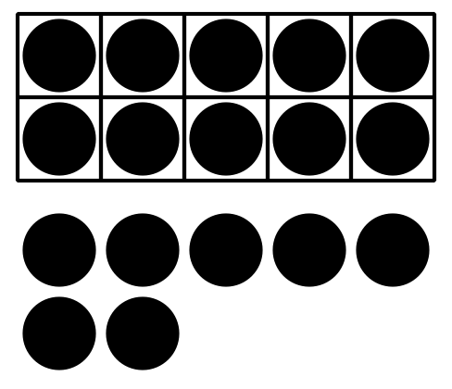
- There are _______________ dots.

- 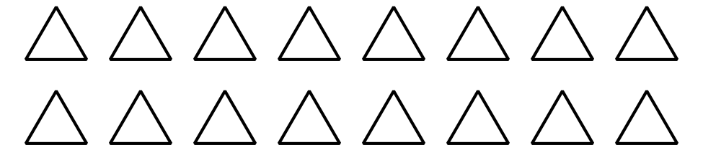
- There are _______________ triangles.

11.2: Color to Match Expressions
- Color the squares to show $10+2$.
- 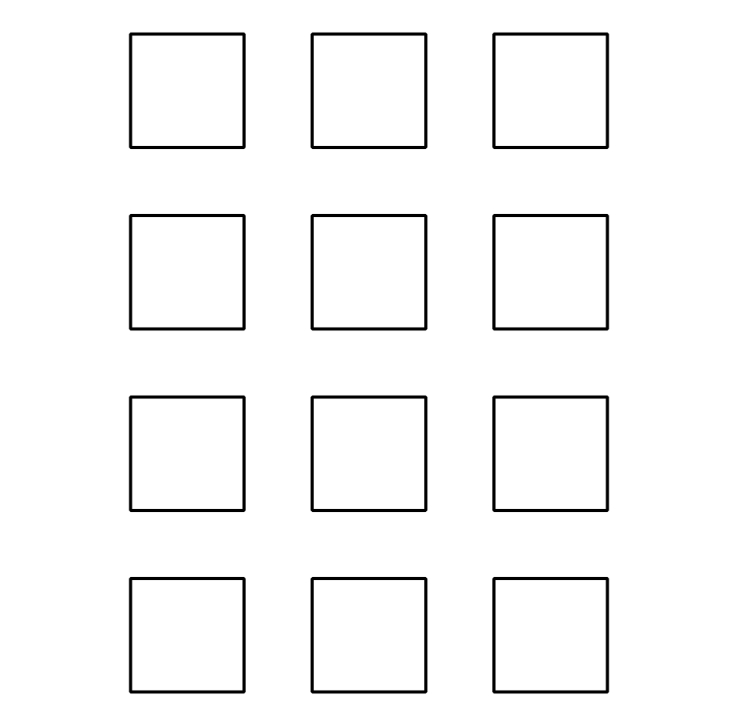
- $10+2=\underset{_}{}$
- Color the triangles to show $10+8$.
- 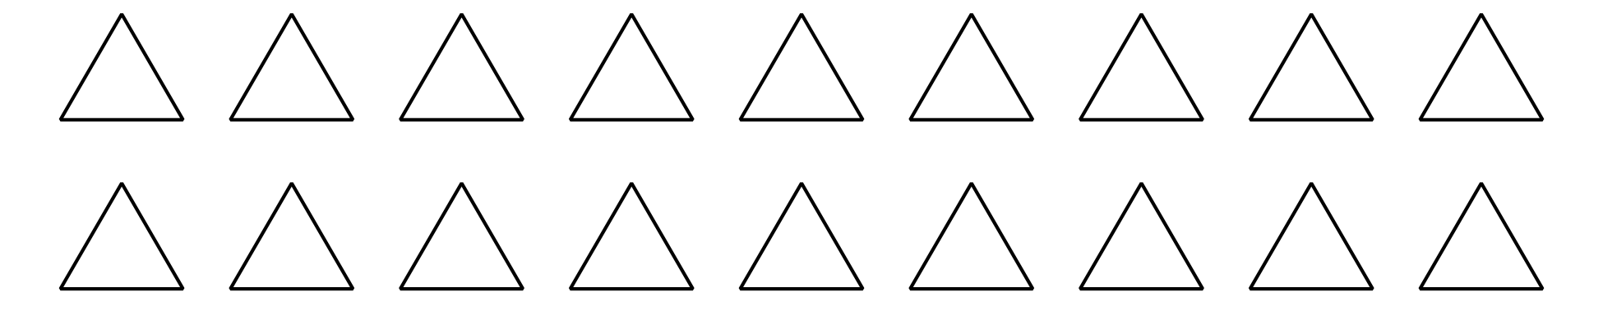
- $10+8=\underset{_}{}$
- Color the hexagons to show $10+4$.
- 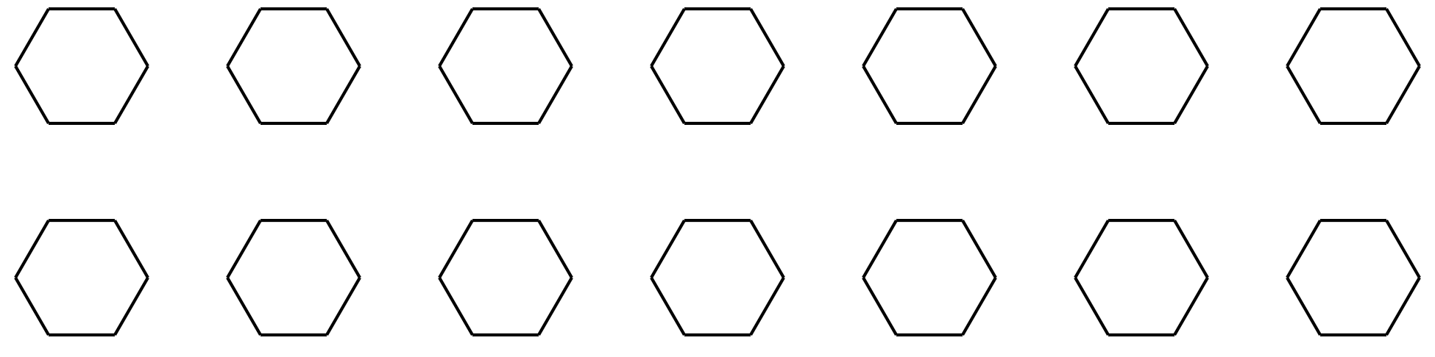
- $10+4=\underset{_}{}$
- Color the circles to show $10+9$.
- 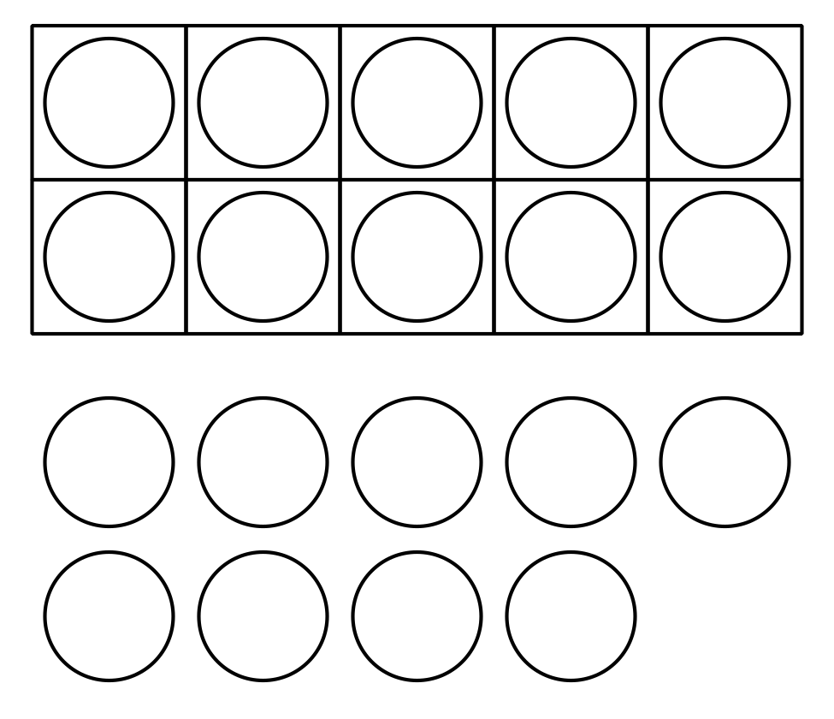
- $10+9=\underset{_}{}$

11.3: Centers: Choice Time
Choose a center.
Find the Value of the Expressions
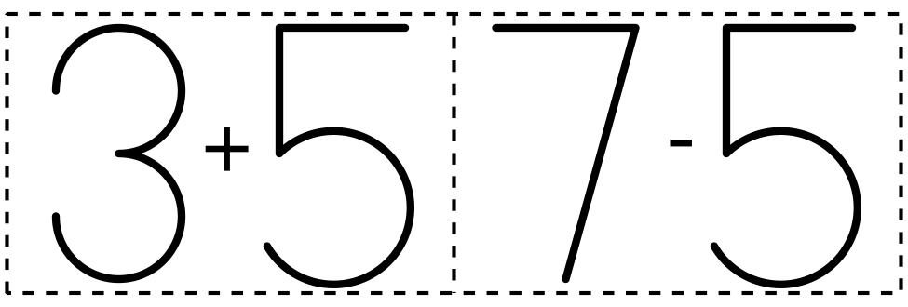
Make or Break Apart Numbers
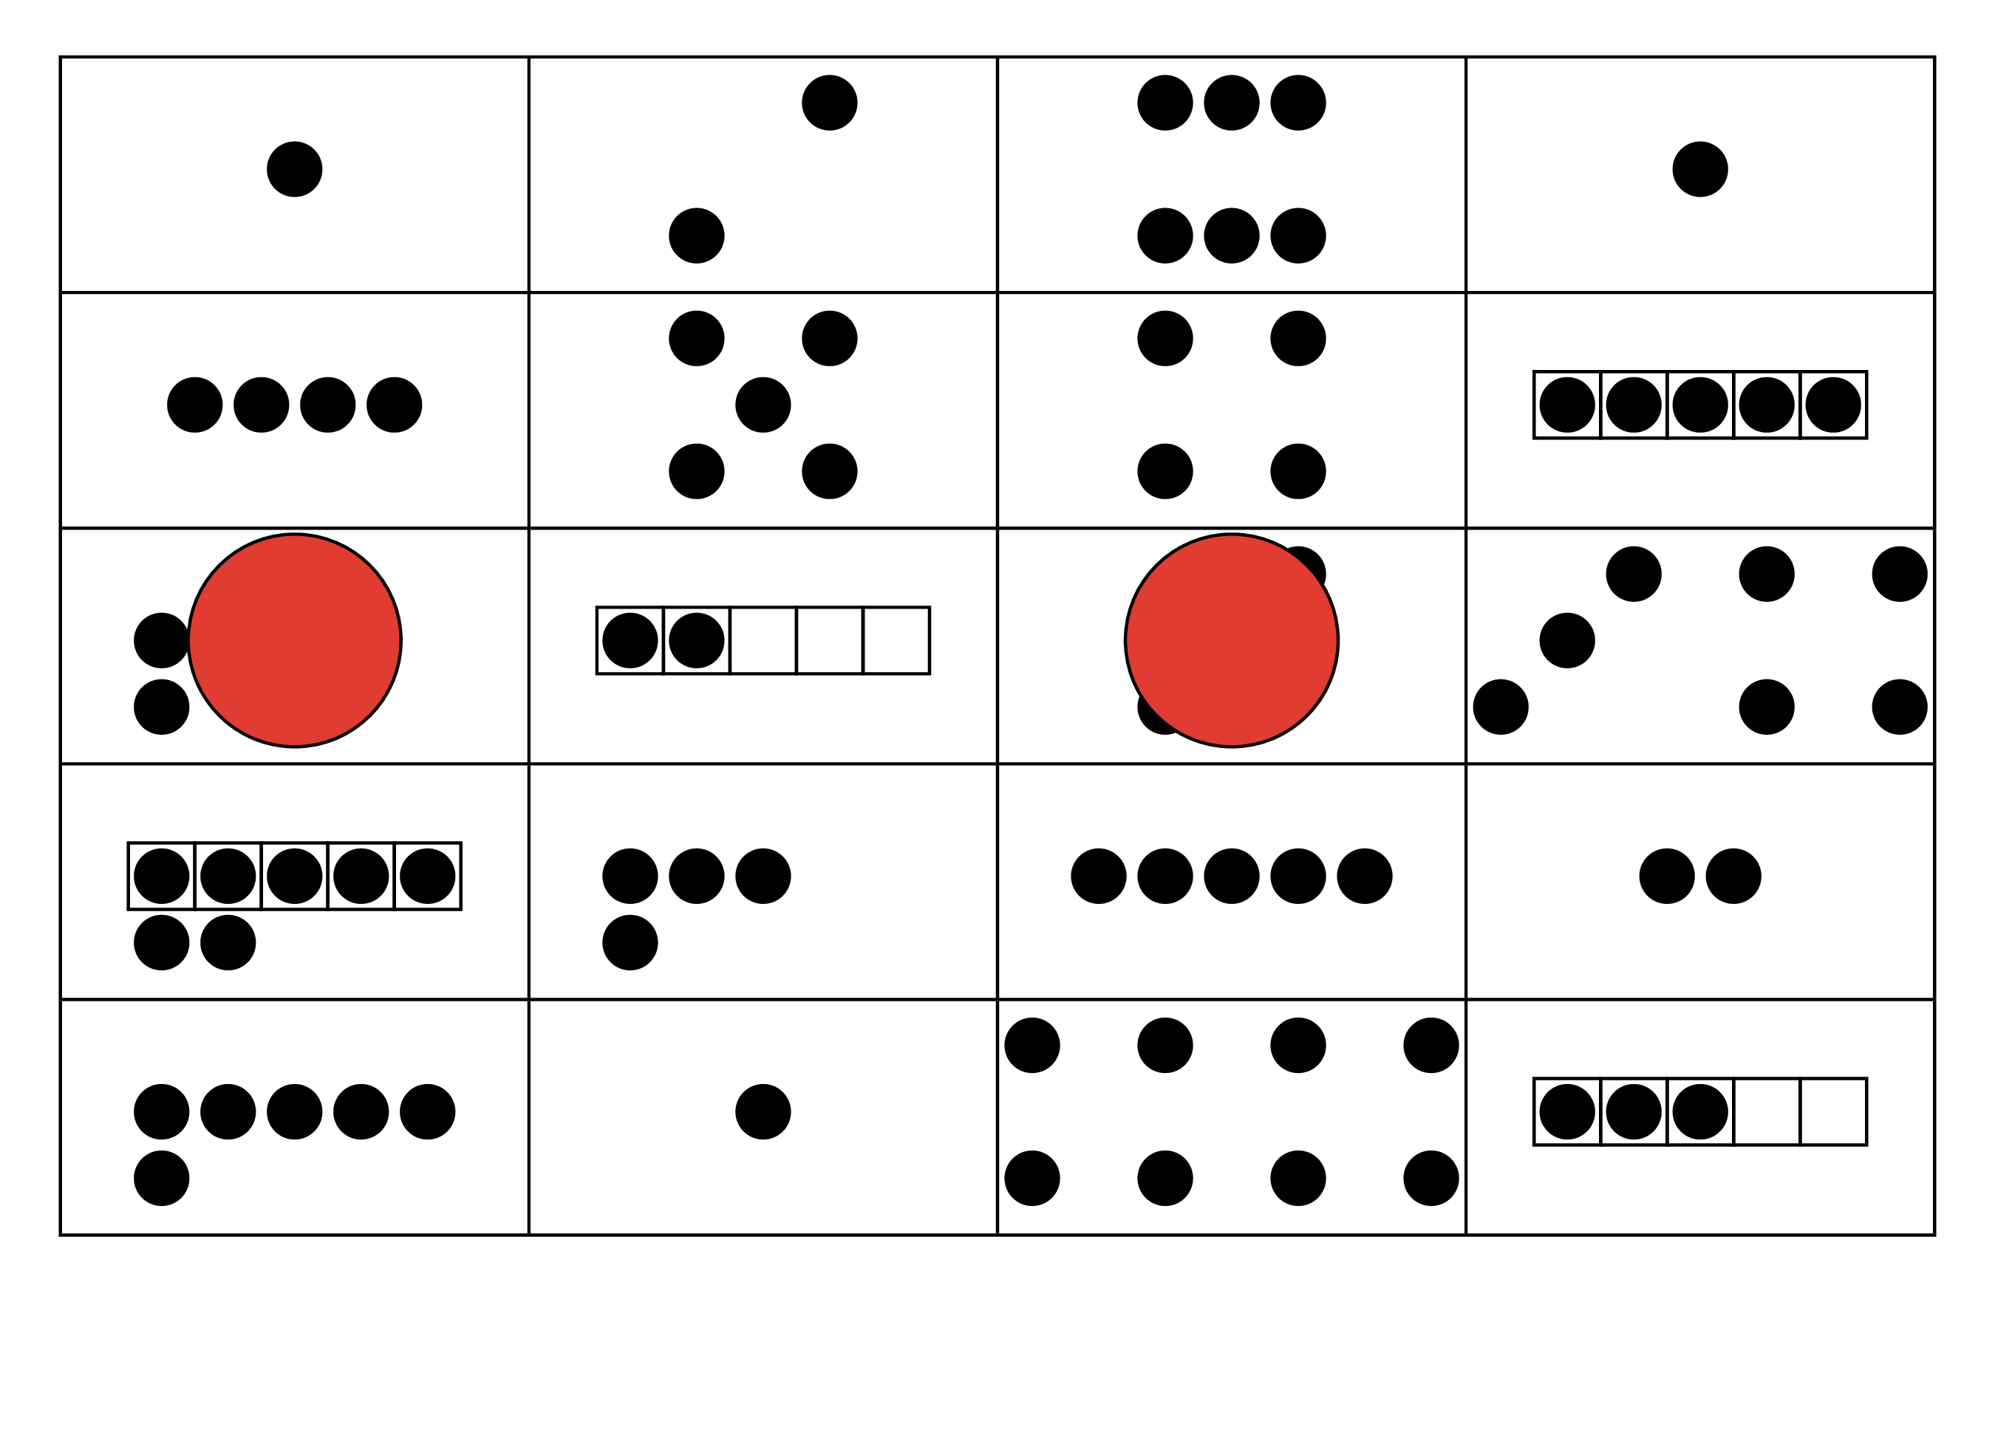
Bingo
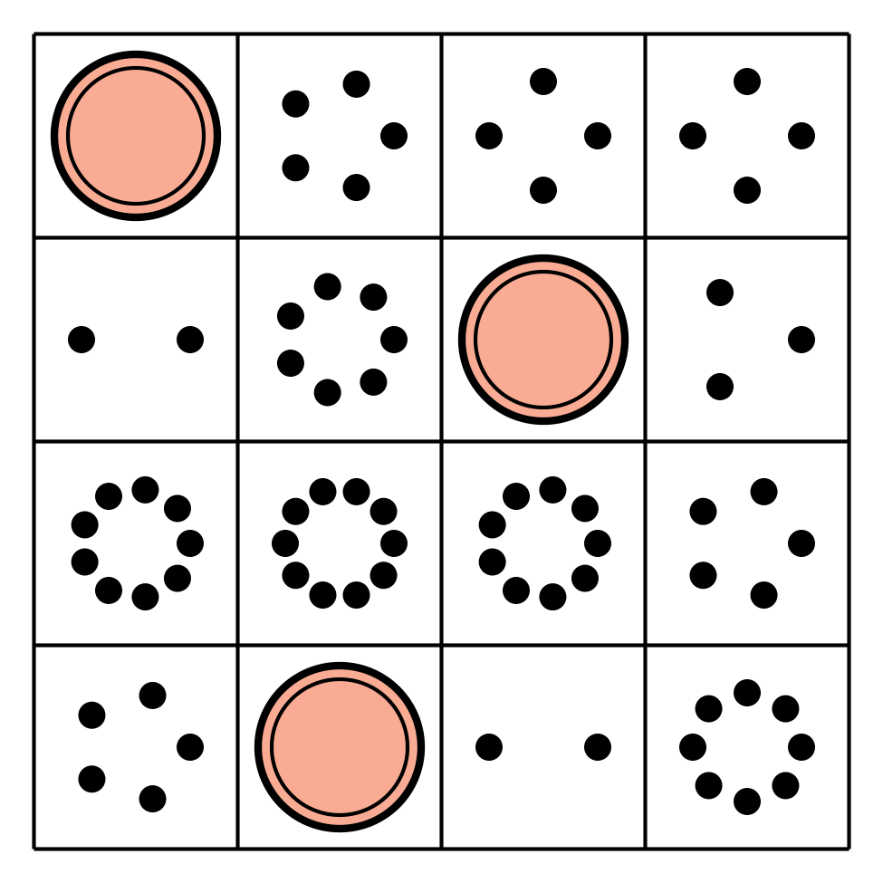
© CC BY 2021 Illustrative Mathematics®

