Lesson 5: More Dilations

5.1: Many Dilations of a Triangle
All of the triangles are dilations of Triangle D. The dilations use the same center $P$, but different scale factors. What do Triangles A, B, and C have in common? What do Triangles E, F, and G have in common? What does this tell us about the different scale factors used?
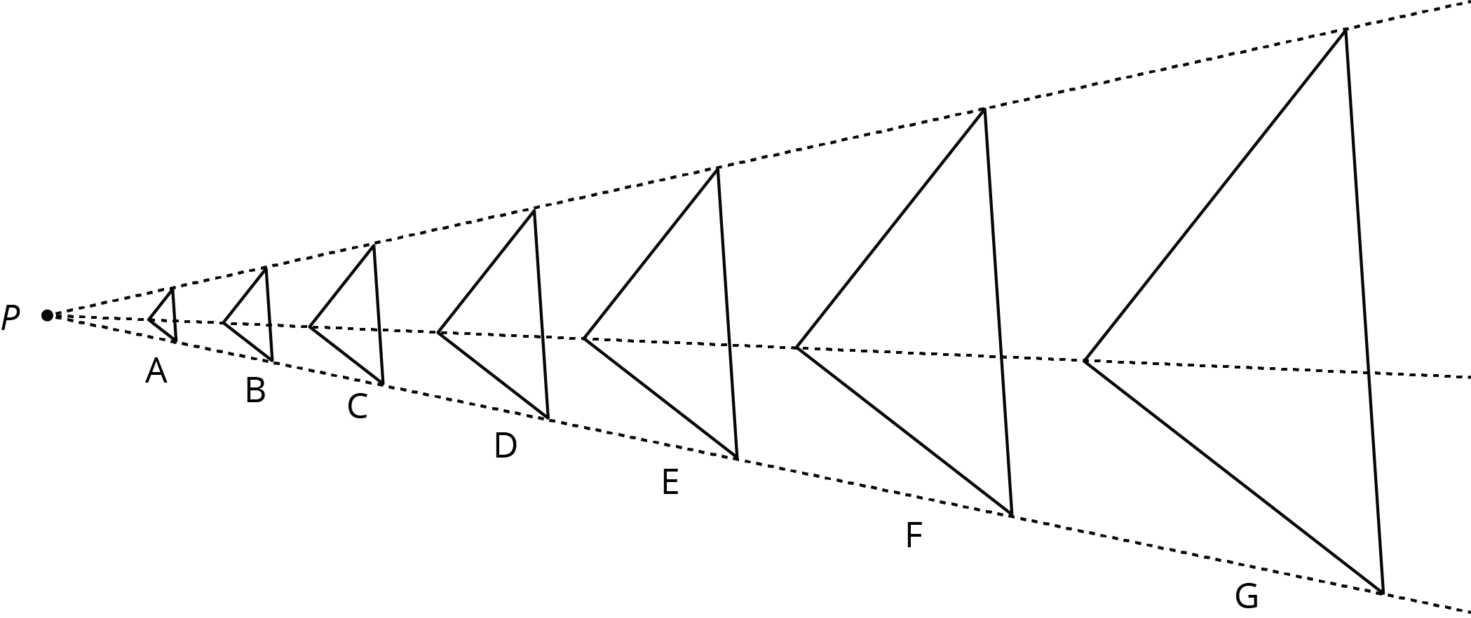

5.2: Info Gap: Dilations
Your teacher will give you either a problem card or a data card. Do not show or read your card to your partner.
If your teacher gives you the problem card:
- Silently read your card and think about what information you need to be able to answer the question.
- Ask your partner for the specific information that you need.
- Explain how you are using the information to solve the problem.
- Continue to ask questions until you have enough information to solve the problem.
- Share the problem card and solve the problem independently.
- Read the data card and discuss your reasoning.
If your teacher gives you the data card:
- Silently read your card.
- Ask your partner “What specific information do you need?” and wait for them to ask for information.
- If your partner asks for information that is not on the card, do not do the calculations for them. Tell them you don’t have that information.
- Before sharing the information, ask “Why do you need that information?” Listen to your partner’s reasoning and ask clarifying questions.
- Read the problem card and solve the problem independently.
- Share the data card and discuss your reasoning.
Pause here so your teacher can review your work. Ask your teacher for a new set of cards and repeat the activity, trading roles with your partner.

Are you ready for more?
Triangle $EFG$ was created by dilating triangle $ABC$ using a scale factor of 2 and center $D$. Triangle $HIJ$ was created by dilating triangle $ABC$ using a scale factor of $\frac{1}{2}$ and center $D$.
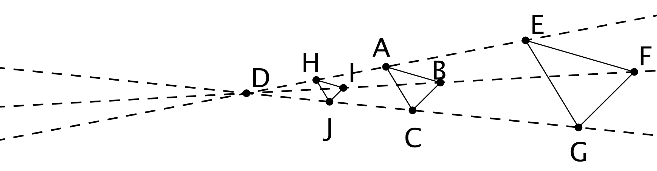
- What would the image of triangle $ABC$ look like under a dilation with scale factor 0?
- What would the image of the triangle look like under dilation with a scale factor of -1? If possible, draw it and label the vertices $A^{′}$, $B^{′}$, and $C^{′}$. If it’s not possible, explain why not.
- If possible, describe what happens to a shape if it is dilated with a negative scale factor. If dilating with a negative scale factor is not possible, explain why not.

Lesson 5 Summary
One important use of coordinates is to communicate geometric information precisely. Let’s consider a quadrilateral $ABCD$ in the coordinate plane. Performing a dilation of $ABCD$ requires three vital pieces of information:
- The coordinates of $A$, $B$, $C$, and $D$
- The coordinates of the center of dilation, $P$
- The scale factor of the dilation
With this information, we can dilate the vertices $A$, $B$, $C$, and $D$ and then draw the corresponding segments to find the dilation of $ABCD$. Without coordinates, describing the location of the new points would likely require sharing a picture of the polygon and the center of dilation.
© CC BY Open Up Resources. Adaptations CC BY IM.

